SYSTEMATIC
TRANSFER
PLAN

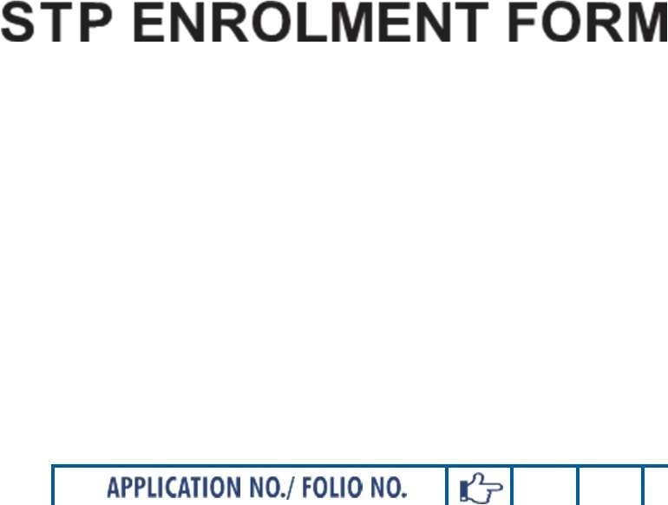

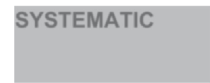


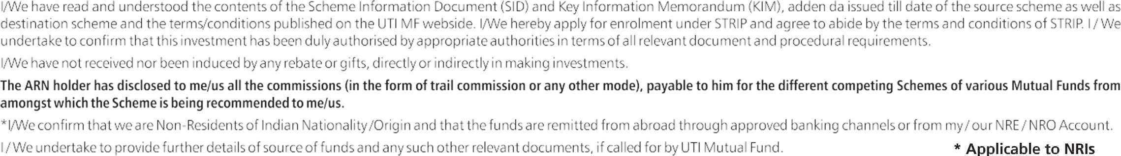


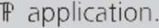

□ I/We hereby confirm that the EUIN box has been intentionally left blank by me/us as this transaction is executed without any interaction or advice by the employee/relationship manager/salesperson of the above distributor/sub broker or notwithstanding the advice of in-appropriateness, if any, provided by the employee/relationship manager/salesperson of the distributor/sub broker

ARN-146262 E253637

Frequency of STP | Daily |  |  | Weekly |  |  | Monthly |  |  | Quarterly
Minimum no of STP |  | 20 |  |  | 6 |  |  | 6 |  |  | 2
Minimum amount |  |  |  |  | 6 |  |  | 6 |  |  | 2

 |  |  | STP Period | No. of STPs
 |  | 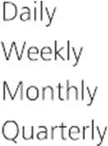
 |  | 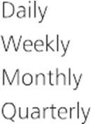
 |  | 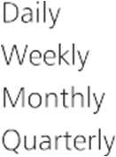




Transfer Frequency | STP Date


- Systematic Transfer Plan: Is a facility wherein investor can opt to transfer a fixed amount at regular intervals from one designated scheme to another designated scheme of UTI Mutual Fund.
- Minimum amount of investment: In the source scheme is NIL.

- Eligible scheme: STP facility is available only under eligible source /destination schemes as provided in SID.

- Default Investment: In the 'To Scheme' if no investment option is ticked default option will be Growth Option. If no IDCW option type is selected, default option will be Reinvestment. If no frequency is ticked, however date of transfer is ticked by the investor, then by default Monthly option will be considered. If no frequency is ticked and if all 4 dates are ticked, same will be treated as weekly option and processed accordingly. Is frequency and Date are ticked however no period is mentioned / Number of transfer is left blank, STP shall commence immediately on the next STP date (Business Day) after days from the time stamping, date of the form and will continue until default period of 5 years a case of clear body
Default amount- If no amount is mentioned then by default minimum amount as prescribes under each frequency shall be considered as the STP amount.

- Periodicity of transfer: STP facility offered with the following periodicity: Daily, Weekly, Monthly and Quarterly.

- Transfer of funds: Transfer of funds will take place from source scheme to destination scheme for the schemes mentioned in the SID.

- Date of Transfer: Unit holder will be eligible to transfer a fixed amount on any business day of his/her choice. If chosen day being a holiday, next business day will be considered for the transaction,

- Minimum amount of transfer: The minimum amount to be transferred is Rs.100/- per business day under Daily periodicity, Rs.1000/- under Weekly periodicity, Rs.1000/- Under Monthly periodicity and Rs.3000/- under quarterly periodicity.

- Maximum amount of transfer: There is no upper limit for transfer under all periodicities.
b

- Minimum Number of STP s Minimum number of STPs will be 20 under Daily Periodicity, 6 under Weekly Periodicity, 6 under Monthly Periodicity and 2 under Quarterly Periodicity. There will be no upper limit if the minimum number is not mentioned, then by default, the transaction to be continued till the amount in the source scheme is exhausted.

- Transfer of amount: The transfer of amount from the source scheme to the destination scheme will be affected by redeeming the units of the source scheme at applicable NAV/redemption price as on specified date and the amount will be converted into units as per applicable NAV/purchase price under the destination scheme as on the specific date.
- Load: Load structure existing at the time of investment under source/destination scheme will be applicable under the respective schemes.
In terms of SEBI circular no. SEB/MD/CIR No.4/168230/09 dated June 30, 2009, no entry load will be charged by the Schemes to the investor effective August 1, 2009. Upfront commission shall be paid directly by the investor to the AMFI registered Distributors based on the investors' assessment of various factors including the service rendered by the distributor. No entry load shall be charged for direct applications received by the Asset Management Company (AMC) i.e. applications received through internet, submitted to AMC or collection center that are not routed through any distributor / MFD. No entry load shall also be charged for additional purchases done directly by the investor under the same folio and switch into a scheme from other schemes if such a transaction is done directly by the investor. Whenever the ARN Code of a MFD /Distributor given in the application form has to be struck off, it has to be counter signed by the first applicant. In case the first applicant does not counter sign it the application will net be treated as a direct application. For direct applications, the area for providing, ARN Code of a MFD/Sub- distributor / Distributor should not be left blank. It should be marked Direct or "Not Applicable'. All Official Points of Acceptance will be available on the website of UTI Mutual Fund www.utimf.com, No entry and exit load will be charged on Bonus Units issued and on Units allotted on Re-investment of IDCW.
GENERAL INSTRUCTION

- Termination of STP: STP will automatically get terminated under the following conditions
  - The unit holdings under the source scheme becomes nil or lower than minimum amount to be transferred as stipulated.
  - In the case of death of the first unit holder.
  - It the unit holder wishes to terminate at any time by sending a written request to official point of acceptance. Such notice will have to be sent at least 1 calendar days prior to the due date of the next transfer date.
  - If lien or pledge or STOP is marked against the units in the source scheme.
  - If redemption is put for all units or entire amount in the source scheme during the STP transfer then the STP would cease off after units are redeemed.

- STP will be registered and activated on T+1 business day from the day of clear funds are available in the Source scheme.

GENERAL INSTRUCTION
- The name of unitholders (1st, 2nd & 3rd) and their order should be identically mentioned in the source scheme application form as well as STP enrolment form.
- New Investor desiring to opt for STP facility is required to fill in source scheme application form as well as STP enrolment form.
- The provision of 'Minimum Application Amount and Minimum Redemption Amount’ It specified in the respective scheme information document of the source and destination scheme will not be applicable in the case of transaction through STP except Institutional Plan.
- STP request will be registered for a folio, even if it is already under Systematic Investment Plan (SIP), Monthly Withdrawal Plan (MWP) or Fixed Withdrawal Plan (FWP).
- If the residual amount in source Scheme is less than the scheme minimum amount or strip amount whichever is less, then the residual amount will be included in the last STP installment.
However, on termination of STP, if the balance in the destination scheme is found to be below the minimum amount as per the provisions of scheme, the same will be redeemed at the redemption price applicable on the effective date of termination under the conditions stated in point no. 13 above.
- It the total Investment amount to be transferred is not mentioned then the entire invested amount will be transferred.
- UTI Asset Management Co. Ltd, reserves the right to reject STP mandate without assigning any reasons thereof.
- UTI AMC reserves the right to change / modify the terms and conditions of STP facility at any time.
- SOAs under STP- Daily/Weekly Periodicity will be issued on quarterly basis viz December, March, June & September respectively.
- Knew Your Client (KYC) requirement is now mandatory for all investors, irrespective of the amount of investment w.e.f January 01, 2011. For details, please refer to Statement of Additional Information (SAI).
- Note on EUIN: investors should mention the EUIN of the person who has advised the investor, If left blank please sign the declaration provided in the application form. EUIN will assist in tackling the problem of miss-selling ever if the employee/ relationship manager/sales person leave the employment of the ARN holder/ Sub distributor Applicability of EUIN:
  - Transactions to be included: Purchase, Switch, SIP/ STP Triggers registration, IDCW Transfer Plan.
  - Transactions to be excluded: Auto SIP/STP/SWP/ STP Triggers Installments, IDCW reinvestment, Bonus units, Redemption, SWP Registration, Zero Balance Folio creation and IDCW Transfer Plan installments.

