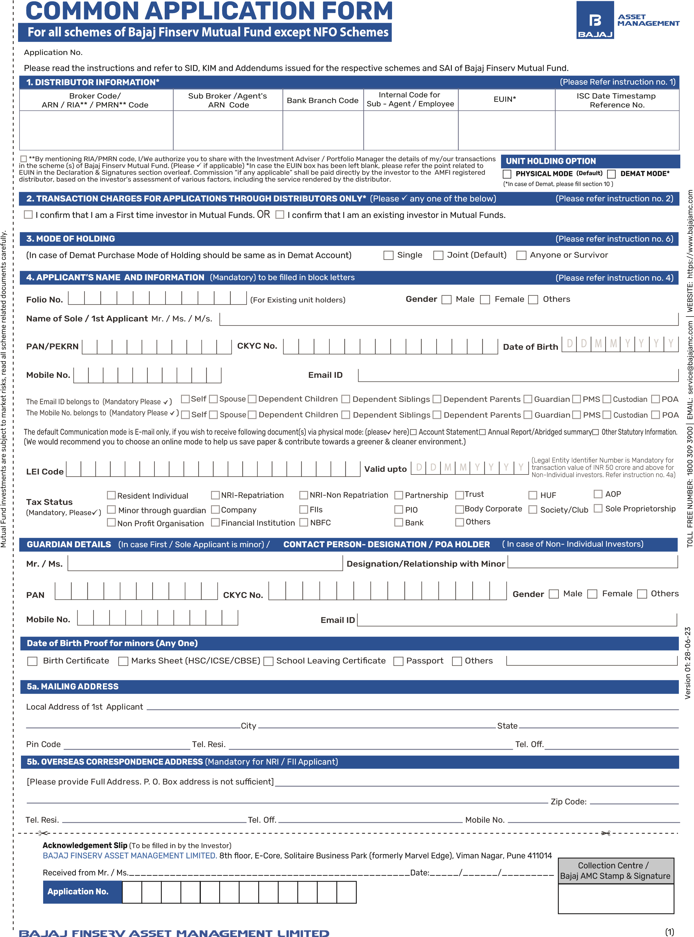
ARN-146262
6a. SECOND APPLICANT'S DETAILS* (In case of Minor, there shall be no joint holders) [Name and DOB shall be as per PAN Card]
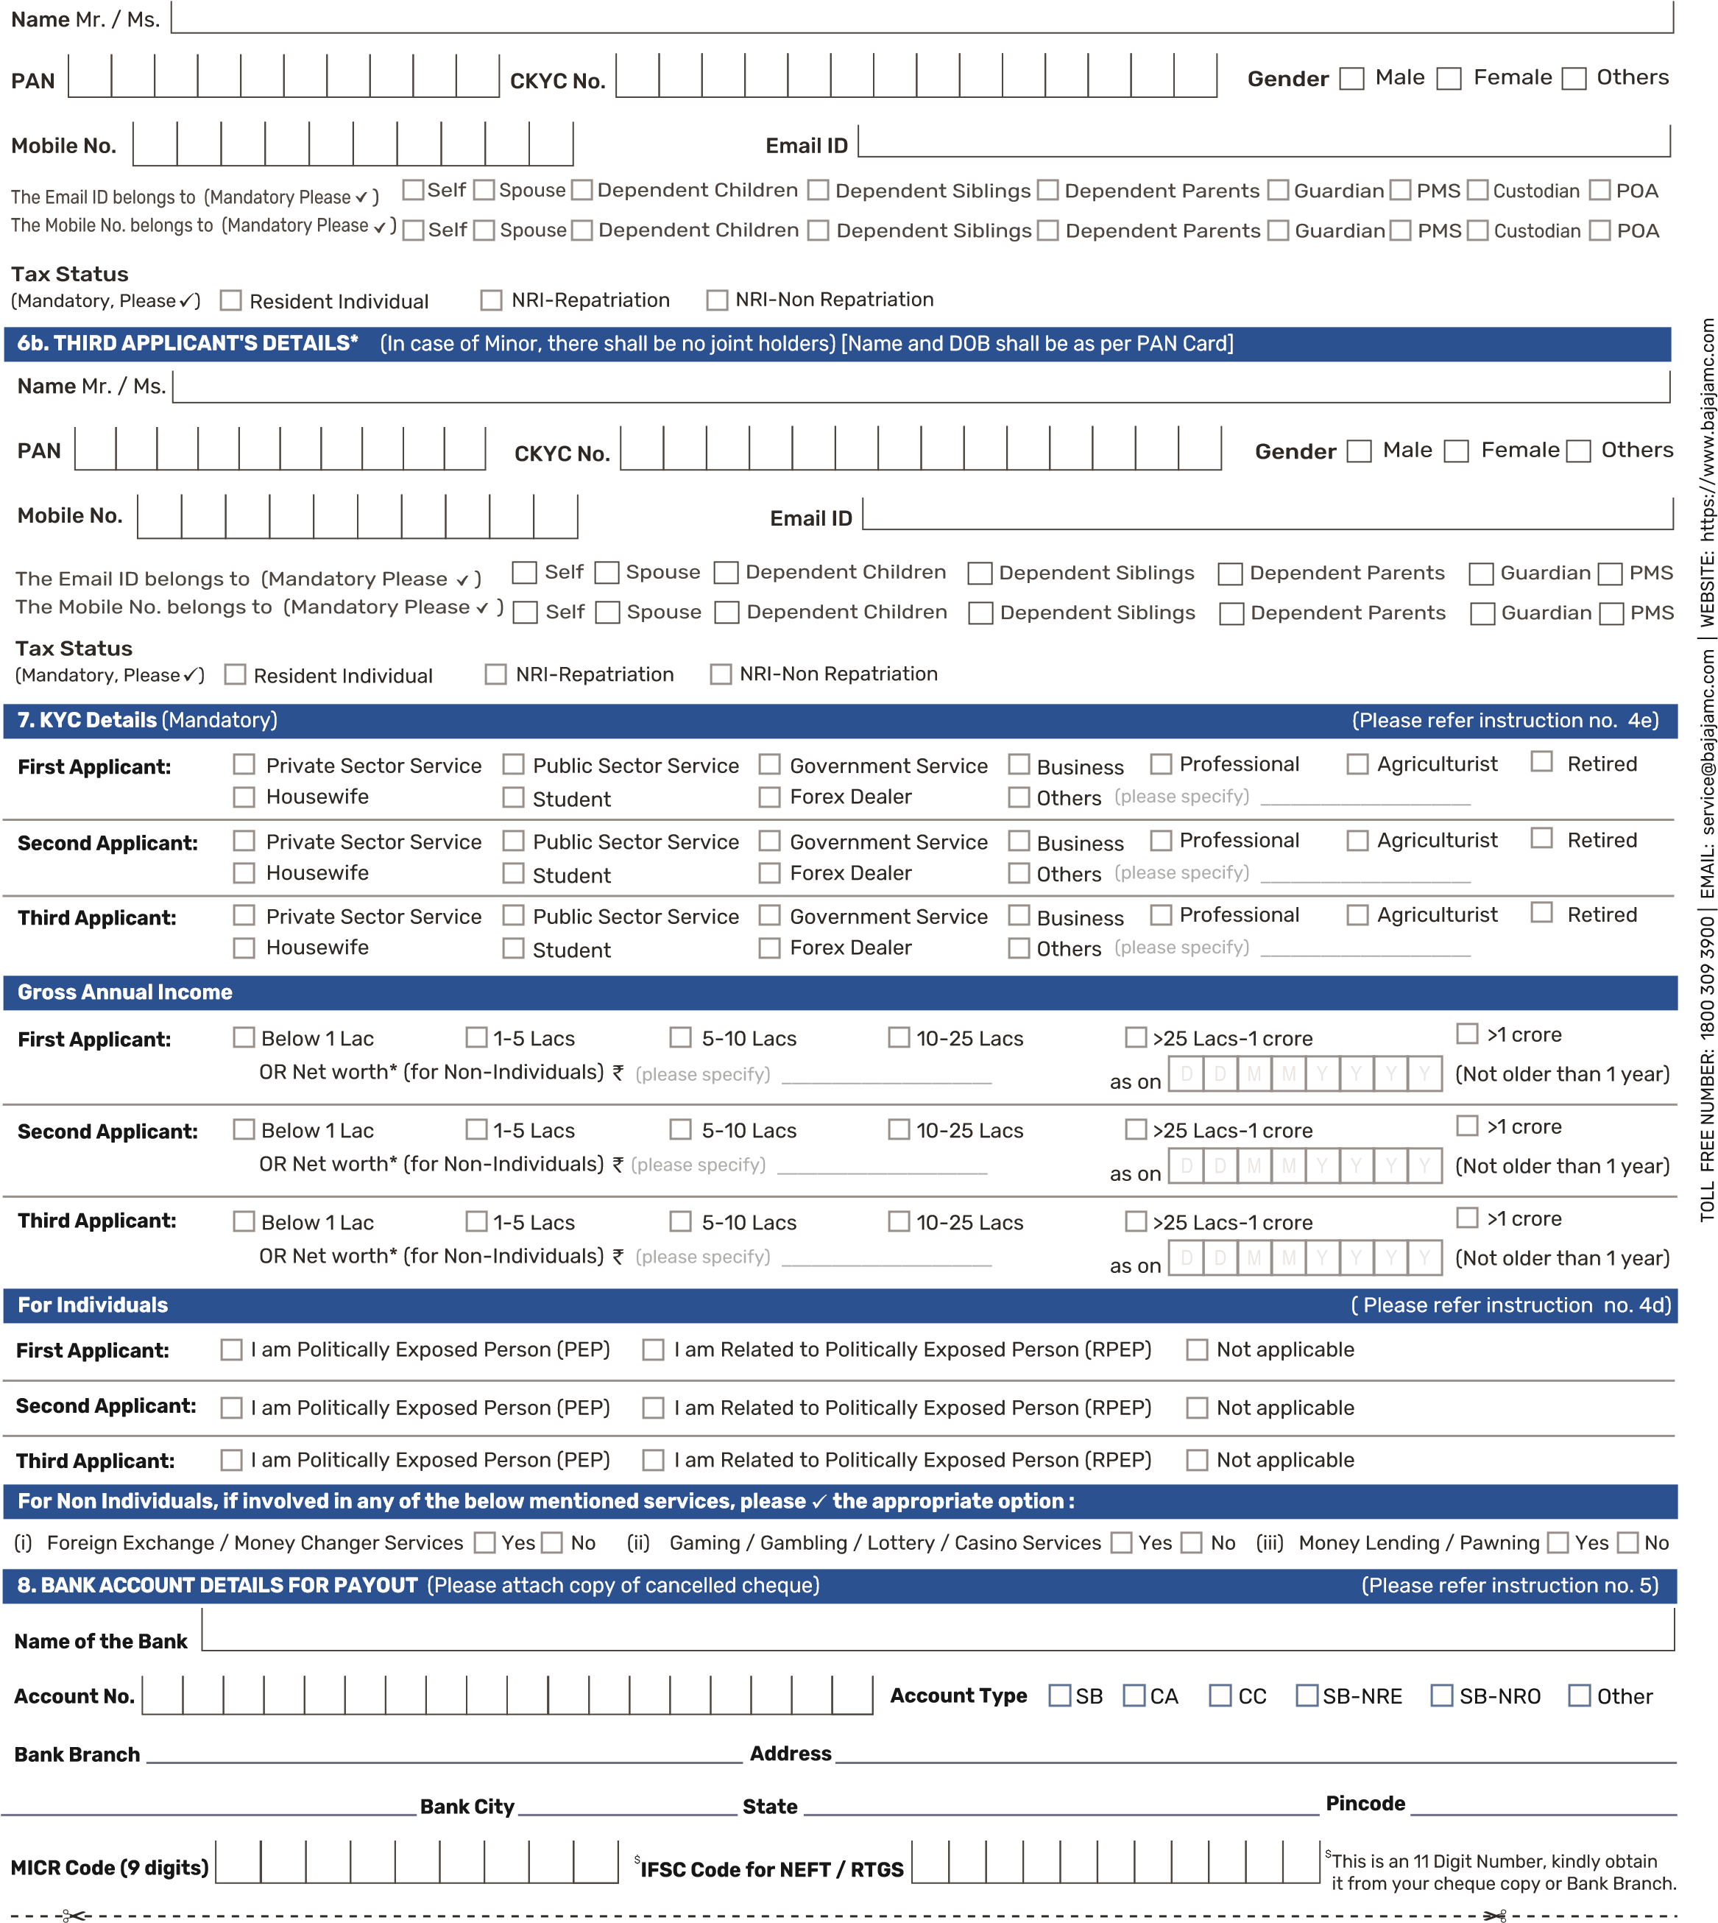
Sr.  No. | Scheme Name /Plan | Option |  |  | Net Amount Paid (`) | Payment Details
 |  |  |  |  |  | Cheque/DD No./UTR No. (in case of NEFT/RTGS) | Bank and Branch
1 | Bajaj Finserv  Regular Direct | Growth  IDCW Payout
1 | Bajaj Finserv  Regular Direct |  |  | IDCW Reinvestment
.

(2)
9. INVESTMENT & PAYMENT DETAILS* The name of the first/ sole applicant must be pre-printed on the cheque. (Please refer instruction no. 7)
Scheme Name | Plan | Option
Bajaj Finserv | Regular Plan Direct Plan |  |  | Growth (Default)  IDCW Payout IDCW ReinvestmentTransfer of IDCW  IDCW Frequency Daily Weekly Fortnightly Monthly
Cheque/DD should be drawn in favour of scheme name e.g. “Bajaj Finserv Liquid Fund”
. FATCA AND CRS DETAILS FOR INDIVIDUALS
11
Including Sole Proprietor)
(

The below information is required for all applicants/guardian
First Applicant / Guardian
Particulars
Second Applicant
Third Applicant
Place/City of Birth
Country of Citizenship / Nationality
Indian

U.S.

Others
(
)
Please specify
_____________________
Indian
U.S.
Others
(
Please specify
)
_____________________
Indian
U.S.
Others
)
Please specify
(
_____________________
Country of Birth
(Please refer instruction no. 9)
TOLL FREE NUMBER:
1800 309 3900
| EMAIL: service@bajajamc.com | WEBSITE: https://www.bajajamc.com
National Securities Depository Limited
DP Name
Central Depository Services (India) Limited
Enclosures - Please
(
✓

)
Client Masters List (CML)

Transaction cum Holding Statement

Delivery Instruction Slip (DIS)
IN
Beneficiary A/c No.
Beneficiary A/c No.
10

DEMAT MODE*
PHYSICAL MODE (Default)
. UNIT HOLDING OPTION
(Please refer instruction no. 8)
Mode of Payment
Amount (INR)
Mode of Payment ( Please )
Cheque / DD
NEFT / RTGS
Cheque / DD No. / UTR No.
Cheque / DD No. / UTR No.
Drawn on Bank and A/c no
Date
Lumpsum
Non-Third Party
SIP*
Third Party Payment
Pls fill third party declaration form)
(

✓
Payment Type ( Please )
✓
*If you wish to register SIP, kindly fill the relevant SIP Registration & OTM Debit Mandate Form.
Reason for investment House Children’s Education Children’s Marriage Car Retirement Others (please specify) _____________________
Investment horizon Please ( ) anyone 5 Years 10 Years 15 Years 20 Years 25 Years
*Demat Account details are mandatory if the investor wishes to hold the units in Demat Mode. Please ensure that the sequence of names as given in the order of the applicants matches as per the Depository Details. In case of any ambiguity or validation failure with the depository details, AMC will allot units in the Physical Mode.
Mutual Fund investments are subject to market risks, read all scheme related documents carefully.
DP Name
DP ID
Non-Individual investors should mandatorily fill separate FATCA and Ultimate Beneficial Ownership (UBO) Form.
Are you a tax resident (i.e., are you assessed for Tax) in any other country outside India? Yes No [Please tick ( ✓ )]
If ‘YES’ please fill for ALL countries (other than India) in which you are a Resident for tax purpose i.e. where you are a Citizen/Resident/Green Card Holder/Tax Resident in the respective countries.
Particulars | Country of Tax Residency | Tax Identification Number or Functional Equivalent | Identification Type ) (TIN or other please specify | If TIN is not available please tick ( )✓ the reason A, B or C (as defined below)
First Applicant / Guardian |  |  |  | Reason : A | B  C
Second Applicant |  |  |  | Reason : A | C  B
Third Applicant |  |  |  | Reason : A | C  B
❑ Reason A  The country where the Account Holder is liable to pay tax does not issue Tax Identification Numbers to its residents.
❑ | Reason B  No TIN required (Select this reason only if the authorities of the respective country of tax residence do not require the TIN to be collected)
❑ | Reason C  Others, please state the reason thereof: _____________________________________________________________
 | *Address Type of Sole/1st Holder:  Residential Registered Office Business | *Address Type of 2nd Holder:  Residential Registered Office Business | *Address Type of 3rd Holder:  Residential Registered Office | Business
*If the address type is not ticked the default will be considered as residential.

12. NOMINATION DETAILS* (To be filled in by individuals singly or jointly. Mandatory only for Investors who opt to hold units in Non-Demat) |  |  |  |  |  | (Please refer instruction no. 10)
 |  | I/We do hereby nominate the person(s) more particularly described here under to receive the Units held in my/our Folio in the event of my/our death.  (Please fill the nominee details in the table given below) | OR |  | I/We hereby confirm that I/We do not wish to appoint any nominee(s) for my mutual fund units held in my/our mutual fund folio. I/We understand the implications/issues involved in non-appointment of any nominee(s) and am/are further aware that in case of my demise/ death of all the unit holders in the folio, my/our legal heir(s) would need to submit all the requisite documents issued by the Court or such other competent authority, as may be required by the Mutual Fund/AMC for settlement of death claim/transmission of units in favour of the legal heir(s), based on the value of the units held in the mutual fund folio.
If you do not wish to nominate (Opt Out of Nomination), it is mandatory to sign as per the mode of holding in signature space provided below i.e. in Nomination Details section
Name and PAN of Nominee(s) | Relationship with  Applicant | Date of Birth | Guardian Name | Guardian’s relationship with nominee | Signature of Nominee/ Guardian of Nominee (Optional) | Proportion (%) in which the units will be shared  by each Nominee (should aggregate to 100%)
Name and PAN of Nominee(s) | Relationship with  Applicant | (to be furnished in case the Nominee is a minor) |  |  | Signature of Nominee/ Guardian of Nominee (Optional)
Documents  Nominee 1 |  | DD/MM/YYYY
Nominee 2 |  | DD/MM/YYYY
Nominee 3 |  | DD/MM/YYYY
Signature(s)
Sign of 1st Applicant / Guardian |  | Sign of 2nd Applicant |  | Sign of 3rd Applicant
13. CONFIRMATION CLAUSE
14. DECLARATION AND SIGNATURES | (Please refer instruction no. 11)
All Unit holders to mandatorily sign irrespective of the mode of holding.
Mutual Fund investments are subject to market risks, read all scheme related documents carefully.
I/We hereby confirm to have read, understood and agree to the privacy policy available on www.bajajamc.com. I/We accord my/our consent to the AMC/Fund for collecting, receiving, possessing, storing, dealing, handling or disclosure of my/our personal data and hereby authorise to disclose it to the third party or another body corporate or any person acting under a contract with the AMC or the Fund.
I/We hereby confirm and declare as under:- I/We have read and understood the contents of the Statement of Additional Information of Bajaj Finserv Mutual Fund and the Scheme Information Document(s)/Key Information memorandum of the respective Scheme(s) and Addenda thereto, issued from time to time and the Instructions. I/We, hereby apply to the Trustee of Bajaj Finserv Mutual Fund for allotment of units of the Scheme(s) of Bajaj Finserv Mutual Fund, as indicated above and agree to abide by the terms, conditions, rules and regulations of the relevant Scheme(s). I/We have neither received nor been induced by any rebate or gifts, directly or indirectly in making this investment. I/We declare that I am/We are authorised to make this investment and the amount invested in the Scheme is through legitimate sources only and is not designed for the purpose of contravention or evasion of any Act, Regulation, Rule, Notification, Directions or any other applicable laws enacted by the Government of India or any Statutory Authority. The ARN holder has disclosed to me/us all the commissions (in the form of trail commission or any other mode), payable to him for the different competing Schemes of various Mutual Funds from amongst which the Scheme(s) is/are being recommended to me/us. I/We declare that the information given in this application form is correct, complete and truly stated. In the event of my/our not fulfilling the KYC process to the satisfaction of the AMC/Bajaj Finserv Mutual Fund, I/We hereby authorise the AMC/Bajaj Finserv Mutual Fund to redeem the units against the funds invested by me/us at the applicable NAV as on the date of such redemption. I/We agree that Bajaj Finserv Mutual Fund can debit from my Folio Transaction Charges as applicable. I/We agree to notify Bajaj Finserv Asset Management Limited immediately in the event the information in the self-certification changes. For investors investing in Direct Plan: I/We hereby agree that the AMC has not recommended or advised me/us regarding the suitability or appropriateness of the product/scheme/plan. Applicable to Micro Investors: I/We hereby declare that I/We do not have any existing Micro investments which together with the current application will result in aggregate investments exceeding Rs. 50,000 in a year. Applicable to NRls: I/We confirm that I am/We are Non-Resident(s) of Indian Nationality/Origin and I/We hereby confirm that the funds for subscription have been remitted from abroad through normal banking channels or from funds in my/our Non-Resident External / Ordinary Account / FCNR Account ( s ) . FATCA and CRS Declaration: I/We hereby acknowledge and confirm that the information provided in this form is true and correct to the best of my/our knowledge and belief. In case any of the above specified information is found to be false or untrue or misleading or misrepresenting, I/We shall be liable for it. I/We also undertake to keep you informed in writing about any changes/modification to the above information in future and also undertake to provide any other additional information as may be required at your end. I/We hereby authorise you to disclose, share, remit in any form, mode or manner, all/any of the information provided by me/us, including all changes, updates to such information as and when provided by me/us to Mutual Fund, its Sponsor, Asset Management Company, trustees, their employees ('the Authorised Parties') or any Indian or foreign governmental or statutory or judicial authorities/agencies including but not limited to the Financial Intelligence Unit-India (FIU-IND), the tax /revenue authorities and other investigation agencies without any obligation of advising me/us of the same.
TOLL FREE NUMBER:
1800 309 3900
| EMAIL: service@bajajamc.com | WEBSITE: https://www.bajajamc.com
Please ✓ : if the EUIN space is left blank: I / We hereby confirm that the EUIN box has been intentionally left blank by me/us as this is an “execution-only” transaction without any interaction or advice by the employee/relationship manager/sales person of the above distributor or notwithstanding the advice of in-appropriateness, if any, provided by the employee/relationship manager/sales person of the distributor and the distributor has not charged any advisory fees on this transaction.
Signature(s)
should be as it appears in the Folio / on the Application Form and in the same order. In case the mode of holding is joint, all Unit holders are required to sign.
  Sign of 1st Applicant / Guardian / Authorised Signatory / POA
  Sign of 2nd Applicant / Authorised Signatory / POA |  | Sign of 3rd Applicant / Authorised Signatory / POA
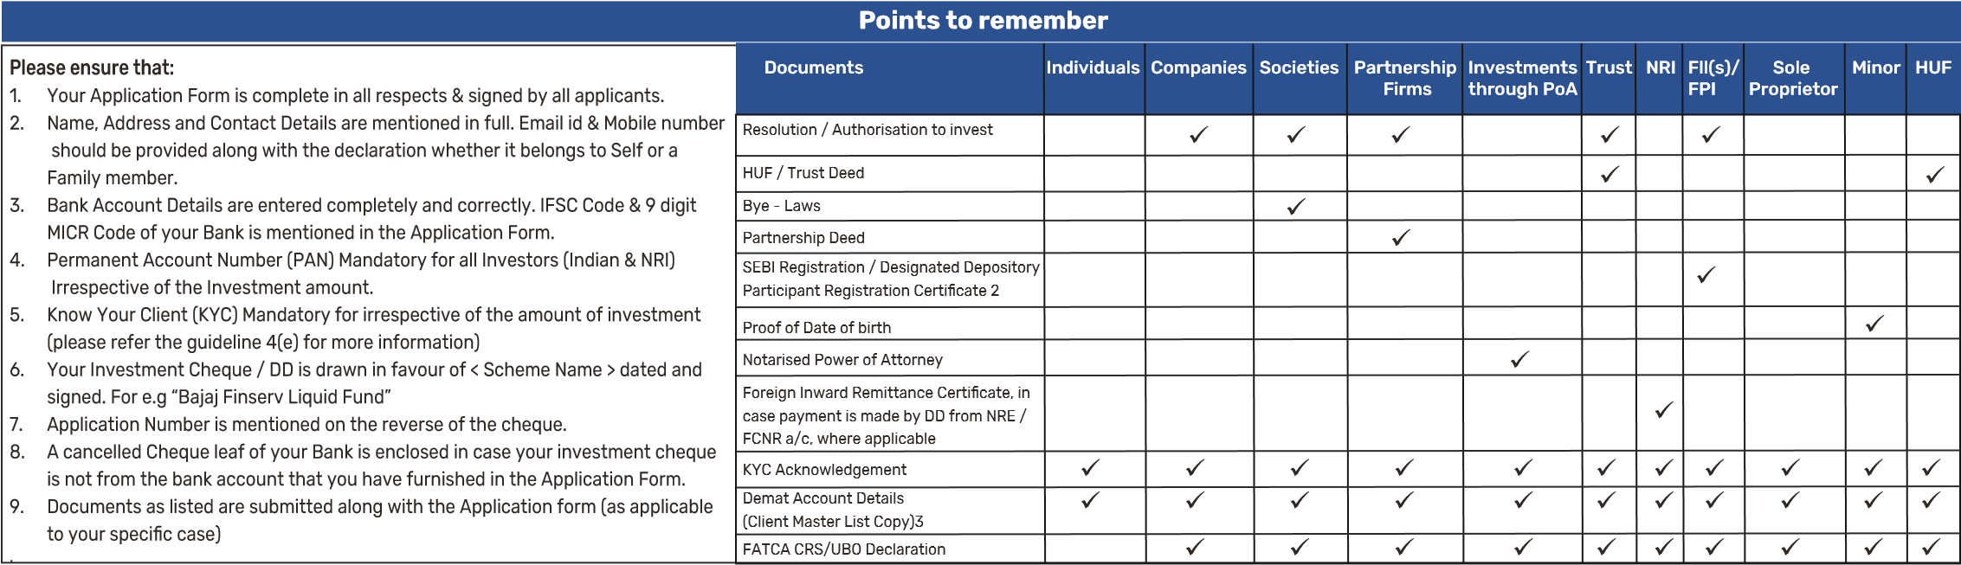
1. Self attestation is mandatory 2. Copy of SEBI registration certificate (for FII) or Designated Depository Participant registration certificate (for FPI) should be provided 3. In case Units are applied in Electronic (Demat) mode.

GENERAL GUIDELINES FOR COMMON APPLICATION FORM
- Please read the Scheme Information Document/Key Information Memorandum of the respective Scheme carefully before investing.
- Please furnish all information marked as ‘MANDATORY’. In the absence of any mandatory information, the application would be rejected.
- The application form should be completed in ENGLISH and in BLOCK LETTERS.
- All cheques, demand drafts and pay orders should be crossed “Account Payee only” and made in favour of “Scheme Name” - E.g. Bajaj Finserv Liquid Fund.
- If the Scheme name on the application form and on the payment instrument are different, the application may be processed and units allotted at applicable NAV of the scheme mentioned in the application / transaction slip duly signed by investor(s).
- Any over-writing / changes made while filling the form must be authenticated by canceling the
original entry, re-entering correct details and ensuring that all applicants counter-sign against

INSTRUCTIONS FOR COMMON APPLICATION FORM
1. DISTRIBUTOR INFORMATION
- Commission (if any) shall be paid directly by the investor to the AMFI registered Distributors based on the investors’ assessment of various factors including the service rendered by the distributor.
- Please mention ‘DIRECT’ in case the application is not routed through any distributor.
- Pursuant to SEBI circular dated September 13, 2012, mutual funds have created a unique identity number of the employee/ relationship manager/ sales person of the distributor interacting with the investor for the sale of mutual fund products, in addition to the AMFI Registration Number (ARN) of the distributor. This Employee Unique Identification Number is referred as “EUIN”. EUIN aims to assist in tackling the problem of mis-selling even if the employee/relationship manager/sales person leaves the employment of the distributor or his/her sub broker. Quoting of EUIN is mandatory in case of advisory transactions.
- Distributors are advised to ensure that the sub broker affixes his/her ARN code in the column “Sub broker ARN code” separately provided, in addition to the current practice of affixing the internal code issued by the main ARN holder in the “Sub broker code (as allotted by ARN holder)” column and the EUIN of the Sales Person (if any) in the “EUIN” column.
- Distributor are advised to ensure that they fill in the RIA/PMRN code, in case they are a Registered Investment Advisor / Portfolio Manager.
- Investors are requested to note that EUIN is applicable for transactions such as Purchases, Switches, Registrations of SIP / STP and EUIN is not applicable for transactions such as Instalments under SIP/STP / SWP, Redemption, SWP Registration.
- Investors are requested to note that EUIN is largely applicable to sales persons of non
individual ARN holders only (whether acting in the capacity of the main distributor or sub broker). Further, EUIN will not be applicable for overseas distributors who comply with the requirements as per AMFI circular.
2. TRANSACTION CHARGES
In terms of SEBI circular, Cir/ IMD/ DF/13/ 2011 dated August 22, 2011, the distributors of mutual fund products are allowed to be paid transaction charges for purchase transactions :
- @ Rs. 100/- per subscription of Rs. 10,000/- and above in respect of existing unitholders; and
- @ Rs. 150/- for subscription of Rs. 10,000/- and above in respect of a first time investor in mutual funds.
In case of SIPs, the transaction charge if any, shall be applicable only if the total commitment through SIPs aggregates to Rs. 10,000/- and above and shall be recovered in 4 instalments. The transaction charge shall be deducted from the subscription amount and paid to the distributor; and the balance shall be invested in the Scheme. The transaction charges and the net investment amount and the number of units allotted will be clearly mentioned in the Account Statement issued by the Mutual Fund.
There shall be no transaction charges on
- ‘Direct’ investments;
- subscription below Rs. 10,000/- and
- switch (including STP) and redemption (including SWP) transactions.
Distributors shall be able to choose to opt out of charging the transaction charge. However, the ‘opt out’ shall be at distributor level and not investor level i.e. a distributor shall not charge one investor and choose not to charge another investor.
- EXISTING INVESTORS OF BAJAJ FINSERV MUTUAL FUND
If you are an existing investor please mention your existing folio number, so the unit will be allotted in the same folio. If it left blank, then new folio number will be generated.
- SOLE/ FIRST APPLICANT’S DETAILS
a. Please furnish names of all applicants. The name of the Sole /First Applicant should be mentioned in the same manner in which it appears in the Income Tax PAN card. Please note the following:
- In case the applicant is a Non individual Investor (including HUF), then Legal Entity
Identifier(LEI) Number is mandatory to be mentioned in the space provided. As per the
RBI circular No. RBI/2020-21/82 - DPSS.CO.OD No.901/06.24.001/2020-21 dated
January 05, 2021, it is mandatory for all Non-individuals to obtain Legal Entity Identifier
(LEI) and quote the same for any transactions beyond Rs.50 crore routed through RTGS / NEFT w.e.f 1st April’21. Further , the Contact person’s name to be stated in the space provided (Name of (Guardian/Contact Person)
- In case the applicant is a minor, the Guardian’s name should be stated in the space provided (Name of Guardian / Contact Person). It is mandatory to provide the minor’s date of birth in the space provided.
- In case the application is being made on behalf of a minor, he / she shall be the Sole Holder/Beneficiary. There shall be no joint account with a minor unitholder.
b. Please indicate the tax status of the sole/1 applicant at the time of investment. The abbreviations used in this section are: NRI: Non-Resident Indian Individual, PIO: Person of Indian Origin, FII: Foreign Institutional

Investor, NGO: Non Government Organization, AOP: Association of Persons, BOI: Body of Individuals, HUF : Hindu Undivided Family.
each correction.
- Investors must write the application form number / folio number /PAN number on the reverse of the cheque / demand draft.
- FATCA Declaration: Individual investors, please fill in FATCA / CRS annexure and attach along with Application form. Non-Individual investors, please fill in UBO form along with
FATCA / CRS annexure and attach along with Application form available on our website
- In case of new individual investors who are not KYC compliant, please fill the CKYC form issued by Central KYC Registry (CKYC) appended in the form and also available on our website.
- In case of new non-individual investors, please fill the KYC application form issued by KYC
Registration Agency available on our website https://www.bajajamc.com
- In case of existing individual and non individual investors who are KYC compliant, please provide the KYC acknowledgement issued by the KYC Registration Agency.
- Please strike off sections that are not applicable.
be ignored.
- Guardian should be either a natural guardian (i.e. father or mother) or a court appointed ^{legal guardian.}
- Guardian should mention the relationship with Minor and date of birth of the Minor on the application form.
- A document evidencing the relationship and date of birth of the Minor should be submitted along with the application form. Photo copy of any one of the following documents can be submitted a) Birth certificate of the minor or b) school leaving certificate/ mark sheet of Higher Secondary board of respective states, ICSE, CBSE etc. c) Passport of the minor d) Any other suitable proof evidencing the relationship.
- Where the guardian is not a natural guardian (father or mother) and is a court appointed legal guardian, suitable supporting documentary evidence should be provided.
- Payment for investment by any mode shall be accepted from the bank account of the minor, parent or legal guardian of the minor or from the joint account of the minor with parent or legal guardian.
- If the mandatory details and/or documents are not provided, the application is liable to be rejected without any information to the applicant.
- Politically Exposed Person (PEP)^
  - ^PEP are defined as individuals who are or have been entrusted with prominent public functions in a foreign country, e.g., Heads of States or of Governments, senior politicians, senior Government/ judicial/ military officers, senior executives of state owned corporations, important political party officials, etc.
  - Domestic PEPs: Individuals who are or have been entrusted domestically with prominent public functions within India, for example Heads of State or of Governments, senior government, judicial or military officials, senior executives of state-owned corporations.
  - Family members are individuals who are related to PEP either directly or through marriage or similar forms of partnership.
- KYC Requirements and details:
Please furnish PAN & KYC details for each applicant/unit holder, including the Guardian and/or Power Of Attorney (POA) holders as explained in the below points.
- PAN
It is mandatory for all investors (including guardians, joint holders, NRIs and power of attorney holders) to provide their Income Tax Permanent Account Number (PAN) and also submit a photo copy of the PAN card at the time of purchase of Units except for investors who are exempted from PAN requirement, please refer to KYC Form for exemption of PAN requirement.
- KNOW YOUR CUSTOMER (KYC)
- Individual client who has registered under Central KYC Records Registry (CKYCR) has to fill the 14 digit KYC Identification Number (KIN) in application form as per AMFI circular 135/BP/68/2016-17. To download Common KYC Application Form, please visit our website https://www.bajajamc.com
- In accordance with the aforesaid SEBI circulars and AMFI best practice guidelines for implementation of CKYC norms with effect from February 1, 2017:
- Individual investors who have never done KYC process under KRA regime i.e. a new investor who is new to KRA system and whose KYC is not registered or verified in the KRA system shall be required to provide KYC details in the CKYC Form to the Mutual Fund/
AMC.
- Individual investor who fills old KRA KYC Form, should provide additional / missing information using Supplementary KYC Form or CKYC Form.
- Details of investors shall be uploaded on the system of CKYCR and a 14 digit unique KYC Identifier (‘KIN’) will be generated for such customer.
- New investors, who have completed CKYC process & have obtained KIN may quote their KIN in the application form instead of submitting CKYC Form/ Supplementary KYC Form.
- AMC/ Mutual Fund shall use the KIN of the investor to download the KYC information from CKYCR system and update its records.
- If the PAN of investor is not updated on CKYCR system, the investor should submit self certified copy of PAN card to the Mutual Fund/ AMC.
In accordance with AMFI circular - 35P/MEM-COR/54/2019-20 dated February 28, 2020, it is mandatory, KYC to be verified by KYC Registration Agency before processing redemption. Further, investor requested to complete KYC process before placing redemption request.
The CKYC Form and Supplementary KYC Form are available at Investor Service Centre (ISC) of Bajaj Finserv Mutual Fund and on website https://www.bajajamc.com The AMC reserves the right to reject transaction application in case the investor(s) fails to submit information and/or documentation as mentioned above. In the event of non compliance of KYC requirements, the Trustee / AMC reserves the right to freeze the folio of the investor(s).
• Micro Investment
c. Where the investment is on behalf of a Minor by the Guardian: financial year i.e April to March does not exceed `50,000/- it shall be exempt from the
- The Minor shall be the first and sole holder in the account. requirement of PAN.
However, requirements of Know Your Customer (KYC) shall be mandatory. Accordingly,
- No Joint holders are allowed. In case an investor provides joint holder details, these shall
investors seeking the above exemption for PAN still need to submit the KYC Acknowl edgement, irrespective of the amount of investment. This exemption will be available only to Micro investment made by the individuals being Indian citizens (including NRIs, Joint holders, minors acting through guardian and sole proprietary firms). PIOs, HUFs, QFIs and other categories of investors will not be eligible for this exemption.
With effect from October 30, 2012, where the aggregate of the lump sum investment (fresh purchase & additional purchase) and Micro SIP instalments by an investor in a

INSTRUCTIONS FOR COMMON APPLICATION FORM (Cotd.)
f. Contact Information
- Please furnish the full postal address of the Sole/ First Applicant with PIN/Postal Code and complete contact details. (P.O. Box address is not sufficient).
- As per SEBI letter SEBI/HO/IMD/DoF4/OW/P/2018/0000019378/1 dated July 9, 2018 and AMFI Best Practice Guidelines Circular No. 77 / 2018-19 the first/sole holder's own email address and mobile number should be provided for speed and ease of communication in a convenient and cost-effective manner, and to help prevent fraudulent transactions. Individual investors must declare whether the primary email address and mobile number being provided belongs to Self or a
Family member and tick the relevant code in the application form. The email id/ contact details mentioned on the application form should be the same as the ones provided in the KRA. If found different , the details mentioned on KRA records will be updated in the folio. Investor will need to update the email id / mobile number with the KRA incase of any change.
- Please note that all communication i.e. Account statement, Annual Report, News
For identifying Third Party Payments, investors are required to comply with the requirements specified below :
a. Payment by Cheque: An investor at the time of his/her purchase must provide the details of pay-in bank account (i.e. account from which a subscription payment is made) and pay-out bank account (i.e. account into which redemption are to be paid). Identification of third party cheques by the AMC / Registrars will be on the basis of either matching of pay-in bank account details with registered/pay-out bank account details or by matching the bank account number/name/signature of the first named investor with the name/account number/signature available on the cheque. If the name/bank account number is not pre-printed on the cheque and signature on the cheque does not match with signature on the application, then the first named applicant/investor should submit any one of the following documents:
Letters will be sent via e-mail, if the e-mail id of the investor is provided in the (ii) a letter* (in original) from the bank on the bank’s letterhead certifying that the investor application form. The Account statement will be encrypted with a password before maintains an account with the bank, along with information like bank account number, bank sending the same to the registered email id. Should the unitholder face any difficulty branch, account type, the MICR code of the branch & IFSC Code (where available). In respect of in accessing/opening the Account Statements/ documents sent via email, the (ii) above, it should be certified by the bank manager with his/her full signature, name, unitholder may call/write to the AMC/Registrar and ask for a physical copy. employee code, bank seal and contact number. Investors should note that where the bank d. Overseas address is mandatory for NRI/FII investors.
5. BANK DETAILS account numbers have changed on account of the implementation of core banking system at a. Please furnish complete Bank Account Details of the Sole/First Applicant. This is a their banks, any related communication from the bank towards a change in bank account mandatory requirement and applications not carrying bank account details shall be number should accompany the application form for subscription of units. rejected. Bank details redemption proceeds.
b. Please provide your complete Core Banking Account Number, (if applicable), in your b. Payment by Prefunded Instrument:
Bank Mandate in the Application Form. In case you are not aware of the Core Banking (i) If the subscription is settled with pre-funded instruments such as Pay Order, Demand
Account Number, kindly check the same with your bankers. Draft, Banker ’s cheque, etc., a certificate (in original) from the Issuing banker must accompany c. Please attach a original cancelled cheque leaf if your investment instrument is not the purchase application, stating the Account holder’s name and the Account number which from the same bank account mentioned in the Application form. has been debited for issue of the instrument. The account number mentioned in the Certificate d. Bajaj Finserv Mutual Fund will endeavour to remit the Redemption through electronic mode, wherever sufficient bank account details of the unit holder are should be a registered bank account or the first named unitholder should be one of the account
available. (ii) A pre-funded instrument issued against cash shall not be accepted, except in case of holders to the bank account debited for issue of such instruments. 6. MODE OF HOLDING
Please select mode of holding, if option left blank then default option of Joint will be considered. payment made by Parents/Grandparents/related persons on behalf of a minor in consideration
7. INVESTMENT/PAYMENT DETAILS of natural love and affection or as gift for a value not exceeding `50,000/-. This also should be
Plans: accompanied by a certificate from the banker giving name, address and PAN of the person who
The AMC has introduced a separate plan for direct investments (i.e. investments not routed has procured the payment instrument. The Certificate(s) mentioned in (i) and (ii) above should through an AMFI Registration Number (ARN) Holder (“Distributor”) (hereinafter referred to as be duly certified by the bank manager with his/her full signature, name, employee code, bank “Direct Plan”).
- There shall be 2 Plans available for subscription under the Schemes viz., Regular seal and contact number.

Plan and Direct Plan. c. Payment by RTGS, NEFT, ECS, Bank transfer, etc:
- Investors subscribing under Direct Plan of the Schemes should indicate the
Scheme/Plan name in the application form as “Scheme Name – Direct Plan” e.g. “Bajaj A copy of the instruction to the bank stating the account number debited must accompany the Finserv Liquid Fund Direct Plan”. Investors should also indicate “Direct” in the ARN purchase application. The account number mentioned on the transfer Instruction copy should column of the application form. However, in case Distributor code is mentioned in the be a registered bank account or the first named unitholder should be one of the account application form, but “Direct Plan” is indicated against the Scheme name, the Distribu holders to the bank account. The above broadly covers the various modes of payment for tor code will be ignored and the application will be processed under Direct Plan. mutual fund subscriptions. The above list is only indicative not exhaustive list and any other
- Please note, where application is received for Regular Plan without Distributor code mode of payment as introduced from time to time will also be covered accordingly. In case the or “Direct” mentioned in the ARN Column, the application will be processed under application for subscription does not comply with the above provisions, the AMC / Registrars
Direct Plan. retains the Sole and absolute discretion to reject/not process such application and refund the
Cheque/Draft should be drawn in favour of the “Scheme name” - e.g. “Bajaj Finserv  Liquid Fund” and crossed “Account Payee only”.  - Please refer to Scheme Information Document, Statement of Additional Information and Key Information Memorandum of the scheme for the Minimum amount criteria of the scheme.  - Please note that third party payments shall not be accepted.  - Third Party Payment shall mean payment made through an instrument issued from  an account other than that of the beneficiary investor. In case of payment instruments issued from a joint bank account, the first named applicant/investor must be one of the joint holders of the bank account from which the payment instrument is issued. ‘Related person/s’ means such persons as may be specified by the AMC from time to time. Exceptions: MF will accept subscriptions to schemes of Bajaj Finserv MF accompanied by Third- Party Payment Instruments only in the following exceptional cases:  - Payment by Employer on behalf of employee under Systematic Investment Plans or lumpsum/one time subscription, through Payroll deductions or deductions out of expense reimbursements.  - Custodian on behalf of a Foreign Portfolio Investors (FPIs) or a client.  - Payment by an AMC to an empanelled Distributor on account of commission/incentive etc. in the form of the Mutual Fund units of the schemes managed by such AMC through SIP or lump sum/ one‐time subscription, subject to compliance with SEBI Regulations and  Guidelines issued by AMFI, from time to time.  - Payment by a Corporate to its Agent/Distributor/Dealer (similar arrangement with  Principal‐ agent relationship), on account of commission or incentive payable for sale of its | you may make a payment by a Demand Draft for the investment amount. Please enter the cheque or DD amount, DD Charges (if applicable) and the investment amount. The AMC shall bear the DD Charges incurred by an applicant as per demand draft charges prescribed by State Bank of India. The AMC shall, however, not refund any DD charges to the investor under any circumstances.  NRI investors  NRI Investors and FPIs- NRIs and PIOs may purchase units of the scheme(s) on a repatriation and non-repatriation basis, while FPIs (erstwhile known as FIIs) may purchase units only on a repatriation basis and subject to applicable laws. They shall attach a copy of the cheque used for payment or a Foreign Inward Remittance Certificate (FIRC) or an Account Debit Certificate from the bankers along with the application form to enable the AMC to ascertain the repatriation status of the amount invested. The account type shall be clearly ticked as NRE or NRO or FCNR, to enable the AMC determine the repatriation status of the investment amount. The AMC and the Registrar may rely on the repatriation status of the investment purely based on the details provided in the application form.  Repatriation basis•  NRIs and PIOs may pay their subscription amounts by way of Demand draft, cheques drawn on Non-Resident External (NRE) Accounts or Indian Rupee drafts payable at par at any of the centres where the AMC has a designated ISC and purchased out of funds held in NRE Accounts / FCNR (B) Accounts. FPIs may pay their subscription amounts either by way of inward remittance through normal banking channels or out of funds held in NRE Accounts / FCNR (B) maintained in accordance with Foreign Exchange Management (Deposit) Regulations, 2016. Non-Repatriation basis
goods/services, in the form of the Mutual Fund Units through SIP or lump sum/one‐time Non-Repatriation basis - NRIs and PIOs may pay their subscription amounts by way of inward
subscription, subject to compliance with SEBI Regulations and Guidelines issued by AMFI , remittance through normal banking channels or out of funds held in NRE/FCNR (B)/ NRO from time to time. account maintained in accordance with Foreign Exchange Management (Deposit) e. Payment by registered Stock brokers of recognized stock exchanges for their clients Regulations, 2016.
having demat accounts. The investors making an application under the above mentioned e. Systematic Investment Plan (SIP) exceptional cases are required to comply with the following, without which their Please read Scheme Information Document, Statement of Additional Information and Key applications for subscriptions for units will be rejected / not processed. Information Memorandum of the respective scheme for the applicability/ availability of • Mandatory KYC compliance of the investor and the person making the payment, in Special Features in the respective scheme.
order to determine the identity of the investor and the person issuing the payment • Incase the investor opts for Normal SIPs the payment details of first instalment needs to instrument. be provided.
• Submit a separate, prescribed, ‘Third Party Payment Declaration Form’ from the • If you wish to register SIP ,kindly fill the relevant SIP Registration & OTM Debit Mandate beneficiary applicant/s and the person making the payment i.e., the Third Party, giving ^{Form.}
8. UNIT HOLDING OPTION (Demat / Non - Demat Mode) details of the bank account from which the payment is made and the relationship of a. Investors can hold units in demat / non-demat mode. In case demat account details are not
the Third Party with the beneficiary. (The declaration form is available at provided or details of DP ID / BO ID, provided are incorrect or demat account is not activated or ^{https:///www.bajajamc.com} not in active status, the units would be allotted in non-demat mode.
- Please indicate the Plan under which you wish to invest. Also indicate your choice for subscription money and shall not be liable for any such rejection. IDCW payout or re-investment. If any information is left blank, the default option will be ^{available.} • Payment may be made only by Cheque or Bank Draft or Electronic Fund Transfer. d. Lumpsum InvestmentIf you are from a city where there is no designated Investor Service Centre of Bajaj Finserv MF
- Submit a cancelled cheque leaf or copy of bank statement /pass book mentioning bank account number, account holders’ name and address or such other document as the AMC may require for verifying the source of funds to ascertain that funds have been remitted from the drawer’s account only.
(i) a copy of the bank passbook or a statement of bank account having the name and address of the account holder and account number.

INSTRUCTIONS FOR COMMON APPLICATION FORM (Contd.)
- Statement of Accounts would be sent to Investors who are allotted units in non-demat mode.
- Units held in dematerialized form are freely transferable with effect from October 01, 2011, except units held in Equity Link Savings Scheme during the lock-in period.
9. FOREIGN ACCOUNT TAX COMPLIANCE (FATCA) FATCA & CRS TERMS & CONDITIONS:
Details under FATCA & CRS: The Central Board of Direct Taxes has notified Rules 114F to 114H, as part of the Income- tax Rules, 1962, which Rules require Indian financial institutions such as the Bank to seek additional personal, tax and beneficial owner information and certain certifications and documentation from all our account holders. In relevant cases, information will have to be reported to tax authorities / appointed agencies. Towards compliance, we may also be required to provide information to any institutions such as withholding agents for the purpose of ensuring appropriate withholding from the account or any proceeds in relation thereto. Should there be any change in any information provided by you, please ensure you advise us promptly, i.e., within 30 days.Please note that you may receive more than one request for information if you have multiple relationships with Bajaj Finserv Mutual Fund or its group entities. Therefore, it is important that you respond to our request, even if you believe you have already supplied any previously requested information.
FATCA & CRS INSTRUCTIONS: If you have any questions about your tax residency, please contact your tax advisor. If you are a US citizen or resident or greencard holder, please include United States in the foreign country information field along with your US Tax Identification Number.
It is mandatory to supply a TIN or functional equivalent if the country in which you are tax resident issues such identifiers. If no TIN is yet available or has not yet been issued, please provide an explanation and attach this to the form.
SEBI issued its circular no. CIR/MIRSD/2/2015 dated August 26, 2015 interalia advising intermediaries to take necessary steps to ensure compliance with the requirements specified in the rules and guidelines specified by the Government of India. AMFI also issued its best practices guidelines circular no. 135/BP/63/2015-16 dated September 18,2015 on this matter. The AMC and the Mutual Fund are required to adhere to various requirements interalia including submission of various information / details relating to the investors in the schemes of the mutual fund, to authorities, as specified under the applicable laws. Accordingly, the following aspects need to be adhered to :
• All investors will have to mandatorily provide the information and declarations pertaining to FATCA/CRS for all new accounts opened, failing which the application / transaction request shall be liable to be rejected.
FATCA & CRS Indicia observed (ticked) | Documentation required for Cure of FATCA/ CRS Indicia
U.S. place of birth | - Self-certification that the account holder is neither a citizen of United States of America nor a resident for tax purposes;  - Non-US passport or any non-US government issued document evidencing nationality or citizenship; AND  - Any one of the following documents:  Certified Copy of “Certificate of Loss of Nationality  or Reasonable explanation of why the customer does not have such a certificate despite renouncing US citizenship; or Reason the customer did not obtain U.S. citizenship at birth
Residence/mailing address in a country other than India | - Self-certification that the account holder is neither a citizen of United States of America nor a tax resident of any country other than India; and  - Documentary evidence
Telephone number in a country other than India | If no Indian telephone number is provided  - Self-certification that the account holder is neither a citizen of United States of America nor a tax resident of any country other than India; and  - Documentary evidence  If Indian telephone number is provided along with a foreign country telephone number  - Self-certification that the account holder is neither a citizen of United States of America nor a tax resident for tax purposes of any country other than  India; OR  - Documentary evidence
Telephone number in a country other than India | 1. Self-certification that the account holder is neither a citizen of United States of America nor a tax resident of any country other than India; and 2. Documentary evidence
Investors are requested to provide all the necessary information / declarations to facilitate compliance, considering India’s commitment to implement CRS and FATCA under the relevant international treaties. Please consult your professional tax advisor for further guidance on your tax residency, if required. In case customer has the following Indicia pertaining to a foreign country and yet declares self to be non-tax resident in the respective country, customer to provide relevant Curing Documents as mentioned below:

10. NOMINATION DETAILS
- The nomination can be made only by individuals applying for/holding units on their own behalf singly or jointly.
- Non-individuals including a Society, Trust, Body Corporate, Partnership Firm, Karta of Hindu undivided family, a Power of Attorney holder and/or Guardian of Minor unitholder cannot nominate.
- Nomination is not allowed in a folio of a Minor unitholder.
- If the units are held jointly (i.e., in case of multiple unitholders in the folio), all joint holders need to sign the Nomination Form (even if the mode of holding/operation is on “Anyone or Survivor” basis).
- A minor may be nominated. In that event, the name and address of the Guardian of the minor nominee needs to be provided.
- Nomination can also be in favour of the Central Government, State Government, a local authority, any person designated by virtue of his office or a religious or charitable trust.
- The Nominee shall not be a trust (other than a religious or charitable trust), society, body corporate, partnership firm, Karta of Hindu Undivided Family, or a Power of Attorney holder.
- A Non-Resident Indian may be nominated subject to the applicable exchange control regulations.
- Multiple Nominees: Nomination can be made in favour of multiple nominees, subject to a maximum of three nominees. In case of multiple nominees, the percentage of the allocation/share should be in whole numbers without any decimals, adding upto a total of 100%. If the total percentage of allocation amongst multiple nominees does not add up to 100%, the nomination request shall be treated as invalid and rejected. If the percentage of allocation/ share for each of the nominee is not mentioned, the allocation /claim settlement shall be made equally amongst all the nominees.
- Every new nomination for a folio/account shall overwrite the existing nomination, if any.
- Nomination made by a unit holder shall be applicable for units held in all the schemes under the respective folio / account.
- Nomination shall stand rescinded upon the transfer of units.
- Death of Nominee/s: In the event of the nominee(s) pre-deceasing the unitholder(s), the unitholder/s is/are advised to make a fresh nomination soon after the demise of the nominee. The nomination will automatically stand cancelled in the event of the nominee(s) pre-deceasing the unitholder(s). In case of multiple nominations, if any of the nominee is deceased at the time of death claim settlement, the said nominee’s share will be distributed equally amongst the surviving nominees.
- Transmission of units in favour of a Nominee shall be valid discharge by the asset management company/ Mutual Fund / Trustees against the legal heir(s).
- The nomination will be registered only when this form is completed in all respects to the satisfaction of the AMC.
- In respect of folios/accounts where the Nomination has been registered, the AMC will not entertain any request for transmission / claim settlement from any person other than the registered nominee(s), unless so directed by any competent court.
- DECLARATION AND SIGNATURES
  - Please tick the box provided for EUIN declaration in this section in case the ARN i s mentioned in the distributor section and the EUIN is left blank.
  - All signatures should be hand written in English or any Indian language. Thumb impressions should be from the left hand for males and the right hand for females and in both cases must be attested by a Judicial Magistrate or a Notary Public.
  - If the application form is signed by a Power of Attorney (PoA) holder, the form should be accompanied by a notarised photocopy of the PoA. Alternatively, the original PoA may be submitted, which will be returned after verification. If the PoA is not submitted with the application, the Application Form will be rejected. The POAshould contain the signature of the investor (POA Donor) and the POA holder.
  - In case of corporates or any non-individual investors, a list of authorised signatories should be submitted along with Application form or in case of any
change in the authorised signatory list, the AMC / Registrar must be notified within
7 days.
  - In case of application under POA or by a Non- Individual (i.e. Company, trust, society, partnership firm etc.) the relevant POA or the resolution should specifically provide for/ authorize the POA holder/ authorized signatory to make application/ invest moneys on behalf of the investor.
- GO GREEN INITIATIVE IN MUTUAL FUNDS
  - With respect to the recent directives issued by SEBI via Gazette Notification SEBI/LAD-NRO/ GN/2018/14 & Circular SEBI / HO / IMD / DF2 / CIR / P/2018/92 regarding Go Green Initiative in Mutual Funds regarding disclosing and providing information to investors through digital platform as a green initiative measure.
  - In line with above initiative, Bajaj Finserv Mutual Fund has adopted `Go Green Initiative for Mutual Funds’ and accordingly, the scheme Annual Reports /Abridged Summary will be hosted on our website https:/www.bajajamc.com in downloadable format . Further, wherever email ids are registered in our records, the scheme Annual Reports / Abridged Summary will be sent via email.
  - If you do not opt-in to receive a physical copy of the scheme Annual Report/ Abridged Summary, you can view the same on our website or alternatively contact
our registered office to get a physical copy of the Annual Report/Abridged
Summary.

This page is intentionally left blank

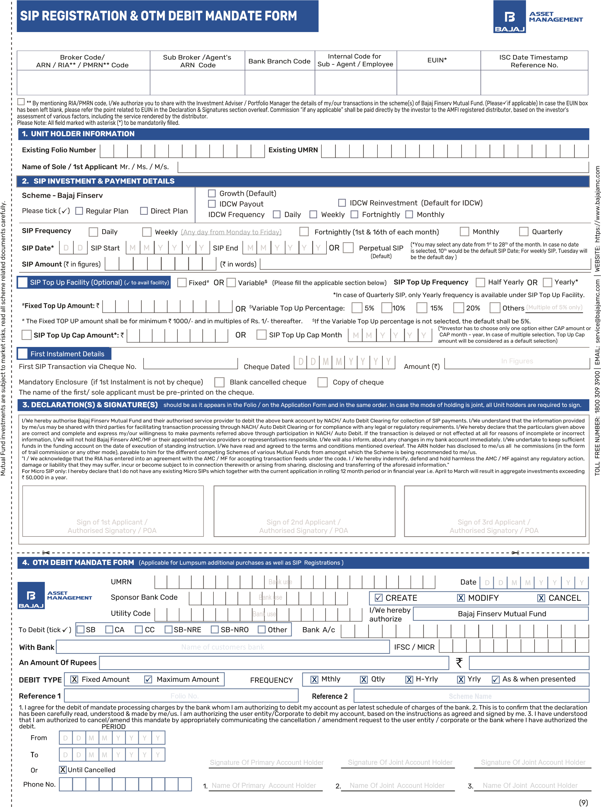

Instructions for Systematic Investment Plan(SIP)
Please read Scheme Information Document along with Statement of Additional Information and addendum issued from time to time before filling this form. The Unitholders of the Scheme can benefit by investing specific amounts periodically, for a continuous period. For debt schemes, at the time of registration, the SIP allows the investors to invest fixed equal amounts subject to minimum of `1000/- and multiples of ` 1/- every day/week/fortnight/month/quarter for purchasing additional Units of the Scheme at NAV based prices. Investors can enrol themselves for SIP in the Scheme by ticking appropriate box on the application form or by subsequently making a written request to that effect to the Registrar & Transfer Agent.
For debt schemes, minimum number of instalments for daily/weekly/fortnightly/monthly/quarterly frequency will be 6. Investors can choose any date of his/her preference to register -any frequency available under the SIP facility. In case the date chosen for SIP falls on a Non-Business Day or on a date which is not available in a particular month, the
SIP will be processed on the immediate next Business Day.
Investors can subscribe to SIP by using OTM. The cheques/Demand Draft should be in favour of the scheme and crossed “Account Payee Only”, and the cheques must be payable at the centre where the applications are submitted to the Investor Service Centre. In case of fresh/additional purchases, if the name of the Scheme on the application form/transaction slip differs from the name on the Cheque/Demand Draft, then the AMC will allot units under the Scheme mentioned on the application form/transaction slip. Further, Investors/ unitholders subscribing for SIP are required to submit SIP request by filling SIP application form at least 21 working days prior to the date of first debit date and SIP start date shall not be beyond 100 days from the date of submission of request for SIP’s.
A fresh Account Statement / Transaction Confirmation will be mailed to the Unitholder, indicating the new balance to his/her credit in the Account. An investor will have the right to discontinue the SIP, subject to giving 15 business days prior notice in writing or by filling SIP cancellation form to the subsequent SIP date.
New Investor: Please fill Common Application Form along with SIP Registration & OTM Debit Mandate Form. If the investor fails to mention the scheme name in the SIP Registration Form, then the Fund reserves the right to register the SIP as per the scheme name available in the Common Application Form. In case of any ambiguity in the form, Fund reserves the right to reject the SIP request.
Existing Investor: Please fill SIP Registration & OTM Debit Mandate Form and mention the existing folio number. If the investor fails to mention the scheme name in the SIP Registration Form, then the Fund reserves the right to register the SIP in the existing scheme (Eligible for SIP) available in the investor’s Folio. In case Multiple Schemes are available in the folio then Fund reserves the right to reject the SIP request.
- In case SIP date is not selected, then the SIP will be registered on 10th (default date) of each Month/Quarter, as applicable. Investors can choose any day of the week from Monday to Friday to register under weekly frequency. In case Day is not specified by the investor transaction will be processed on Tuesday. For Fortnightly frequency, the transaction will be processed on 1st and 16th day of each month, as applicable. Further if multiple SIP dates are opted for or if the selection is not clear, then the SIP will be registered for 10th of each Month/Quarter, as applicable.
- If the Investor has not mentioned the SIP start Month, SIP would commence from the next applicable month, subject to completion of 21 business days time from the receipt of SIP request.
- In case the SIP 'End period' is incorrect or not mentioned by the investor in the SIP form, then SIP Period will be considered perpetual till further instructions are received from the investor.
- After three consecutive SIP transaction failures for a Particular Scheme, the SIP for the scheme shall get auto-terminated.
Micro Systematic Investment Plan (Micro SIP)/PAN Exempt Investments:
In line with SEBI letter no. OW/16541/2012 dated July 24, 2012 addressed to AMFI, Investments in the mutual fund schemes including investments through Systematic Investment Plans (SIPs) up to ` 50,000/- per investor per year shall be exempted from the requirement of PAN.
The maximum installment amount in case of Micro SIP shall be as follows :
- ` 4,000 /-per month for Monthly frequency.
- ` 12,000/- per quarter for Quarterly frequency.
Accordingly, for considering the investments made by an investor up to ` 50,000/-, an aggregate of all investments including SIPs made by an investor in rolling 12 months period, shall be considered and such investors shall be exempted from the requirement of PAN. However, requirements of Know Your Customer (KYC) shall be mandatory and investors seeking the above exemption of PAN will need to submit the PAN Exempt KYC Reference No (PEKRN) / KYC Identification No. (KIN) acknowledgement issued by KRA / (Central KYC Registry) along with the application form.
This exemption is applicable only for individuals including NRIs, minors acting through guardian, Sole proprietorship firms and joint holders*. Other categories of investors e.g. PIOs, HUFs, QFIs, non - individuals, etc. are not eligible for such exemption.
* In case of joint holders, first holder must not possess a PAN.
Investors are requested to note that, in case where a lump sum investment is made during the financial year and subsequently a fresh SIP mandate request is given where the total investments for that financial year exceeds ` 50,000/-, such SIP application shall be rejected.
In case where a SIP mandate is submitted during the financial year and subsequently a fresh lumpsum investment is being made provided where the total investments for that financial year exceeds ` 50,000/-, such lump sum application will be rejected.
Redemptions if any, in the Micro Investment folio, shall not be considered for calculating the exemption limit for such financial year. Consolidation of folio shall be allowed only if the PEKRN in all folios is same along with other investor details.
The first SIP cheque/draft could be of any Business Day but subsequent Auto Debit mandate/ cheques should be for any date from 1st to 28th of a month and there should be a minimum gap of at least 21 business days between the 1st SIP transaction and the 2nd SIP. However, subsequent cheques/ Auto Debit transaction date should have a gap of 21business days or a quarter depending upon the frequency chosen. In case the criteria is not met, the SIP would start on the same date from the next month. Units shall be allotted as per the realisation date. Investors can also start a SIP directly without any initial investment, however he has to submit the application for enrolment of SIP on any working day but the subsequent installment date of SIP shall be any date from 1st to 28th of a month with a minimum gap criteria of 21 business days between the submission of application form and the 1st SIP.
In case an investor intends to continue his SIP forever; he can opt for perpetual SIP which will not have an end date. In the event if the investors want to discontinue the SIP, a written communication will be required from the investors to discontinue the same at least 15 business days before the next SIP due date. If the SIP end date is not filled, the SIP Auto Debit will be considered perpetual till further instructions are received from the investor. SIP Top Up Facility:
- Investors can opt for SIP Top Up facility with Fixed Top Up option or Variable Top Up option, wherein the amount of the SIP can be increased at fixed intervals. In case the investor opts for both options, the Variable Top Up option shall be triggered. And the default Variable Top Up percentage shall be 5%.
- For debt schemes, the Fixed TOP UP amount shall be for minimum ` 1000/‐ and in multiples of ` 1/‐ thereafter.
- Variable Top Up would be available at 5%, 10%, 15% and 20% and such other denominations (over and above 5%, 10%, 15% and 20%) as opted by the investor in multiples of 5%.
- The frequency is fixed i.e. either at Yearly and Half Yearly basis. In case the SIP Top Up facility is not opted by ticking the appropriate box and frequency is not selected, the SIP Top Up may not be registered.
- In case of Quarterly SIP, only the Yearly frequency is available under SIP Top Up.
- SIP Top Up facility shall also be available only for the existing investors who have already registered for SIP facility without Top Up option. Please view below illustration for Fixed Top Up:
- SIP Tenure: 07 Jan 2023 to 07 Dec 2027
- Monthly SIP Instalment: ` 2000/-
- TopUp Amount: ` 1000/• TopUp Frequency: Yearly
Instalment | From Date | To Date | Monthly SIP | Top Up | SIP Amount with
No(s) |  |  | Instalment | Amount (`) | Top Up (`)
1 to 12 | 7-Jan-23 | 7-Dec-23 | 2000 | N.A | 2000
13 to 24 | 7-Jan-24 | 7-Dec-24 | 2000 | 1000 | 3000
25 to 36 | 7-Jan-25 | 7-Dec-25 | 3000 | 1000 | 4000
37 to 48 | 7-Jan-26 | 7-Dec-26 | 4000 | 1000 | 5000
49 to 60 | 7-Jan-27 | 7-Dec-27 | 5000 | 1000 | 6000
Please view below illustration for Variable Top Up:
- SIP Tenure: 07 Jan 2023 to 07 Dec 2027
- Monthly SIP Instalment: ` 2000/-
- TopUp percentage: 10%
- TopUp Frequency: Yearly
Instalment No(s) | From Date | To Date | Monthly SIP Instalment  Amount (`) | Top Up  Amount  (10%) (`) | Top Up round off Amount (`) | SIP Amount with  Top Up (`)
1 to 12 | 7-Jan-23 | 7-Dec-23 | 2000 | N.A | N.A | 2000
13 to 24 | 7-Jan-24 | 7-Dec-24 | 2000 | 200 | 200 | 2200
25 to 36 | 7-Jan-25 | 7-Dec-25 | 2200 | 220 | 220 | 2420
37 to 48 | 7-Jan-26 | 7-Dec-26 | 2420 | 242 | 240 | 2660
49 to 60 | 7-Jan-27 | 7-Dec-27 | 2660 | 266 | 270 | 2930
Top Up Cap Amount and Top Up Month-year:
Top Up Cap Amount: Investor has an option to freeze the Top Up amount once it reaches a fixed predefined amount. The fixed pre-defined amount should be lower than or equal to the maximum amount mentioned by the investor in the bank mandate. In case of difference between the Cap amount and the maximum amount mentioned on Bank mandate, then amount which is lower of the two amounts shall be considered as the default amount of SIP Cap amount.
Top Up Cap Month - Year: It is the date from which Top Up amount will cease and last SIP instalment including Top Up amount will remain constant from Cap date till the end of SIP tenure.
Investor shall have flexibility to choose either Top Up Cap amount or Top Up Cap month - year. In case of multiple selection, Top Up Cap amount will be considered as a default selection. Top Up Cap is applicable for Fixed Top Up option as well as Variable Top Up option.

(10)

