PPFAS MUTUAL FUND
Common Application Form
Parag Parikh Flexi Cap Fund  An open ended dynamic Equity scheme investing across large cap, mid cap, small cap stocks.  This Product is suitable for investors who are seeking*  To generate long-term capital growth from an actively managed portfolio primarily of Equity and Equity related Securities.  Scheme shall invest in Indian equities, foreign equities and related instruments and debt securities. | RISKOMETER  o  t  w  o  L  k  s  i  R  e  t  a  r  e  d  o  M  i  s  k  R  t  e  a  r  e  d  o  M  H  i  g  h  R  i  s  k  M  o  d  e  r  a  t  e  l  y  H  i  g  h  R  i  s  k  V  e  r  y  H  i  g  h  R  i  s  k  The risk of the scheme is very high risk
Long term capital appreciation
Investment predominantly in equity and equity related securities.
The risk of the scheme is very high risk
RISKOMETER

o
t

w
o
L
k
s
i
R

e
t
a
r
e
d
o
M
i
s
k

R
t
e
a
r
e
d
o
M

H
i
g
h

R
i
s
k
M
o
d
e
r
a
t
e
l
y
H
i
g
h

R
i
s
k
V
e
r
y

H
i
g
h

R
i
s
k
Parag Parikh ELSS Tax Saver Fund
An open-ended equity linked saving scheme with a statutory lock in of 3 years and tax benefit.
This Product is suitable for investors who are seeking*
Parag Parikh Conservative Hybrid Fund
RISKOMETER

o
t

w
o
L
k
s
i
R

e
t
a
r
e
d
o
M
i
s
k

R
t
e
a
r
e
d
o
M

H
i
g
h

R
i
s
k
M
o
d
e
r
a
t
e
l
y
H
i
g
h

R
i
s
k
V
e
r
y

H
i
g
h

R
i
s
k
An open-ended hybrid scheme investing predominantly in debt instruments
This Product is suitable for investors who are seeking*
To generate regular income through investments predominantly in debt and money market instruments.
Long term capital appreciation from the portion of equity investments under the scheme. The risk of the scheme is moderately high risk
To generate income by investing in arbitrage opportunities
Predominantly investing in arbitrage opportunities in the cash and derivatives segment of the equity market.
Parag Parikh Arbitrage Fund
An open-ended scheme investing in arbitrage opportunities
The risk of the scheme is low risk
RISKOMETER

o
t

w
o
L
k
s
i
R

e
t
a
r
e
d
o
M
i
s
k

R
t
e
a
r
e
d
o
M

H
i
g
h

R
i
s
k
M
o
d
e
r
a
t
e
l
y
H
i
g
h

R
i
s
k
V
e
r
y

H
i
g
h

R
i
s
k
This Product is suitable for investors who are seeking*
Parag Parikh Dynamic Asset Allocation Fund An open-ended dynamic asset allocation fund.  This Product is suitable for investors who are seeking*  Capital Appreciation & Income generation over medium to long term.  Investment in equity and equity related instruments as well as debt and money market instruments while managing risk through active asset allocation | RISKOMETER  o  t  w  o  L  k  s  i  R  e  t  a  r  e  d  o  M  i  s  k  R  t  e  a  r  e  d  o  M  H  i  g  h  R  i  s  k  M  o  d  e  r  a  t  e  l  y  H  i  g  h  R  i  s  k  V  e  r  y  H  i  g  h  R  i  s  k  The risk of the scheme is moderate risk
Income over the short term
Investments in Debt/money market instruments
Parag Parikh Liquid Fund
An Open-ended Liquid scheme. A Relatively Low Interest Rate Risk and Relatively low Credit Risk
The risk of the scheme is low to moderate risk
RISKOMETER

o
t

w
o
L
k
s
i
R

e
t
a
r
e
d
o
M
i
s
k

R
t
e
a
r
e
d
o
M

H
i
g
h

R
i
s
k
M
o
d
e
r
a
t
e
l
y
H
i
g
h

R
i
s
k
V
e
r
y

H
i
g
h

R
i
s
k
This Product is suitable for investors who are seeking*

Potential Risk Class (PRC) of Parag Parikh Liquid Fund
 | Potential Risk Class
Parag Parikh Liquid Fund | Credit Risk | Relatively Low (Class A) | Moderate  (Class B) | Relatively High (Class C)
Parag Parikh Liquid Fund | Interest Rate Risk | Relatively Low (Class A) | Moderate  (Class B) | Relatively High (Class C)
Parag Parikh Liquid Fund | Relatively Low (Class I) | A-I
Parag Parikh Liquid Fund | Moderate (Class II)
Parag Parikh Liquid Fund | Relatively High (Class III)
 | A-I - A Scheme with Relatively Low Interest Rate Risk and Relatively Low Credit Risk
*Investors should consult their financial advisers if in doubt about whether the product is suitable for them.
Note: Please visit the website address for latest Riskometer updates: https://www.amc.ppfas.com----> Statutory Disclosures ---> Product Label of the Schemes.
ARN/RIA Code/Stock Broker/Portfolio Manager Registration Number (PMRN) |  | ARN / Distributor Name |  | Sub Agent’s ARN | Bank Branch Code |  | Internal Code for Sub-Agent/  Employee | Employee Unique  Identification Number (EUIN)
ARN-146262
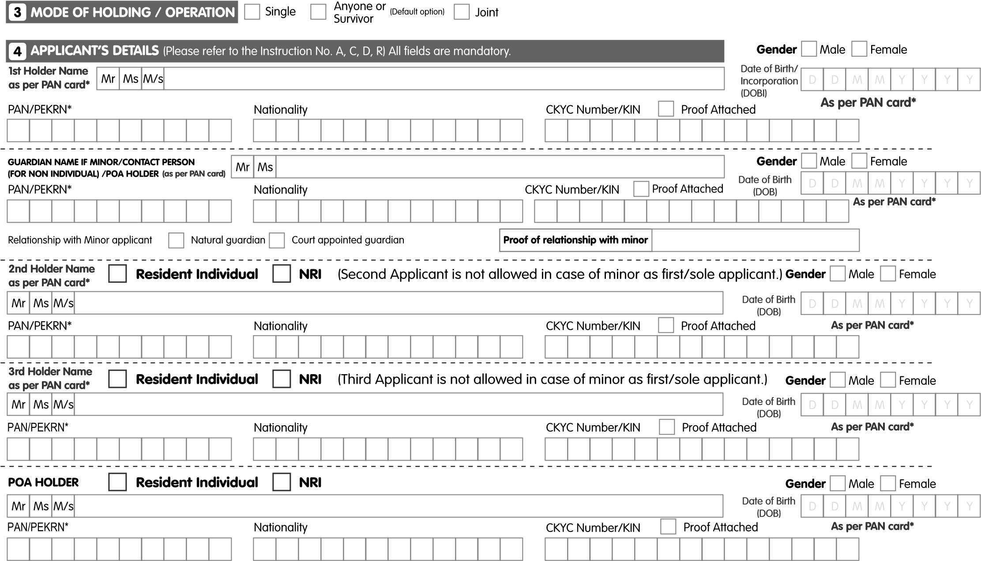
*Mandatory information - If left blank, the application is liable to be rejected. Individual client who has registered under KYC Records Registry (CKYCR) can fill the 14 digit KYC Identification Number (KIN)
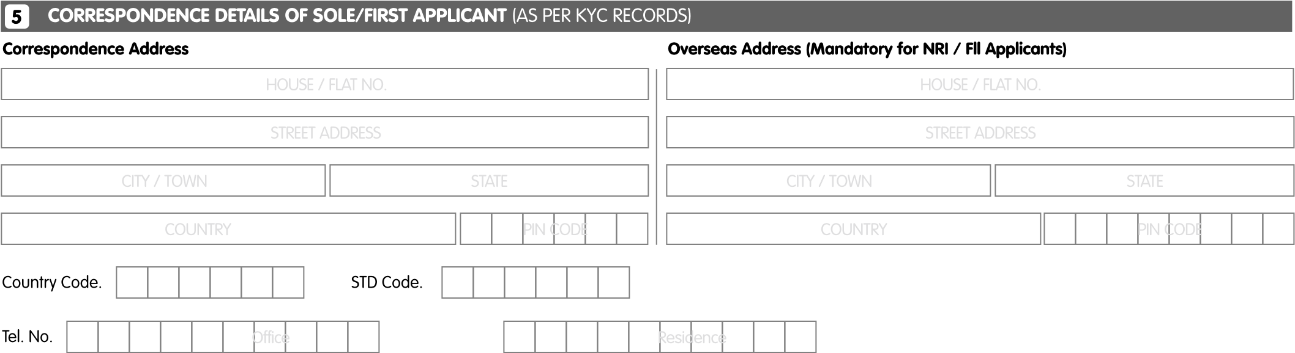
On providing email-id investors shall receive the scheme wise annual report or an abridged summary thereof/ account statements/ statutory and other documents by email.
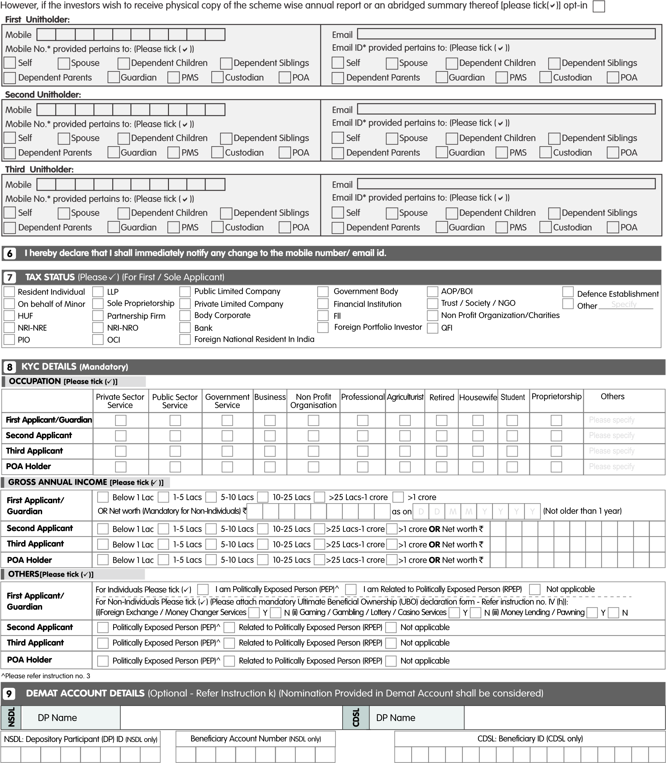
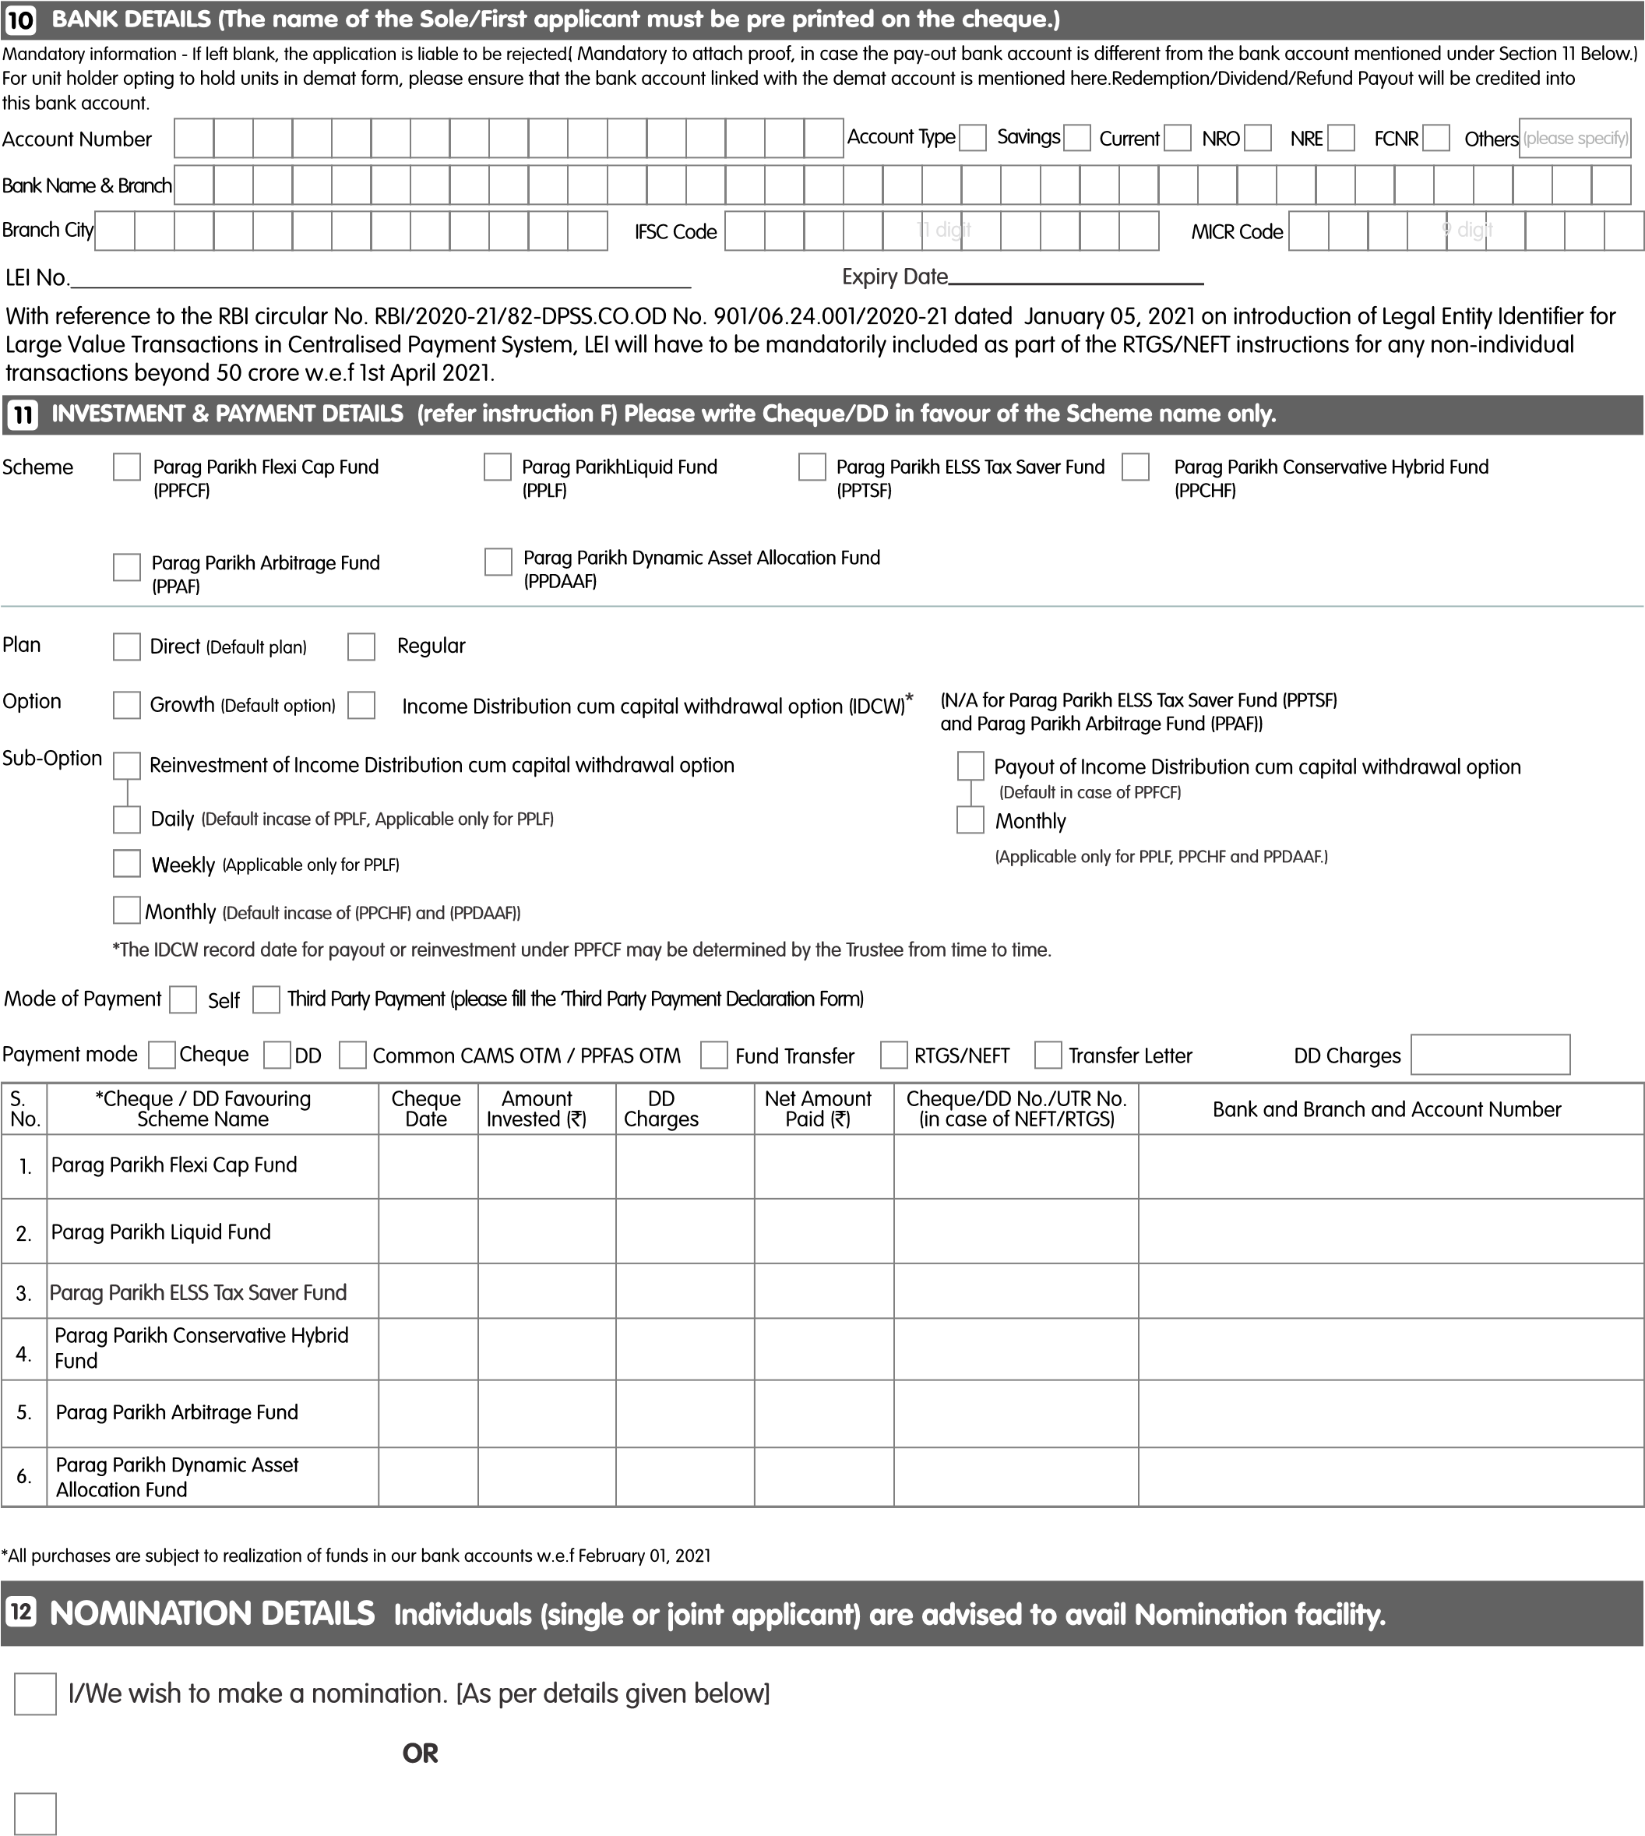I / We hereby confirm that I / We do not wish to appoint any nominee(s) for my mutual fund units held in my / our mutual fund folio and understand the implications / issues involved in non-appointment of any nominee(s) and am/ are further aware that in case of my demise / death of all the unit holders in the folio, my / our legal heir(s) would need to submit all the requisite documents issued by the Court or such other competent authority, as may be required by the Mutual Fund / AMC for settlement of death claim / transmission of units in favour of the legal heir(s), based on the value of the units held in the mutual fund folio/s.
I/We wish to make a nomination and do hereby nominate the following person(s) in the above specified folio(s) who shall receive all the assets held in my / our account/ folio in the event of my / our demise, as trustee and on behalf of my/ our legal heir(s)*. This nomination shall supersede any prior nomination made by us/me if any.

Nomination can be made upto three nominees in the account. |  | Details of 1st Nominee | Details of 2nd Nominee |  | Details of 3rd Nominee
Mandatory information
1 | Name of the  nominee(s) | Mr./Ms . |  | Mr./Ms . | Mr./Ms .
2 | Share of each Nominee# | % |  | % | %
3 | Date of Birth (for Minor) | dd-mmm-yyyy |  | dd-mmm- yyyy | dd-mmm -yyyy
4 | Relationship with the Applicant (select one ) | - Spouse o Father o Mother  - Daughter  - Son  - Others (please specify)  __________________ | o  o o o o o | Spouse  Father  Mother  Daughter  Son  Others (please specify)  __________________ | - Spouse o Father o Mother  - Daughter  - Son  - Others (please specify)  __________________
5 | Nominee/ Guardian  (in case of Minor)  Identification details [Please tick any one of the following and provide ID Number and no copies required]. | PAN  ________________  Aadhaar (masked last 4 digits )  **** **** _______  Passport (for NRIs/OCIs/PIOs)  ________________  Driving License  _________________ |  | PAN  ________________  Aadhaar (masked last 4 digits )  **** **** _______  Passport (for NRIs/OCIs/PIOs)  ________________  Driving License  _________________ | PAN  ________________  Aadhaar (masked last 4 digits )  **** **** _______  Passport (for NRIs/OCIs/PIOs)  ________________  Driving License  _________________
6 | Address of  Nominee(s)/  Guardian in case of Minor  City / Place:  State & Country | Pincode : | Pincode : |  | Pincode :
7 | Mobile of nominee(s)/  Guardian in case of  Minor
8 | Email ID of nominee(s)/ Guardian in case of Minor
Non-mandatory details
9 | Nominee Guardian  Name (in case  Nominee is Minor)
I / We want the details of my / our nominee to be printed in the statement of holding, provided to me/ us by the AMC / DP as follows; (please tick, as appropriate)

Name of nominee(s) with % Nomination: Yes / No (Default )

 | Signature(s) – As per mode of holding in demat accounts / MF Folio(s).
 | Name of the Holder | Signature / Thumb Impression
Sole / First Holder (Mr./Ms.)

Second Holder (Mr./Ms.)

Third Holder (Mr./Ms.)

* Signature of witness, along with name and address are required, if the accou nt holder affixes thumb impression, instead of signature.

# Any odd lot after division shall be assigned / transferred to the first nominee mentioned in the form.

 | *Name and Address of Witness | *Signature of Witness
Witness 1

Witness 2

Note:
The Intermediary shall provide acknowledgement of the nomination form to the account holder(s)
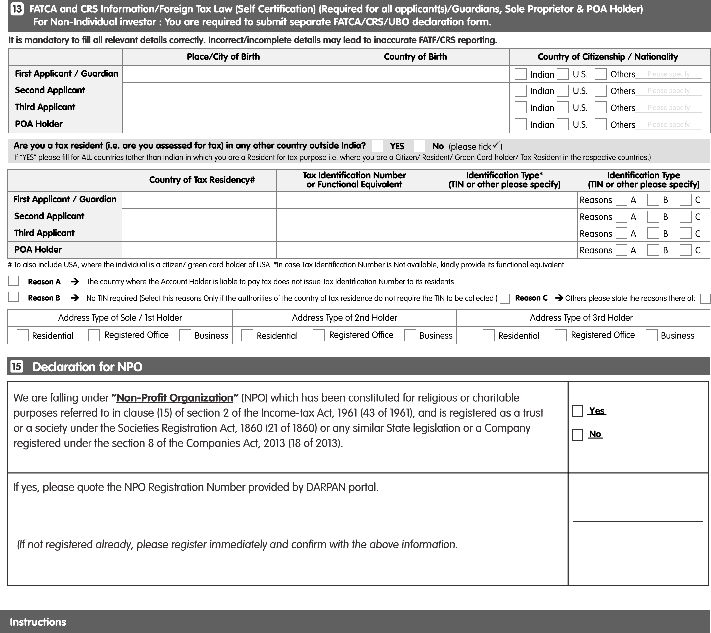
- 'If the Name given in the application does not match the name as appearing on the PAN Card/Aadhaar card, authentication, application may be liable to get rejected or further transactions may be liable to get rejected'
- I /We have understood the information requirement of this Form (read along with the FATCA & CRS Instructions) and hereby confirm that the information provided be me/us on this Form is true, correct, and complete. I/ We also confirm that I /We have read and understood the FATCA & CRS Terms and Conditions below and hereby accept the same.
- Politically Exposed Persons (PEP) are defined as individuals who are or have been entrusted with prominent public function in a foreign country,
e.g., Heads of States or of Governments, senior politicians, senior government/judicial/military officers, senior executive of state-owned corporations, important political party officials, etc.
- Country of Tax Residence and Tax ID number: Tax Regulations require us to collect information about each investor's tax residency. In certain circumstances (including if we do not receive a valid self-certification from you) we may be obliged to share information on your account with relevant tax authorities. If you have any questions about tax residency, please contact your tax advisor. Should any information provided change in the future, please ensure you advise us of the change. If you are a US citizen or resident, please include United States in this related field along with your US Tax Identification Number.
- As per AMFI Circular No. 135/BP/77 /2018-19, please provide email id and Mobile Number of the Primary Unit Holder of the Folio. In cases where the email address/mobile No. is not provided in the application form, the email address/mobile no. of the first applicant as per the KYC data will be taken as the email address/mobile No. The email address of one investor should not be allowed/up dated against folios of other/multiple investors, unless a specific written request is received in this regard, duly signed by the investors or the investors in such folios belong to the same family (applicable in respect of individual investors only).
"Family means self, spouse, dependent children, dependent siblings, dependent parents, and a guardian in case of a minor as per AMFI guidelines dated March 28, 2022"
- The AMC to strengthen control with respect to verification of key details of investors like Bank account details, email id, mobile number, and address, etc and to standardize the process for Validation of Email ID, Mobile Number, Bank Mandate & Two Factor Authentication for
Redemptions of Non-Demat folios. AMC shall take necessary steps to comply with the AMFI Best Practice guidelines dated March 28, 2022, and as amended from time to time. Investors are requested to provide correct Bank account details, email id, and mobile number at the time of submitting the application.
DECLARATION
I/We am/are not prohibited from accessing capital markets under any order/ruling/judgment etc. of any regulation, including SEBI. I/We confirm that my application is in compliance with applicable
Indian and foreign laws. I/We hereby confirm and declare as under:-
- For Non-Individual Investor: I/We hereby confirm that the object clause of the constitution document of the entity (viz. MOA / AOA /Trust Deed, etc. I, allows us to apply for investment in this scheme of PPFAS Mutual Fund and the application is being made within the limits for the same. I/We are complying with all requirements/ conditions of the entity while applying for the investments and I/We, including the entity, if the case may arise so, hereby agree to indemnify PPFAS AMC/ PPFAS Mutual Fund in case of any dispute regarding the eligibility, validity and authorization of the entity and/or the applicants who have applied on behalf of the entity.
- For NRIs only: I/We confirm that I am/we are Non Residents of Indian Nationality/Origin and that I/we have remitted funds from abroad through approved banking channels or from funds In my/our Non Resident External/Non-Resident Ordinary/FCNR account. (Refer Inst. No. F)
- Applicable to PEKRN Holders: I, the first/ sole holder, also hereby declare that I do not hold a permanent Account Number and hold only a sing le PAN Exempt KYC Reference No. (PEKRN) Issued by KYC Registration Authority and that my existing Investments together with the current application will not result in aggregate Investments exceeding Rs. 50,000/-in a rolling 12 months period or in a financial year.
- I have voluntarily subscribed to the online access for transacting the internet facility provided by PPFAS Asset Management Private Ltd. (lnvestment Manager of PPFAS Mutual Fund) and confirm of having read, understood and agree to abide the terms and conditions for availing of the internet facility more particularly mentioned on the website www.amc.ppfas.com and hereby undertake to be bound by the same. I further undertake to discharge the obligations cast on me and shall not at any time deny or repudiate the online transactions effected by me and I shall be solely liable for all the costs and consequences there of.
- I/We have read, understood and hereby agree to comply with the terms and conditions of the scheme related documents and apply for allotment of Units of the Scheme(sl of PPFAS Mutual Fund ('Fund') indicated above.
- I/We am/are eligible lnvestor(s) as per the scheme related documents and am/are authorised to make this investment as per the Constitutive documents/authorization(s). The amount invested in the Scheme(s) is through legitimate sources only and is not for the purpose of contravention and/or evasion of any act, rules, regulations, notifications or directions issued by any regulatory authority in India.
- The information given in/ with this application form is true and correct and further agree to furnish such other further/additional information as may be required by the PPFAS Asset Management Private Limited (AMC)/Fund and undertake to inform the AMC/Fund/Registrars and Transfer Agent (RTA) in writing about any change in the information furnished from time to time.
- That in the event, the above information and/or any part of it is/are found to be false/untrue/misleading, I/We will be liable for the consequences arising there from.
- I/We hereby authorize you to disclose, share, remit in any form/manner/mode the above information and/or any part of It including the changes/updates that may be provided by me/us to the Mutual Fund, Its Sponsor/s, Trustees, Asset Management Company, Its employees, agents and third party service providers, SEBI registered Intermediaries for single updation/ submission, any Indian or foreign statutory, regulatory, judicial, quasi- judicial authorities/agencies including but not limited to Financial Intelligence Unit-India (FIU-IND) etc without any intimation/advice to me/us.
- I/We will indemnify the Fund, AMC, Trustee, RTA and other intermediaries in case of any dispute regarding the eligibility, validity and authorization of my/our transactions.
- The ARN holder (AMFI registered Distributor) has disclosed to me/us all the commissions (In the form of trail commission or any other model, payable to him/them for the different competing Schemes of various Mutual Funds from amongst which the Scheme is being recommended to me/us.
- I/We hereby confirm that I/We have not been offered/ communicated any indicative portfolio and/ or any indicative yield by the fund/amdlts distributor for this investment.
- Preferred mode of payment Electronic Credit. RTGS IFSC/NEFT code will help us transfer the amount to your bank account quicker, electronically. In case the bank does not credit my /our bank account with / without assigning any reason thereof, or if the transaction is delayed or not effected at all or credited into the wrong account for reasons of incomplete or incorrect information, I / We would not hold PPFAS Mutual Fund responsible. Further the Mutual Fund reserves the right to Issue a demand draft/ payable at par cheque In case it is not possible to make payment by DC/NEFT /ECS.
- I/We acknowledge that in case any of the above specified information is found to be false or untrue or misleading or misrepresenting, I/We am/are aware that I/We may liable for it. I/We hereby authorize you [Fund/ AMC/RTA/other participating entities] to disclose, share, remit in any form, mode or manner, all / any of the information provided by me, including all changes, updates to such information as and when provided by me to Mutual Fund, its Sponsor, Asset Management Company, trustees, their employees/ RTAs (’the Authorized Parties') or any Indian or foreign governmental or statutory or judicial authorities/ agencies Including but not limited to the Financial Intelligence Unit-India (FIU-IND), the tax I revenue authorities in India or outside India wherever it is legally required and other investigation agencies without any obligation of advising me/us of the same. Further, I/We authorize to share the given information to other SEBI Registered Intermediaries /or any regulated Intermediaries registered with SEBI /RBI/ IRDA / PFRDA to facilitate single submission / update & for other relevant purposes. I/We also undertake to keep you informed in writing about any changes / modification to the above information in future and also undertake to provide any other additional information as may be required at your / Fund's end. As may be required by domestic or overseas regulators/ tax authorities, I/We authorize Fund/ AMC/RTA to withhold and pay out any sums from your account or close or suspend your account(s) without any obligation of advising me of the same
- Consent for Telemarketing: I/We hereby accord my/our consent to PPFAS AMC for receiving the promotional information/ material via email, SMS, telemarketing calls etc. on the mobile number and email provided by me/us in this Application Form.
- For Foreign National Resident in India only: I/We will redeem my/our entire investment/s before I/We change my/our Indian residency status. I/We shall be fully liable for all consequences (including taxation) arising out of the failure to redeem on account of change in residential status.
- For NRIs/PIO/OCIs only: I/We confirm that my application is in compliance with applicable Indian and foreign laws.
Please ( ) Yes No If Yes, ( ) Repatriation basis Non-repatriation basis
DECLARATION
I declare that the information is to the best of my knowledge and belief, accurate and complete.
I agree to notify PPFAS Mutual Fund/PPFAS Asset Management Private Limited immediately in the event the information in the self-certification changes.
? | ? | ?
FIRST OR SOLE APPLICANT/ GUARDIAN/POA SECOND APPLICANT |  |  | THIRD APPLICANT

ACKNOWLEDGMENT SLIP (To be filled by the Investor)
Application No. |  |  |  |  | ISC Stamp & Signature
PPFAS MUTUAL FUND  Registered Office: 81/82, 8th Floor, Sakhar Bhavan, Ramnath Goenka Marg, 230, Nariman Point, Mumbai - 400 021.  Received, subject to realisation, verification and conditions, an application for purchase of Units as mentioned in the application form. |  |  |  |  | ISC Stamp & Signature
From
 |  | Dated | Amount (RS) | Scheme

INSTRUCTIONS

A. General Instructions
- Please read the key Information Memorandum and the Scheme Information Documents) of the Scheme and Statement of Additional Information carefully before filling the application Form. Investors should apprise themselves of the prevailing Load structure on the date of submitting the Application Form.
- Investors are deemed to have accepted the terms subject to which these offers are being made and bind themselves to the terms upon signing the Application Form and tendering payment.
- New investors wishing to make SIP investment will need to complete and submit both the Application Form and the SIP Enrollment Form.
- The Application Form is for Resident lnvestors/NRls/ FIIs and should be completed in ENGLISH and in BOLD LETTERS only. Please tick in the appropriate box for relevant options wherever applicable.
- Please do not overwrite. For any correction I changes (if any) made, the sole I all applicants are requested to authenticate the same by canceling and re-writing the correct details and counter-signing the same.
- Applications complete in all respects, may be submitted at the designated Investor Service Centres (ISCs)/ Official points of Acceptance.
- The signature should be in English or in any of the Indian languages specified in the eighth schedule of the Constitution of India. Thumb Impressions must be attested by a magistrate or a notary public or a special executive magistrate under his/her official seal. Applications by minors should be signed by the guardians. In case of H.U.F., the Karta should sign on behalf of the H. U. F.
- The AMC /Trustee retains the sole and absolute discretion to reject any application. It may be noted that the Securities and Exchange Board of India (SEBI) vide its Notification dated May 31, 2010 read with Circular dated June 24, 2010 states that with effect from June 01, 2010, the distributors, agents or any persons employed or engaged or to be employed or engaged in the sale and/or distribution of mutual fund products shall be required to have a valid certification from the National Institute of Securities Markets (NISM) by passing the certification examination.

- Further, no agents / distributors would be entitled to sell units of mutual funds unless the intermediary is registered with AMFI.
- List of Official Points of Acceptance is available on the website of the Mutual Fund http://amc.ppfas.com
- In case the cheque is returned on account of whatever reasons the applicant would have to fill a new application form and submit the same along with a fresh cheque at the nearest Official Point of Acceptance of Transactions. Applicability of NAV shall be based on receipt of application and also the realization of funds in the Bank account of respective scheme (and NOT the time of deposit of Cash in the Bank) within the applicable cut-off timing. However, if the credit is received in the Bank account of the scheme but investor has not yet submitted the application form, units will be allotted as per receipt of application. (time stamping)
- Applications rejected by AMC/CAMS ISC post time stamping cannot be represented.

B. Existing Unitholder information
If you have an existing folio, please mention the Folio Number in the "EXISTING INVESTOR DETAILS" and proceed to point 11 in the application form. Please note that the all details and mode of holding will be as per the existing folio.

C. Unitholder Information
Applicant's name and address must be given in full (P. 0. Box Address may not be sufficient. Investors residing overseas, please provide your Indian address and overseas address).
All communication and payments shall be made to the first applicant or the Karta in case of HUF / Guardian in case of minor.
The subscription amounts can be tendered by cheque payable locally at any of the AMC offices or CAMS Investor Service Centres (ISC) which are designated Official Points of Acceptance of Transactions and crossed "A/c Payee only".
"On behalf of Minor" Accounts: Name of Guardian must be mentioned if investments are being made on behalf of a minor. Date of birth is mandatory in case of minor. The minor shall be the first and the sole holder in the account (folio). No joint holder will be allowed in an account (folio) where minor is the first or sole holder. Guardian in the account (folio) on behalf of the minor should either be a natural guardian (i.e. father or mother) or a court appointed legal guardian and the same must be mentioned in the space provided in application form. Copy of document evidencing the date of birth of the minor and relationship of the guardian with the minor (whether natural or legal guardian) should mandatorily be provided while opening of the account (folio). Also, nomination shall not be allowed in a folio/account held on behalf of a minor. When the minorattains majority then, please fill the Form for Minor attaining Majority
In case of an application under Power of Attorney or by a limited company, body corporate, registered society, trust or partnership, etc the relevant Power of attorney or the relevant resolution or authority to make the application as the case maybe, or duly notarised copy thereof, along with the Memorandum and Articles of Association/ Bye Laws must be lodged with the application form.
Documentation to be submitted by Corporate Investors/Societies I Trusts /Partnership
Firms/FILL
In accordance with SEBI Circular No. CIR/MIRSD/13/2013 dated December 26, 2013.the additional details viz. Occupation details Gross Annual lncome/networth and Politically Exposed Person (PEP)*status mentioned under section 4 & 5 which was forming part of uniform KYC form will now be captured in the application form of the Fund. Also, the detail of nature of services viz Foreign Exchange/Gambling/Money lending. etc. (applicable for the first/sole applicant) is required to be provided as part of client Due Diligence (CCD) Process of the Fund.
The said details are mandatory for both Individual and Non Individual Applications. *PEP are defined as individuals who are or have been entrusted with prominent public function in the foreign country, e.g. Heads of states or of Government, senior politicians, senior Government I judicial / military officers, senior executive of state owned corporation, important political party officials, etc.
Further if you are a Citizen or resident or green card holder or tax resident other than India. please include all such countries in the tax resident country information field along with your tax Identification Number or any other relevant ID / Number. If no TIN is yet available or has not yet been issued, please provide an explanation and attach this to the form.
Documents | Individuals | Companies  / LLP / FIIs* | Trusts | Societies | Partnership Firms | Minor | NRIs | POA
Resolution / Authorisation to invest |  | ✓ | ✓ | ✓ | ✓
List of Authorised Signatories with Specimen Signature(s) @ |  | ✓ | ✓ | ✓ | ✓ |  |  | ✓
Certificate of Incorporation |  | ✓
Memorandum and Articles of Association / Partnership Deed |  | ✓ |  |  | ✓
Trust Deed |  |  | ✓
Bye-laws |  |  |  | ✓
Account Debit Certificate in case payment is made by DD from NRE / FCNR A/c where applicable |  |  |  |  |  |  | ✓
PAN/PERN Proof (not required for existing investors) | ✓ | ✓ | ✓ | ✓ | ✓ | ✓ | ✓ | ✓
KYC acknowledgment letter | ✓ | ✓ | ✓ | ✓ | ✓ | ✓ | ✓ | ✓
Copy of cancelled Cheque/debit proof | ✓ | ✓ | ✓ | ✓ | ✓ | ✓ | ✓ | ✓
PIO/OCI Card (As applicable) |  |  |  |  |  |  | ✓
Notarised POA |  |  |  |  |  |  |  | ✓
UBO | ✓ | ✓ | ✓ | ✓ | ✓ |  |  | ✓
FACTA and CRS | ✓ | ✓ | ✓ | ✓ | ✓ | ✓ | ✓ | ✓
Proof of Date of Birth |  |  |  |  |  | ✓
Proof of Relationship with  Guardian |  |  |  |  |  | ✓
Names of the relevant persons holding senior management position# |  | ✓
Registered office and the principal  place of its business if it is  different.# |  | ✓ |  |  | ✓
Names of all the partners# |  |  |  |  | ✓
Names of the beneficiaries, trustees, settlor and authors of the trust and the address of the registered office of the trust.# |  |  | ✓
List of trustees and documents as are required for individuals as per  Prevention of Money-laundering  (Maintenance of Records)  Amendment Rules, 2023 under sub-rule (4). for those discharging role as trustee and authorised to transact on behalf of the trust.# |  |  | ✓
#These are additional documents to be submitted voluntarily
@ Should be original or true copy certified by the Director / Trustee / Company Secretary / Authorised Signatory / Notary Public, as applicable.
* For FIIs, copy of SEBI registration certificate should be provided.
The Power of Attorney should necessarily be signed by both the investor and the constituent
Power of Attorney. Where only uncertified photocopies of the documents
are submitted/attached to the application form, the onus for authentication of the documents so submitted shall be on investors and the PPFAS Mutual Fund will accept and act in good faith on uncertified/not properly authenticated documents submitted/attached with the application form. Submission of such documents by investors shall be full and final investor's authority to invest and the PPFAS Mutual Fund shall not be liable under any circumstances for any defects in the documents so submitted.
Non-Individual investors are required to ensure that the object clause of the constitution document (viz. MOA / AOA / Trust Deed, etc.) permits investment in the scheme of PPFAS Mutual Fund. PPFAS Mutual Fund shall accept and process the applications made by these entities in good faith by relying on the undertaking given with respect to the authority, validity and compliance with all relevant formalities/conditions etc. in the application for making such investments with PPFAS Mutual Fund. Further, PPFAS Mutual Fund/Trustees or any of its affiliates shall not be liable in case of any dispute arising with respect to eligibility, validity and authorization of the entity and/or the applicants who have applied on behalf of the entity, as applicable
- Applicants can specify the mode of holding in the application form as "Single" or "Joint" or "Anyone or Survivor". In the case of holding specified as "Joint", redemption and all other request / transactions would have to be signed by all unit holders. However, in cases of holding specified as· Anyone or Survivor", any one of the unit holders will have the power to make all necessary requests, without it being necessary for all the unit holders to sign. In the event the account has more than one registered unit holders and the mode of holding is not specified in the application form, the default option for holding would be considered to be “anyone or survivor". However, in all cases, the proceeds of all IDCW/redemption will be paid to the first named holder. All communications will also be sent to the first named holder.
- Investors should clearly indicate their preference of Plan/option on the application form. If no plan is selected in the application form, the investment will be deemed to be for the default option i.e. Direct Plan.

D. Bank Details
a).Pay- Out Bank Account Details:
An investor at the time of purchase of units must provide the details of his / her pay-out bank account (i.e. account into which redemption proceeds are to be paid) in Section 9 in the Application Form.
b).Multiple Bank Account Registration:
The AMC/ Mutual Fund provides a facility to the investors to register multiple bank accounts (currently upto 5 for Individuals and 10 for Non-Individuals) for receiving redemption proceeds etc. by providing necessary documents. Investors must specify any one account as the "Default Bank Account". The investor, may however, specify any other registered bank account for credit of redemption proceeds at the time of requesting for the redemption.
Investors holding units in non-dematform are requested to avail the facility of registering multiple bank accounts by filling in the 'Multiple Bank Accounts Registration Form' available at our Investor Service Centres (ISCs) or on our website http://amc.ppfas.com.

c).lndlan Financial System Code (IFSC)
IFSC is a 11 digit number given by the banks on the cheques. IFSC will help to secure transfer of redemption payouts via the various electronic mode of transfers that are available with the banks.

E. Applications through Rupee Drafts / NRE / FCNR accounts
In case of FII / NRIs / Persons of Indian Origin applying on repatriation basis, payment may be made by Cheques drawn out of NRE / FCNR Accounts. In case of Indian Rupee Drafts purchased abroad or payments from FCNR / NRE accounts, a certificate from the
Bank issuing the draft confirming the debit and / or foreign inward remittance certificate (FIRC) issued by investor's banker should also be enclosed. The Mutual Fund reserves the right to hold redemption proceeds in case the requisite details are not submitted.

Bank details
Investors are requested to mention the bank account details where the redemption cheques should be drawn, since the same is mandatory as per the directives issued by SEBI. Applications without this information will be deemed to be incomplete and are liable for rejection. The Mutual Fund reserves the right to hold redemption proceeds in case the requisite details are not submitted. Please attach a copy of the canceled cheque.

F. Third Party Payments
1. PPFAS Asset Management Private Limited ("PPFAS AMC") / PPFAS Mutual Fund ("Mutual Fund"), shall not accept applications for subscriptions of units accompanied with Third Party Payments except in cases as enumerated in para G.2a below.
"Third Party Payment" means payment made through an instrument issued from a bank account other than that of the first named applicant/ investor mentioned in the application form. In case of payment instruments issued from a joint bank account, the first named applicant/ investor must be one of the joint holders of the bank account from which the payment instrument is issued.

Illustrations
Illustration 1: An Application submitted in joint names of A, B & C along with cheque issued from a bank account in names of C, A & B. This is a valid application and will not be considered as Third Party Payment.
Illustration 2: An Application submitted in joint names of A, B & C along with cheque issued from a bank account in name of A. This is a valid application and will not be considered as Third Party Payment.
Illustration 3: An Application submitted in joint names of A, B & C along with cheque issued from a bank account in names of B, C & Y. This will be considered as Third Party Payment.
2a. As referred to in para G.1 above, following are the exceptional cases where third party payments will be accepted subject to submission of requisite documentation/declarations.
- Payment by Parents/Grand-Parents/Related Persons* on behalf of a minor in consideration of natural love and affection or as gift for a value not exceeding Rs. 50,000 for each regular purchase or per SIP installment. However this restriction of Rs 50,000 will not be applicable for payment made by a Guardian whose name is registered in the records of Mutual Fund in that folio (i.e. Father/Mother/ Court Appointed Legal Guardian).
- Payment by Employer on behalf of employee under Systematic Investment Plans or as lump sum / one-time subscription, through Payroll deductions.
- Custodian on behalf of an FII or a Client.
*'Related Person' means any person investing on behalf of a minor in consideration of natural love and affection or as a gift.
2b. For investments through third party payments, Investors must accompany the 'Third Party Payment Declaration Form' (available at any of our ISCs or on our website http://amc.ppfas.com along with the Application Form for subscription of units.
3. The Mutual Fund shall adopt the following procedures to ascertain whether payments are Third Party Payments and investors are therefore required to comply with the requirements specified here in below.

G) Source of funds-if paid by cheque
Identification of third party cheques by the AMC/Mutual Fund/ Registrar & Transfer Agent (R&TA) will be on the basis of matching the name / signature on the investment cheque with the name/ signature of the first named applicant available on the application or in our records for the said folio. If the name of the bank account holder is not pre-printed on the investment cheque or the signature on the said cheque does not match with that of the first named applicant mentioned on the application / available in our records for the said folio, then the investor should submit any one of the following documents at the time of investment:
- a copy# of the bank passbook or a statement of bank account having the name and address of the account holder and account number;
- a letter* (in original) from the bank on its letterhead certifying that the investor maintains an account with the bank, along with information like bank account number, bank branch, account type, the MICR code of the branch & IFSC Code (where available).
# Investors should also bring the original documents along with the documents mentioned in (a) above to the ISCs/Official Points of Acceptance of PPFAS Mutual Fund.
The copy of such documents will be verified with the original documents to the satisfaction of the AMC/ Mutual Fund/R&TA. The original documents will be returned across the counter to the investor after due verification.
*In respect of (b) above, it should be certified by the bank manager with his / her full signature, name, employee code, bank seal and contact number.
Investors should note that where the bank account numbers have changed on account of the implementation of core banking system at their banks, any related communication from the bank towards a change in bank account number should accompany the application form for subscription of units. However, for updation of the changed bank details in the folio, the investor should follow the change of bank details process.
The Mutual Fund has also provided a facility to the investors to register multiple bank accounts, as detailed in Instruction No. E b. Investors are requested to avail the facility of registering multiple bank accounts by filling in the 'Multiple Bank Accounts Registration Form' available at our Investor Service Centres (ISCs) or on our website http://amc.ppfas.com.
- Source of funds-if funded by pre-funded Instruments such as Pay Order, Demand Draft, Banker's cheque etc.
Investors should attach anyone of the following supporting documents with the purchase application where subscription for units is vide a pre-funded instrument issued by way of debit to his / her bank account: (i) a Certificate (in original) from the issuing banker duly certified by the bank manager with his / her full signature, name, employee code, bank seal and contact number, stating the Account holder's name, the Bank Account Number which has been debited for issue of the instrument and PAN as per bank records, if available (ii) a copy of the acknowledgment from the bank, wherein the instructions to debit carry the bank account details and name of the investor as an account holder are available (iii) a copy of the passbook/bank statement evidencing the debit for issuance of the instrument.
The account number mentioned in the above supporting documents should be the same as / one of the registered bank account or the bank details mentioned in the application form.
- Source of funds - if paid by RTGS, Bank Account-to-Account Transfer, NEFT, ECS, etc. Investors should attach to the purchase application form, an acknowledged copy of the instruction to the bank also stating the account number debited. The account number mentioned on the transfer instruction copy should be a registered bank account or the first named applicant/ investor should be one of the account holders to the bank account debited for such electronic transfer of funds.

IV) Source of funds - if paid by a pre-funded instrument issued by the Bank against Cash
The AMC/Mutual Fund /R&TA will not accept any purchase applications from investors if accompanied by a pre-funded instrument issued by a bank (such as Pay Order, Demand Draft, Banker's cheque) against cash for investments of Rs. 50,000 or more. The investor should submit a Certificate (in original) obtained from the bank giving name, bank account number and PAN as per the bank records (if available) of the person who has requested for the payment instrument. The said Certificate should be duly certified by the bank manager with his / her full signature, name, employee code, bank seal and contact number. The AMC / Mutual Fund / R&TA will check that the name mentioned in the Certificate matches with the first named investor.
The account number mentioned in the Certificate should be the same as / one of the registered bank account or the bank details mentioned in the application form. PPFAS Mutual Fund / PPFAS AMC reserves the right to seek information and / or obtain such other additional documents/information from the investors for identifying whether it is a third party payment.

H) E-mail communication
If the investor has provided an email address, the same will be registered in our records. Thus, Allotment confirmations, Consolidated Account Statement/ Account Statement, annual report/ abridged summary and any statutory / other information as permitted would be sent by email. These documents shall be sent physically in case the Unit holder opts/ request for the same.
Should the Unit holder experience any difficulty in accessing the electronically delivered documents, the Unit holder shall promptly advise the Mutual Fund to enable the Mutual Fund to make the delivery through alternate means. It is deemed that the Unit holder is aware of all security risks including possible third party interception of the documents and contents of the documents becoming known to third parties.
The AMC / Fund reserve the right to send any communication in physical mode.
I) Mode of Payment of Redemption / IDCW proceeds via Direct Credit/ NEFT / ECS

• Direct Credit
The AMC has entered into arrangements with banks to facilitate direct credit of redemption / IDCW proceeds (if any) into the bank account of the respective Unit holders maintained with any of these banks. The list of banks is subject to change from time to time.

• National Electronic Funds Transfer (NEFT)
The AMC provides the facility of 'National Electronic Funds Transfer (NEFT)' offered by Reserve Bank of India (RBI), which aims to provide credit of redemption / IDCW payouts directly into the bank account of the Unit holder maintained with the banks (participating in the NEFT System). Unit holders can check the list of banks participating in the NEFT System from the RBI website i.e. www.rbi.org.in or contact any of our Investor Service Centres.
However, in the event of the name of Unit holder's bank not appearing in the 'List of Banks participating in NEFT' updated on RBI website www.rbi.org.in, from time to time, the instructions of the Unit holder for remittance of redemption /IDCW proceeds via NEFT System will be discontinued by PPFAS Mutual Fund/ PPFAS Asset Management Private Limited without prior notice to the Unit holder and the payouts of redemption / IDCW proceeds shall be effected by sending the Unit holder(s) a cheque/demand draft.

• Electronic Clearing Service (ECS)
The Investors will receive their redemption / IDCW proceeds directly into their bank accounts in the following order:
- In case the bank account of an investor is covered under Direct Credit facility then the payment of redemption / IDCW proceeds will happen via direct credit payout mode only.
- In case the bank account of an investor is not covered under Direct Credit facility but covered under NEFT system offered by the RBI then the payment of redemption / IDCW proceeds shall be effected via NEFT mechanism only.
Each of the above facilities aims to provide direct credit of the redemption / IDCW proceeds into the bank account (as furnished in point 10 of the Application Form) of the Unit holder and eliminates the time lag between dispatch of the cheque, its receipt by the Unit holders and the need to personally bank the instrument and await subsequent credit to the Unit holders account.
Further, the potential risk of loss of instruments in transit through courier/ post is also eliminated. Each of the said facility as a mode of payment, is faster, safer and reliable.
In case the bank account as communicated by the Unit holder is with any of the said banks with whom the AMC has entered into arrangements to facilitate such direct credits or with any of the banks participating in the NEFT System offered by RBI, the AMC shall automatically extend this facility to the Unit holders.
PPFAS Asset Management Private Limited/PPFAS Mutual Fund shall not be held liable for any losses/ claims, etc. arising on account of processing the direct credit or credit via NEFT/ ECS of redemption proceeds on the basis of Bank Account details as provided by the unit holder in the Application Form.
In case of unforeseen circumstances, the AMC reserves the right to issue a cheque / demand draft.

• Mode of Payment for Unit holders holding Units in Demat form
Investors will receive their maturity proceeds directly into their bank accounts linked to the demat accounts. Please ensure to furnish the Bank Account details under Section 8.
J. TRANSACT
The Service facility includes PPFAS Self Invest.

PPFASMF Online
This facility enables investors to transact online http://amc.ppfas.com using PPFASMF Online On PPFASMF Online Unitholders can execute transactions online for purchase, redemption and also register for Systematic Investment Plan (SIP) / of units of scheme of PPFAS Mutual Fund and other services as may be introduced by PPFAS Mutual Fund from time to time. Unitholders can also view account details and portfolio valuation online, download account statements and request for documents via email, besides other options.
Unitholders must possess a Folio Number (KRA validated), valid PAN, Bank Account Number registered in the folio and Net banking facility with any of the select banks to avail the PPFASMF Online facility.

eAlerts
This facility enables the Unit holder to receive SMS confirmation for purchase, redemption or switch and other alerts.
Apart from above mentioned facilities, the facility of ePayouts comprising of mode of payment of Redemption Proceeds, via Direct Credit/ NEFT / ECS is covered under e-Services facility.

K. Dematerialization
- Investors can hold units in Dematerialized (Demat) / Non-Demat mode. In case the investor has not provided his / her Demat account details or the details of DP ID /BO ID provided by the investor is incorrect, or Demat account is not activated or not in an active status, the units would be allotted in Non-Demat mode.
- Statement of Accounts would be sent to investors who are allotted units in non-Demat mode only.
- Investors are requested to note that Units held in dematerialized form are freely transferable
- The units will be allotted based on the applicable NAV as per the SID and will be credited to investor's Demat account on weekly basis upon realization of funds. For e.g. Units will be credited to investors Demat account every Monday for realization status received in last week from Monday to Friday.

Option to hold Units in dematerialized (demat) form
Investors have the option to hold the units in demat form . Please tick the relevant option of Yes/No for opting/not opting units in demat form. If no option is exercised, 'No' will be the default option. Applicants must ensure that the sequence of names as mentioned in the application form matches with that of the account held with the Depository Participant. If the details mentioned in the application are incomplete/incorrect or not matched with the Depository data, the application shall be treated as invalid and shall be liable to be rejected. The application form should mandatorily accompany the latest Client investor master/ Demat account statement.
The investors shall note that for holding the units in demat form, the provisions laid in the Scheme Information Document (SID) of the Scheme and guidelines/procedural requirements as laid by the Depositories (NSDL CDSL) shall be applicable. In case the unit holder wishes to convert the units held in non-demat mode to demat mode or vice versa at a later date, such request along with the necessary form should be submitted to their Depository Participant(s).
Units held in demat form will be freely transferable, subject to the applicable regulations and the guidelines as may be amended from time to time.

L. Nomination
- If you are opening a new demat account / MF folio, you have to provide nomination.
Otherwise, you have to follow the specified procedure for Opt-out
- The nomination can be made only by individuals applying for/holding units on their own behalf singly or jointly.
- You can make nomination or change nominee any number of times without any restriction. 4. You are entitled to receive acknowledgement from the AMC / DP for each instance of providing or changing nomination.

- Non-individuals including a Society, Trust, Body Corporate, Partnership Firm, Karta of Hindu undivided family, a Power of Attorney holder and/or Guardian of Minor unitholder cannot nominate.
- Nomination is not allowed in a folio where Minor is the unitholder.
- The signatories for this nomination form in joint folios / account, shall be the same as that of your joint MF folio / demat account. i.e.
- Either or Survivor' Folios / Accounts - any one of the holders can sign.
- First holder Folios / Accounts – only First Holder can sign.
- Jointly' Folios / Accounts - both holders have to sign
- A minor may be nominated. In that event, the name and address of the Guardian of the minor nominee is to be provided optionally.
- Nomination can also be in favour of the Central Government, State Government, a local authority, any person designated by virtue of his office or a religious or charitable trust.
- The Nominee shall not be a trust (other than a religious or charitable trust), society, body corporate, partnership firm, Karta of Hindu Undivided Family, or a Power of Attorney holder. 11. A Non-Resident Indian may be nominated subject to the applicable exchange control regulations.
- Multiple Nominees: Nomination can be made in favour of multiple nominees, subject to a maximum of three nominees. In case of multiple nominees, the percentage of the allocation/ share should be in whole numbers without any decimals, adding upto a total of 100%. If the percentage of allocation/share for each of the nominee is not mentioned, the allocation / claim settlement shall be made equally amongst all the nominees. Any odd lot after division shall be assigned / transferred to the first nominee mentioned in the form.
- In case of demise of the investor and any one of the nominees, the regulated entities shall distribute the assets pro-rata to the remaining nominees
- Every new nomination for a folio/account shall overwrite the existing nomination, if any.
- Nomination made by a unit holder shall be applicable for units held in all the schemes under the respective folio / account.
- Nomination shall stand rescinded upon the transfer of units.
- Transmission of units in favour of a Nominee shall be valid discharge by the asset management company/ Mutual Fund / Trustees against the legal heir(s).
- The nomination will be registered only when this form is completed in all respects to the satisfaction of the AMC.
- In respect of folios/accounts where the Nomination has been registered, the AMC will not entertain any request for transmission / claim settlement from any person other than the registered nominee(s), unless so directed by any competent court.

Transmission aspects
· Upon demise of the investor, the nominees shall have the option to either continue as joint holders with other nominees or for each nominee(s) to open separate single account / folio.
· In case all your nominees do not claim the assets from the AMC / DP, then the residual unclaimed asset shall continue to be with the AMC in case of MF units and with the concerned Depository in case of Demat account.
· Nominee(s) shall extend all possible co-operation to transfer the assets to the legal heir(s) of the deceased investor. In this regard, no dispute shall lie against the AMC / DP.
· Death of Nominee/s: In the event of the nominee(s) pre-deceasing the unitholder(s), the unitholder/s is/are advised to make a fresh nomination soon after the demise of the nominee. The nomination will automatically stand cancelled in the event of the nominee(s) pre-deceasing the unitholder(s). In case of multiple nominations, if any of the nominee is deceased at the time of death claim settlement, the said nominee's share will be distributed on pro-rata basis (as illustrated below) amongst the surviving nominees. Nominee's legal heir cannot claim the assets on behalf of deceased Nominee(s).

% share as specified by investor at the time of nomination |  |  | % assets to be apportioned to surviving nominees upon demise of investor and nominee ‘A’
Nominee | % share |  | Nominee | % initial share | % of A’s share to be  apportioned | Total % share
A |  | 60% | A | 0 | 0 | 0
B |  | 30% | B | 30% | 45% | 75%
C |  | 10% | C | 10% | 15% | 25%
Total |  | 100% | - | 40% | 60% | 100%

M. Permanent Account Number
(I) As per SEBI Circular No. MRD/DoP/Cir- 05/2007 dated April 27, 2007, it is now mandatory that Permanent Account Number (PAN) issued by the Income Tax Department would be the sole identification number for all participants transacting in the securities market, irrespective of the amount of transaction. Accordingly investors will be required to furnish a copy of PAN together with request for fresh purchases, additional purchases and Systematic Investment Plan (SIP). Application Forms without these information and documents will be considered incomplete and are liable to be rejected without any reference to the investors. The procedure implemented by the AMC and the decisions taken by the AMC in this regard shall be deemed final. ii) PAN card copy is to be provided and should be clear and visible. iii) If a minor PAN number is given, a minor PAN card also required.
- Guardian PAN card and date of birth as per PAN is mandatory in case investment is in the name of a minor.
- If either Name validation or date of birth validation as per PAN fails or Aadhaar seeding status is Inoperative, then the application / transaction will be treated as NIGO.

N. Prevention of Money Laundering
Prevention of Money Laundering Act, the SEBI Circulars on Anti Money Laundering and the Client Identification implementation procedures prescribed by AMFI interalia require the AMC to verify the records of identity and address(es) of investors. To ensure adherence to these requirements, investors are required to approach Points of Service (POS) (list of POS available on www.amfiindia.com) appointed by any of the KYC Registration Agency and submit documents for completion of appropriate KYC checks. The details for KYC compliance can also be downloaded from AMFI website, www.amfiindia.com or website of the mutual fund, www.amc.ppfas.com. The Mutual Fund website also prescribes the list of documents that can be submitted by investors to the POS to get their KYC checks completed.
It is mandatory for all investors (including joint holders, NRIs, POA holders and guardians in the case of minors) to furnish such documents and information as may be required to comply with the Know Your Customers (KYC) policies under the AML Laws. Applications without such documents and information may be rejected. In terms of SEBI circulars dated April 27, 2007 and June 30, 2008 read with SEBI letter dated June 25, 2007, Permanent Account Number (PAN) would be the sole identification number for all participants transacting in the securities market, irrespective of the amount of transaction, except (a) investors residing in the state of Sikkim; (b) Central Government, State Government, and the officials appointed by the courts e.g. Official liquidator, Court receiver etc. (under the category of Government) and (c) investors participating only in micro-pension. SEBI, in its subsequent letters dated June 19, 2009 and July 24, 2012 has conveyed that systematic investment plans (SIP) and lumpsum investments (both put together) per mutual fund up to Rs.50,000/- per year per investor shall be exempted from the requirement of PAN.
Accordingly, investments in PPFAS Mutual Fund (including SIP investment where the aggregate of SIP installments in a rolling 12 months period or in a financial year i.e April to March) of upto Rs 50,000/- per investor per year shall be exempt from the requirement of PAN. However, eligible Investors (including joint holders) should comply with the KYC requirement through registered KRA by submitting Photo Identification documents as proof of identification and the Proof of Address [self-attested by the investor / attested by the ARN Holder/ AMFI distributor]. These exempted investors will have to quote the "PERN (PAN exempt KYC Ref No) in the application form. This exemption of PAN will be applicable only to investments by individuals [including NRIs but not PIOs), joint holders, Minors and Sole proprietary firms. PIOs, HUFs and other categories of investors will not be eligible for this exemption.
Thus, submission of PAN is mandatory for all other investors existing as well as prospective investors (except the ones mentioned above) (including all joint applicants/holders, guardians in case of minors, POA holders and NRIs but except for the categories mentioned above) for investing with mutual funds from this date.
Investors are required to register their PAN with the Mutual Fund by providing the PAN card copy (along with the original for verification which will be returned across the counter). All investments without PAN (for all holders, including Guardians and POA holders) are liable to be rejected. Application Forms without quoting of PERN shall be considered incomplete and are liable to be rejected without any reference to the investors. The procedure implemented by the AMC and the decisions taken by the AMC in this regard shall be deemed final.
After completion of KYC compliance, investors need to approach KRA for Change of Address and not Registrar (CAMS). In respect of KYC compliant Folio, prospective
Change of Address received along with transaction slip will not be processed by Registrar (CAMS). The AMC reserves the right to reject subscription requests in the absence of appropriate compliance with the AML Laws. In line SEBI circular No. MIRSD/Cir-5/2012 dated April 13, 2012 and various other guidelines issued by SEBI on the procedural matters for KYC Compliances, the following additional provisions are applicable effective December 1, 2012:
- In case of an existing investor who is already KYC Compliant under the erstwhile centralized
KYC with CAMSKRA or CVL (CVLMF) then there will be no effect on subsequent Purchase/
Additional Purchase (or ongoing SIPs/STPs, etc) in the existing folios/accounts which are KYC compliant. Existing Folio holder cannot open a new folio with PPFAS Mutual Fund with the erstwhile centralized KYC.
- In case of an existing investor who is not KYC Compliant as per our records, the investor will have to submit the standard KYC Application forms available in the website www.cvlkra.com along with supporting documents at any of the SEBI registered intermediaries at the time of purchase / additional purchase/ new registration of SIP/STP etc. In Person Verification (IPV) will be mandatory at the time of KYC Submission. This uniform KYC submission would a onetime submission of documentation.
- Investors who have complied with KYC process before December 31, 2011 (KYC status with CVL-KRA as "MF - VERIFIED BY CVLMF") and not invested in the schemes of PPFAS Mutual Fund i.e. not opened a folio earlier, and wishes to invest on or after December 01, 2012, such investors will be required to submit 'missing/not available' KYC information and complete the IPV requirements.
- In case of Non Individual investors, complied with KYC process before December 31, 2011, KYC needs to be done afresh due to significant and major changes in KYC requirements.
- Further, investors investing under a SIP up to Rs. 50,000 per year i.e. the aggregate of installments in a rolling 12 month period ("Micro SIP"), are also required to comply with the above mentioned KYC procedure. However, they are exempt from the requirement of providing PAN as a proof of identification.
O. EMPLOYEE UNIQUE IDENTIFICATION NUMBER (EUIN): Pursuant to SEBI guidelines, investor(s) have the provision in the application form to specify the unique identity number ("EUIN") of the employee/relationship manager/sales person ("RM") of the distributor interacting with the investor(s) for the sale of mutual fund products, along with the AMFI Registration Number (”ARN") of the mutual fund distributor. AMFI has allotted EUIN to all the
RM's of AMFI registered mutual fund distributors. Investors are required to specify the valid ARN of the distributor (including sub-broker where applicable), and the valid EUIN of the distributor's/sub-broker's RM in the application form in the place provided for it. This will assist in handling the complaints of mis-selling, if any, even if the RM on whose advice the transaction was executed leaves the employment of the distributor.

P. PLEDGE/LIEN
In case investor creates pledge / lien on their units in favour of any financial institution or lender, the details of the same shall be provided to PPFAS Mutual Fund or CAMS within two days of creations of such pledge/lien. The redemption proceeds/IDCW payment will be on hold till proper details are made available.

Q. Regular and Direct Plans
In compliance with SEBI Master circular dated June 27, 2024, PPFAS Mutual Fund provides "Direct and Regular plan”.
The Direct Plan is only for investors who purchase /subscribe Units in a Scheme directly with the Fund and is not available for investors who route their investments through a Distributor. All Plans / Options / Sub-Options offered under the Schemes ("Regular Plan") will also be available for subscription under the "Direct Plan". Thus, there shall be two Plans available for subscription under the Schemes viz., Regular Plan and Direct Plan. For details please refer to the table on Scheme options.

R. Change of Bank Details
The request for updation of bank accounts in the folio should be submitted either through the Bank Account Registration Form or through "Change/updation in Bank Details" in the Transaction Form. Any one of the following documents in Original or copy attested by bankers should accompany the change request form. Cancelled cheque of the new bank mandate with first unit holder name and bank account number printed on the face of the cheque OR a Self attested bank statement, duly signed and stamped by the Branch Manager OR self attested copy of the Bank passbook with current entries (not older than 3 months) OR Bank Letter duly signed by branch manager/authorized personnel AND
Cancelled cheque of the existing (old) bank mandate with first unit holder name and bank account number printed on the face of the cheque OR original bank account statement / Pass book OR original letter issued by the bank on the letterhead confirming the bank account holder with the account details, duly signed and stamped by the Branch Manager OR in case such bank account is already closed, a duly signed and stamped original letter from such bank on the letter head of bank, confirming the closure of said account.

S. Applicability of Stamp Duty
Pursuant to Notification No. 5.0. 1226(E) and G.S.R. 226(E) dated March 30, 2020 issued by Department of Revenue, Ministry of Finance, Government of India, read with Part I of Chapter IV of Notification dated February 21, 2019 issued by Legislative Department, Ministry of Law and Justice, Government of India on the Finance Act, 2019 and SEBI communication No. SEBI / IMD/DF2/ OW/ P/ 2020/ 11099/1 dated June 29, 2020, a stamp duty @ 0.005% of the transaction value would be levied on applicable mutual fund transactions, with effect from July 01, 2020. Accordingly, pursuant to levy of stamp duty, the number of units allotted on purchase/switch-in transactions (including IDCW reinvestment) to the unitholders would be reduced to that extent.
- Details under FATCA/Foreignlaws:
Tax Regulations require us to collect information about each investor's tax residency. lncertain circumstances (including if we do not receive a valid self-certification from you) we may be obliged to share information on your account with the relevant tax authority. If you have any questions about your tax residency, please contact your tax advisor. Further if you are a Citizen or about your tax residency, please contact your tax advisor. Further if you are a Citizen or countries in the tax resident country information field along with your Tax Identification Number or any other relevant reference ID/ Number. If there is any change in the information provided, promptly intimate the same to us within 30 days.
- Ultimate Beneficial Owners (S) pursuant to SEBI master Circular No. CIR/ISD/AML/3/2010 dated December 31, 2010 on Anti Money Laundering Standards and Guidelines on identification of Beneficial
Ownership issued by SEBI vids its Circular No. CIR/MIRSD/2/2013 dated January 24,
2013, Investors (other than Individuals) are required to provide details of 'Ultimate Beneficial Owner(s) (UBO(S)); In case the investor or owner of the controlling interest is a company listed on a stock exchange or is a majority owned subsidiary of such a company, the details of shareholders or beneficial owners are not required to be provided.
Non-Individuals applicants/investors are mandated to provide the details on ‘Ultimate
Beneficial Owner(s) (UB0(s))' by filling up the declaration from for 'Ultimate Beneficial Ownership’ Please contact the nearest Investor Services Center (ISC) of PPFAS Mutual Fund or log on to 'lnvestor Comer' section on our website www.amc.ppfas.com for the Declaration Form

V. Non Profit Organization (NPO) declaration
Non Profit Organization (NPO) declaration is mandatory if the entity or organisation is falling under " Non Profit organisation" (NPO) which has been constituted for religious or charitable purposes referred to in clause (15) of section 2 of the Income-tax Act, 1961 (43 of 1961), and is registered as a trust or a society under the Societies Registration Act, 1860 (21 of 1860) or any similar State legislation or a Company registered under the section 8 of the Companies Act, 2013 (18 of 2013).

VI. FATCA & CRS Terms & Conditions
Details under FATCA & CRS: The Central Board of Direct Taxes has notified Rules 114F to 114H, as \ part of the Income- tax Rules, 1962, which Rules require Indian financial institutions such as the Bank to seek additional personal, tax and beneficial owner information and certain certifications and documentation from all our account holders. In relevant cases, information will have to be reported to tax authorities/ appointed agencies. Towards compliance, we may also be required to provide information to any institutions such as withholding agents for the purpose of ensuring appropriate withholding from the account or any proceeds in relation there to. Should there be any change in any information provided by you, please ensure you advise us promptly. i.e., within 30 days. Please note that you may receive more than one request for information if you have multiple relationships with (Insert Fl's name) or its group entities. Therefore, it is important that you respond to our request, even if you believe you have already supplied any previously requested information.
If you have any questions about your tax residency, please contact your tax advisor. If you are a US citizen or resident green card holder, please include united States in the foreign country information field along with you US Tax identification number $ It is mandatory to supply TIN or functional equivalent if the country in which you are tax resident issues such identifiers. If no TIN yet available or has not yet been issued, please provide an explanation and attach file to the from. In case customer has the following lndicia pertaining to a foreign country and yet declares self to be non-tax resident in the respective country, customer to provide relevant curing Documents as mentioned below.

FATCA & CRS lndicia observed (ticked) | Documentation required for cure of FATCA & CRS lndicia
U.S. place of birth | - Self-certification that the account holder is neither a citizen of United States of America nor a resident for tax purposes;  - Non-US passport or any non-US government issued document evidencing nationality or citizenship (refer list below);AND  - Any one of the following documents: Certified Copy of “certificate of Loss of Nationality or Reasonable explanation of why the customer does not have such a certificate despite renouncing US citizenship; or Reason the customer did not obtain U.S. citizenship at birth
Residence/mailing address in a country other than India | - Self-certification that the account holder is neither a citizen of United States of America nor a tax resident of any country other than India; and  - Documentary evidence (refer list below)
Telephone number in a country other than India | If no Indian telephone number is provided  - Self-certification that the account holder is neither a citizen of United States of America nor a tax resident of any country other than India;nor a tax resident of any country other than India; and  - Documentary evidence (refer list below)  If Indian telephone number is provided along with a foreign country telephone number  1. Self-certification that the account holder is neither a citizen of United States of America nor a tax resident for tax purposes of any country other than India; OR 2. Documentary evidence (refer list below)
Telephone number in a country other than India | - Self-certification that the account holder is neither a citizen of United States of America nor a tax resident of any country other than India; and  - Documentary evidence (refer list below)
List of acceptable documentary evidence needed to establish the residence(s) for tax purpose:
- Certificate of residence issued by an authorized government body*
- Valid identification issued by an authorized government body* (e.g. Passport, National identity card, etc.)
* Government or agency thereof or a municipality of the country or territory in which the payee claims to be a resident.

W. Plans/Options Offered
Scheme /Plan | Option | Sub-Option/Facilities | Frequency of IDCW | Day
Parag Parikh Flexi Cap Fund  >Direct Plan  >Regular Plan | Growth
Parag Parikh Flexi Cap Fund  >Direct Plan  >Regular Plan | Income Distribution cum capital withdrawal (IDCW) | Reinvestment of Income Distribution cum capital withdrawal option  Payout of Income Distribution cum capital withdrawal option |  | As may be decided by the Trustee from time to time
Parag Parikh ELSS Tax Saver Fund^  >Direct Plan  >Regular Plan | Growth
Parag Parikh Arbitrage Fund  >Direct Plan  >Regular Plan | Growth
Parag Parikh Liquid Fund  >Direct Plan  >Regular Plan | Growth
Parag Parikh Liquid Fund  >Direct Plan  >Regular Plan | Income Distribution cum capital withdrawal (IDCW) | Daily Reinvestment of Income Distribution cum capital withdrawal option | Daily | All days for which NAV is published on AMFI and AMC website*
 |  | Weekly Reinvestment of Income Distribution cum capital withdrawal option | Weekly | Every Monday*
 |  | Monthly Reinvestment of Income Distribution cum capital withdrawal option  Monthly Payout of Income Distribution cum capital withdrawal option | Monthly | Last Monday of the Month*
Parag Parikh Conservative Hybrid  Fund  >Direct Plan  >Regular Plan | Growth
 | Income Distribution cum capital withdrawal (IDCW) | Monthly Reinvestment of Income Distribution cum capital withdrawal option  Monthly Payout of Income Distribution cum capital withdrawal option | Monthly | Last Monday of the Month*
Parag Parikh Dynamic Asset  Allocation Fund  >Direct Plan  >Regular Plan | Growth
 | Income Distribution cum capital withdrawal (IDCW) | Monthly Reinvestment of Income Distribution cum capital withdrawal option  Monthly Payout of Income Distribution cum capital withdrawal option | Monthly | Last Monday of the Month*
*Immediately succeeding Business Day if that is not a Business Day. The Trustee reserves the right to change the frequency/ record date from time to time.
^Units purchased cannot be assigned / transferred / pledged / redeemed / switched out until completion of 3 years from the date of allotment of the respective Units.
The AMC reserves the right to change the Lock-in Period prospectively from time to time to the extent permitted under the Equity Linked Savings Scheme, 2005 as amended from time to time.
In cases of wrong/ invalid/ incomplete ARN codes are mentioned on the application form, the application shall be processed under Direct Plan.
The AMC shall contact and obtain the correct ARN code within 30 calendar days of the receipt of the application form from the investor/ distributor.
In case, the correct code is not received within 30 calendar days, the AMC shall reprocess the transaction under Direct Plan from the date of application without any exit load.
For Default Plan, please refer SID section- Ill (“units and Offer”) under section “A” (Plans and Options offered)
AMC Name: PPFAS Asset Management Private Limited | Trustee Company: PPFAS Trustee Company Private Limited.
Registered Office: 81/82, 8th Floor, Sakhar Bhavan, Ramnath Goenka Marg, 230, Nariman Point, Mumbai - 400 021,
Maharashtra, India. Tel: 91 22 6140 6555 Fax: 91 22 6140 6590 Website: amc.ppfas.com
Investor Helpline Toll Free: 1800 266 7790, Email: mf@ppfas.com | Distributors Helpline: 91 22 6140 6538, Email: partners@ppfas.com
Mutual Fund investments are subject to market risks, read all scheme related documents carefully.

