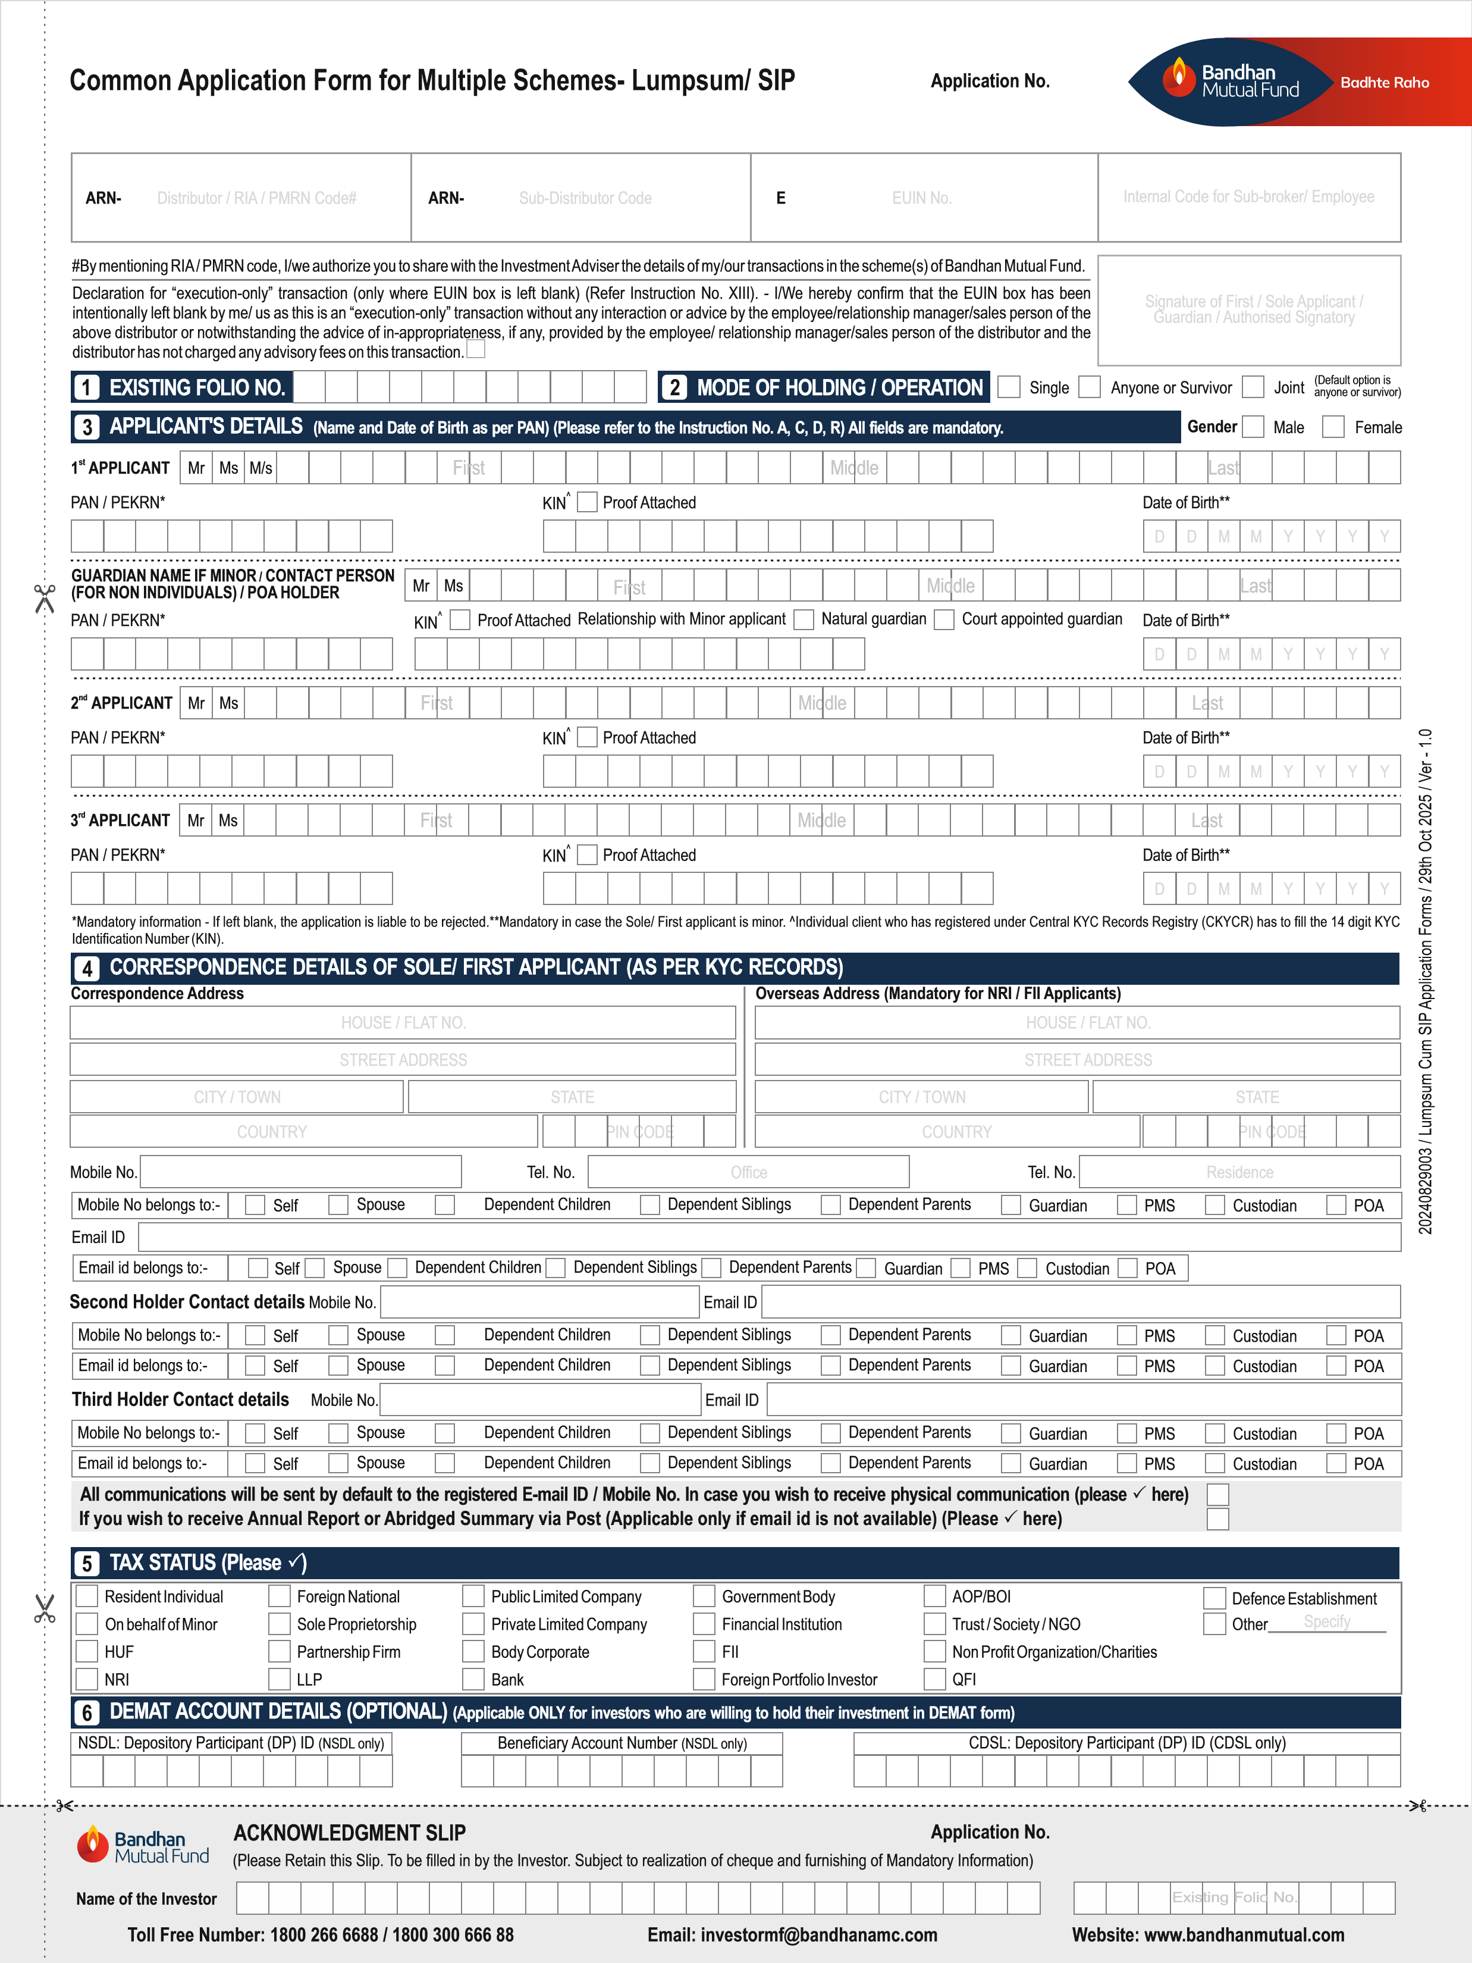
ARN-146262

ARN-146262
Note: In case the registered bank mandate is different from that used to source the investment, please enclosed the a cheque copy.
I / We understand that the instructions to the bank for Direct Credit / NEFT / CAMS OTM will be given by the Mutual Fund, and such instructions will be adequate discharge of the Mutual Fund towards redemption / dividend / refund proceeds. In case the bank does not credit my /our bank account with / without assigning any reason thereof, or if the transaction is delayed or not effected at all or credited into the wrong account for reasons of incomplete or incorrect information, I / We would not hold Bandhan Mutual Fund responsible. Further the Mutual Fund reserves the right to issue a demand draft / payable at par cheque in case it is not possible to make payment by DC/NEFT/CAMS OTM.
8 | INVESTMENT & PAYMENT DETAILS (#Please draw the cheque in favour of Bandhan Mutual Fund)
Type of Investment (ü anyone) Lumpsum SIP SIP with TOP-UP Micro SIP Photo ID No. (for Micro SIP)
Instrument No.
Dated
Amount (
`
)
Scheme
D
D
M
M
Y
Y
BANK DETAILS

Mandatory) Redemption / Dividend / Refund payouts will be credited into this bank account in case it is in the current list of banks with whom Bandhan MF has DC facility (Please refer to the Instruction No. I
(
)
Name of the Bank
MICR Code
RTGS/NEFT Code (IFSC Code)
City
Account Type
Current
Savings
NRO
NRE
FCN
R
Ot
hers
(
plea
se sp
ecify
)
Branch
Account Number
7
Scheme |  |  |  | Name | Plan | Option | Amount | Dividend Frequency | Dividend Sweep  (fill relevant form)
I | Bandhan
II | Bandhan
III | Bandhan
IV | Bandhan
V | Bandhan
 |  |  |  |  |  |  |  |  | Total
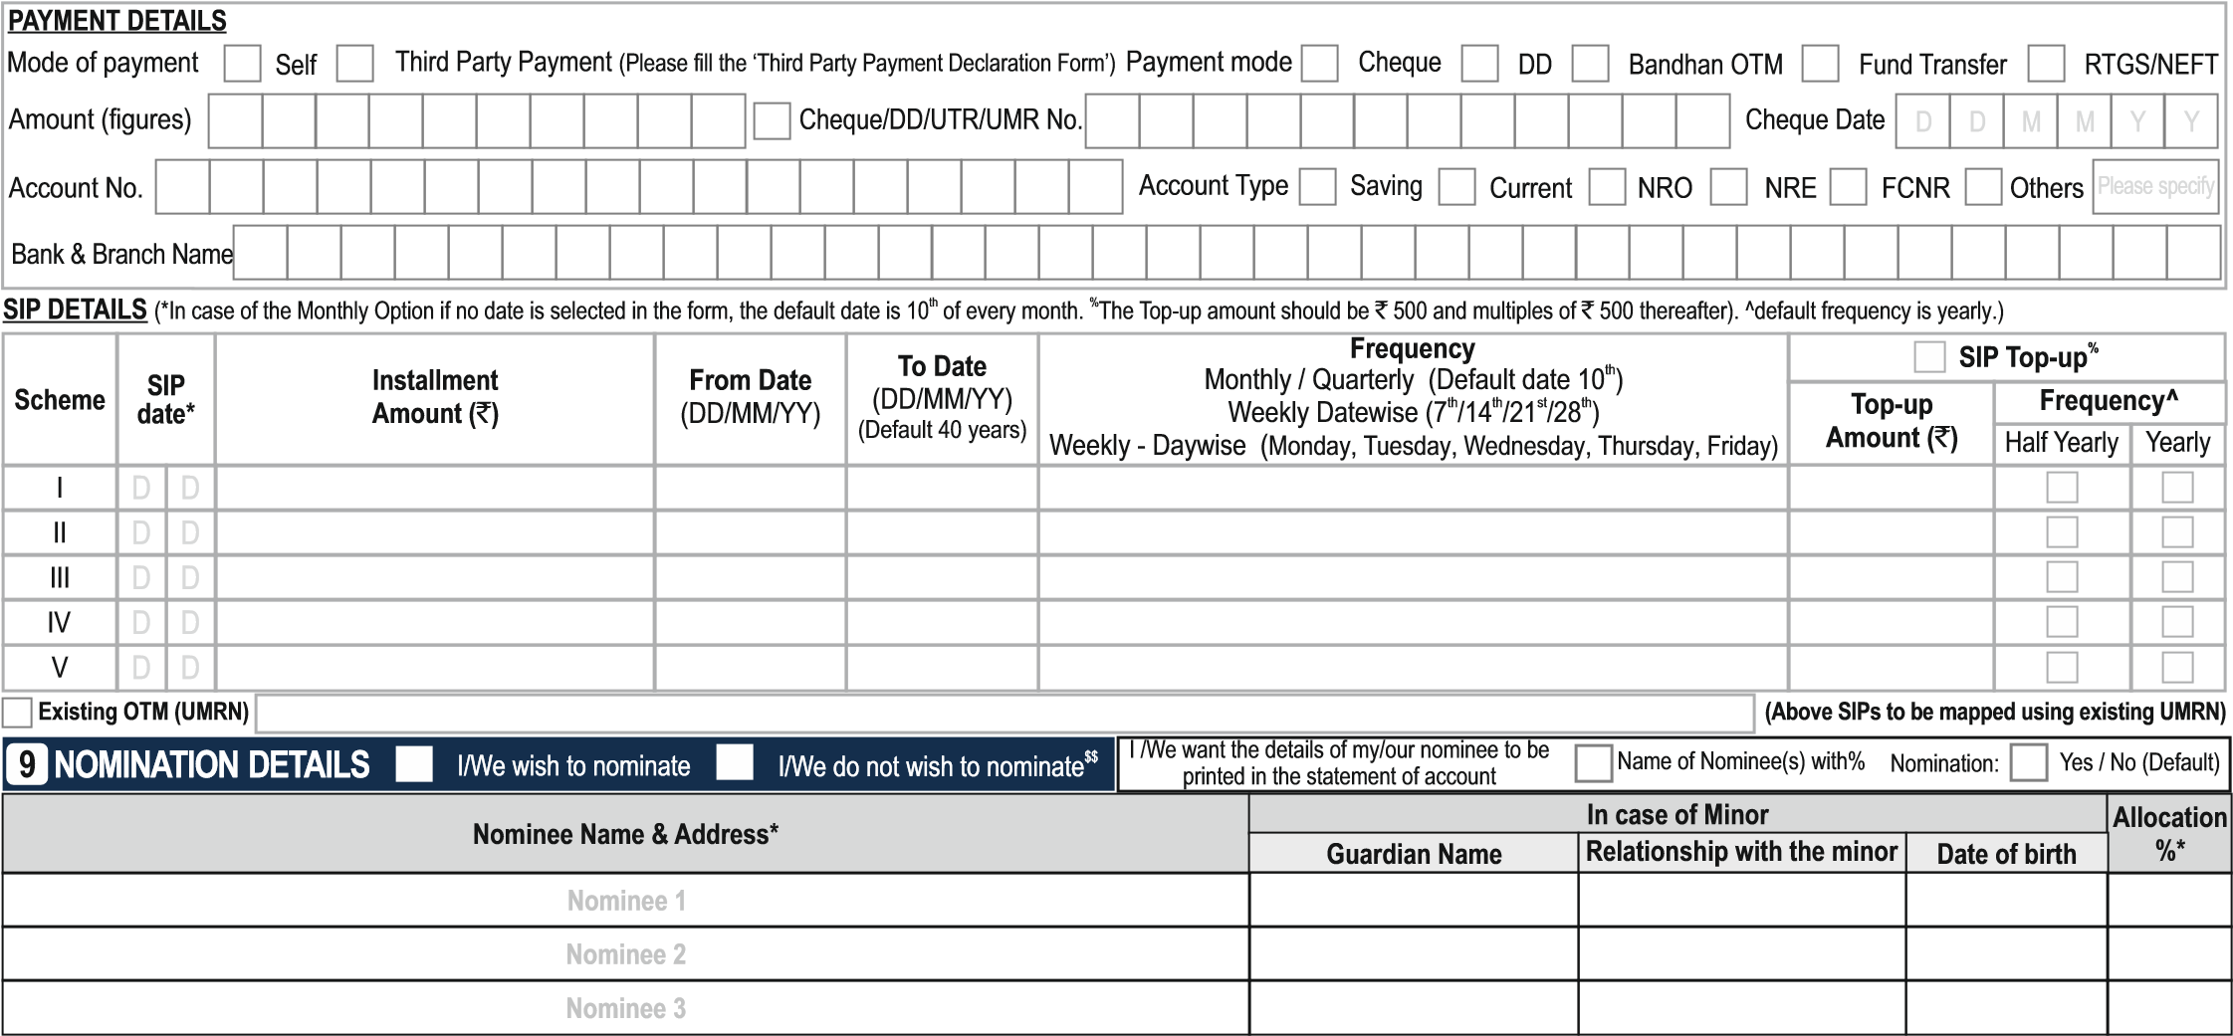

(a) *Mandatory (b) Other Details (Guardian details to be furnished in case nominee is a minor) (c) **For identification details investor can provide PAN, Aadhaar, Driving license or Passport
Nominee 1 | Identification Details** | Mobile* | Email ID* | Relationship with investor*
Nominee 2 | Identification Details** | Mobile* | Email ID* | Relationship with investor*
Nominee 3 | Identification Details** | Mobile* | Email ID* | Relationship with investor*
$$ OPT-OUT: I / We hereby confirm that I / We do not wish to appoint any nominee(s) for my mutual fund units held in my / our mutual fund folio and understand the issues involved in non-appointment of nominee(s) and further are aware that in case of death of all the account holder(s), my / our legal heirs would need to submit all the requiste documents issued by Court or other such competent authority, based on the value of assets held in my / our folio.
Sign Here → |  | First / Sole Applicant / Guardian | Second Applicant | Third Applicant
10 | FATCA AND CRS DETAILS FOR INDIVIDUALS (including Sole Proprietor) (Mandatory)
Non-Individual investors should mandatorily fill separate FATCA Form (Annexure II). The below information is required for all applicants / guardian
 | Place/City of Birth | Country of Birth | Country of Citizenship / Nationality
First Applicant / Guardian |  |  |  |  | Indian |  | U.S. |  | Others | Please specify
Second Applicant |  |  |  |  | Indian |  | U.S. |  | Others | Please specify
Third Applicant |  |  |  |  | Indian |  | U.S. |  | Others | Please specify
Are you a tax resident (i.e. are you assessed for tax) in any other country outside India? YES NO (please tick ü)
If “YES” please fill for ALL countries (other than India in which you are a Resident for tax purpose i.e. where you are a Citizen/ Resident/ Green Card holder/ Tax Resident in the respective countries.
Country of Tax Residency Tax Identification Number or Functional Equivalent (TIN or other please specifyIdentification Type ) (TIN or other please specifyIdentification Type )
First Applicant / Guardian Reasons A B C
Second Applicant Reasons A B C
Third Applicant Reasons A B C
Reason A è The country where the Account Holder is liable to pay tax does not issue Tax Identification Number to its residents.
Reason B è No TIN required (Select this reasons Only if the authorities of the country of tax residence do not require the TIN to be collected) Reason C è Others please state the reasons thereof :
Address Type of Sole /1st Holder |  |  |  |  |  |  | Add |  |  | ress Type of 2nd Holder |  |  |  | Add |  |  | ress Type of 3rd Holder
 |  | Residential |  | Registered Office |  | Business |  |  | Residential |  | Registered Office |  | Business |  |  | Residential |  | Registered Office |  | Business
Annexure I and Annexure II are available on the website of AMC i.e. www.bandhanmutual.com or at the Investor Service centres (ISCs) of Bandhan Mutual Fund
OCCUPATION
(
Please tick
[
ü
)]
First Applicant / Guardian
Second Applicant
Third Applicant
Private Sector Service
Public Sector Service
Government Service
ess
Busin
Professional
urist
Agricult
ed
Retir
wife
House
ent
Stud
ealer
Forex D
Others
Please specify
Please specify
Please specify
GROSS ANNUAL INCOME
[
Please tick
(
ü
)]
First Applicant / Guardian |  |  | Below 1 Lac Net worth (Man |  | 1-5 Lacs ory for Non-I |  | 5-10 La viduals) ` | cs |  |  | 10-25 Lacs |  |  |  | >25 Lacs-1 cro |  |  | re |  | >1 crore
First Applicant / Guardian |  | OR | Below 1 Lac Net worth (Man | dat | 1-5 Lacs ory for Non-I | ndi | 5-10 La viduals) ` |  |  |  |  |  |  |  |  |  |  |  | as on |  | D | D | M | M | Y |  | Y |  | Y |  | Y |  | as on (Not older than 1 year)
Second Applicant |  |  | Below 1 Lac |  | 1-5 Lacs |  | 5-10 La | cs |  |  | 10-25 Lacs |  |  |  | >25 Lacs-1 cro |  |  | re |  | >1 crore OR Net worth `
Third Applicant |  |  | Below 1 Lac |  | 1-5 Lacs |  | 5-10 La | cs |  |  | 10-25 Lacs |  |  |  | >25 Lacs-1 cro |  |  | re |  | >1 crore OR Net worth `
11 | KYC DETAILS (Mandatory)

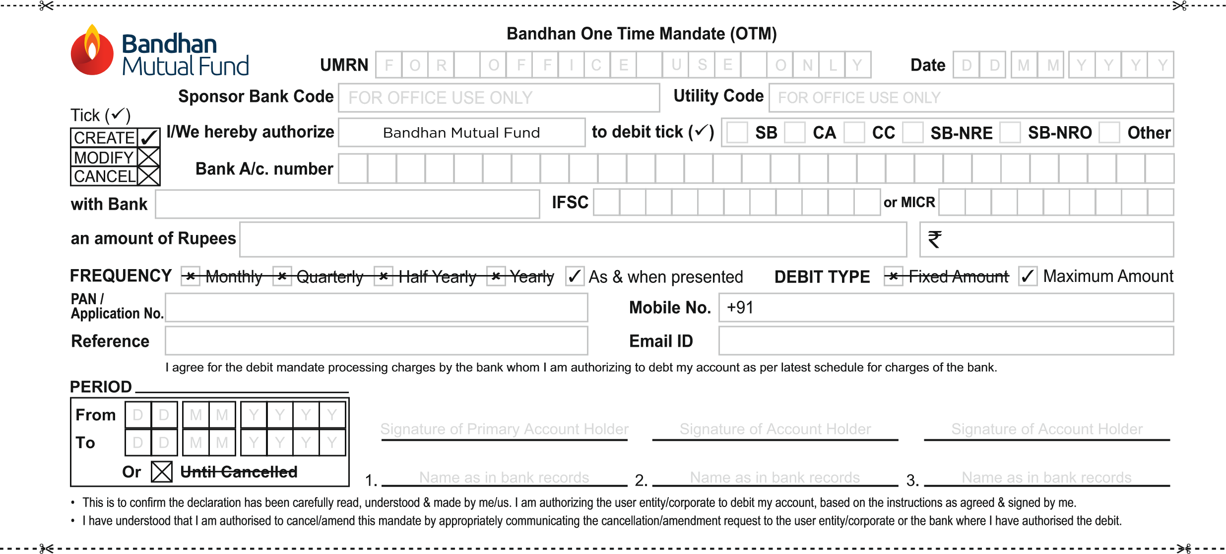
OTHERS [Please tick (ü)]
First Applicant / Guardian |  | For Individuals Please tick (ü) |  |  |  | I am Politically Exposed Person (PEP)^ |  |  |  |  |  |  |  | I am Related to Politically Exposed Person (RPEP) |  |  |  |  |  |  |  | Not applicable
 |  | For Non-Individuals Please tick (ü) (Please attach mandatory Ultimate Beneficial Ownership (UBO) declaration form - Refer instruction no. IV(h)):
 |  | (i) Foreign Exchange / Money Changer Services |  |  |  |  |  |  |  | Y |  | N (ii) Gaming / Gambling / Lottery / Casino Services |  |  |  |  |  | Y |  | N (iii) Money Lending / Pawning |  |  |  | Y |  | N
Second Applicant |  |  |  | Politically Exposed Person (PEP)^ |  |  |  | Related to Politically Exposed Person (RPEP) |  |  |  |  |  |  |  | Not applicable
Third Applicant |  |  |  | Politically Exposed Person (PEP)^ |  |  |  | Related to Politically Exposed Person (RPEP) |  |  |  |  |  |  |  | Not applicable
12 | DECLARATION & SIGNATURES (Please refer to the Instruction No. K)
I/ We have read, understood and agree to comply with the terms and conditions of the Statement of Additional Information, Scheme Information Documents and Key Information Memorandum of the Scheme(s), Foreign Account Tax Compliance Act and Common Reporting Standards, statutory requirements prescribed by SEBI, AMFI, Prevention of Money Laundering Act, 2002 (PMLA), Privacy Policy of Bandhan AMC Limited available on the website of Bandhan Mutual Fund www.bandhanmutual.com and all applicable rules and regulations and hereby confirm that I/We have not received nor been induced by any rebate or gifts, directly or indirectly, to make this investment. I/We hereby declare that I/we do not have any existing Micro SIPs which together with the current application will result in a total investments exceeding ` 50,000 in a year. The ARN holder has disclosed to me/us all the commissions (in the form of trail commission or any other mode), payable to him for the different competing Schemes of various Mutual Funds from amongst which the Scheme is being recommended to me/us. For NRIs / PIOs / FPIs only: I / We confirm that I am / we are Non Resident Indians / Person(s) of Indian Origin / Foreign Portfolio Investors but not (i) United States persons as per applicable Regulations or (ii) residents of Canada, and I / we have remitted funds from abroad through approved banking channels or from funds in my / our Non-Resident External / Non-Resident Ordinary / FCNR Account maintained in accordance with applicable RBI guidelines. I/We hereby provide my/our consent to Bandhan AMC Limited for (i) collecting, storing and usage of personal information for the purposes of processing my/our application and providing the services to which I/we have subscribed and for the purposes of meeting legal and regulatory requirements; (ii) receiving updates on promotional material and transaction related communication via mail, telecall, SMS, etc.
Sign Here → | First / Sole Applicant / Guardian | Second Applicant | Third Applicant

