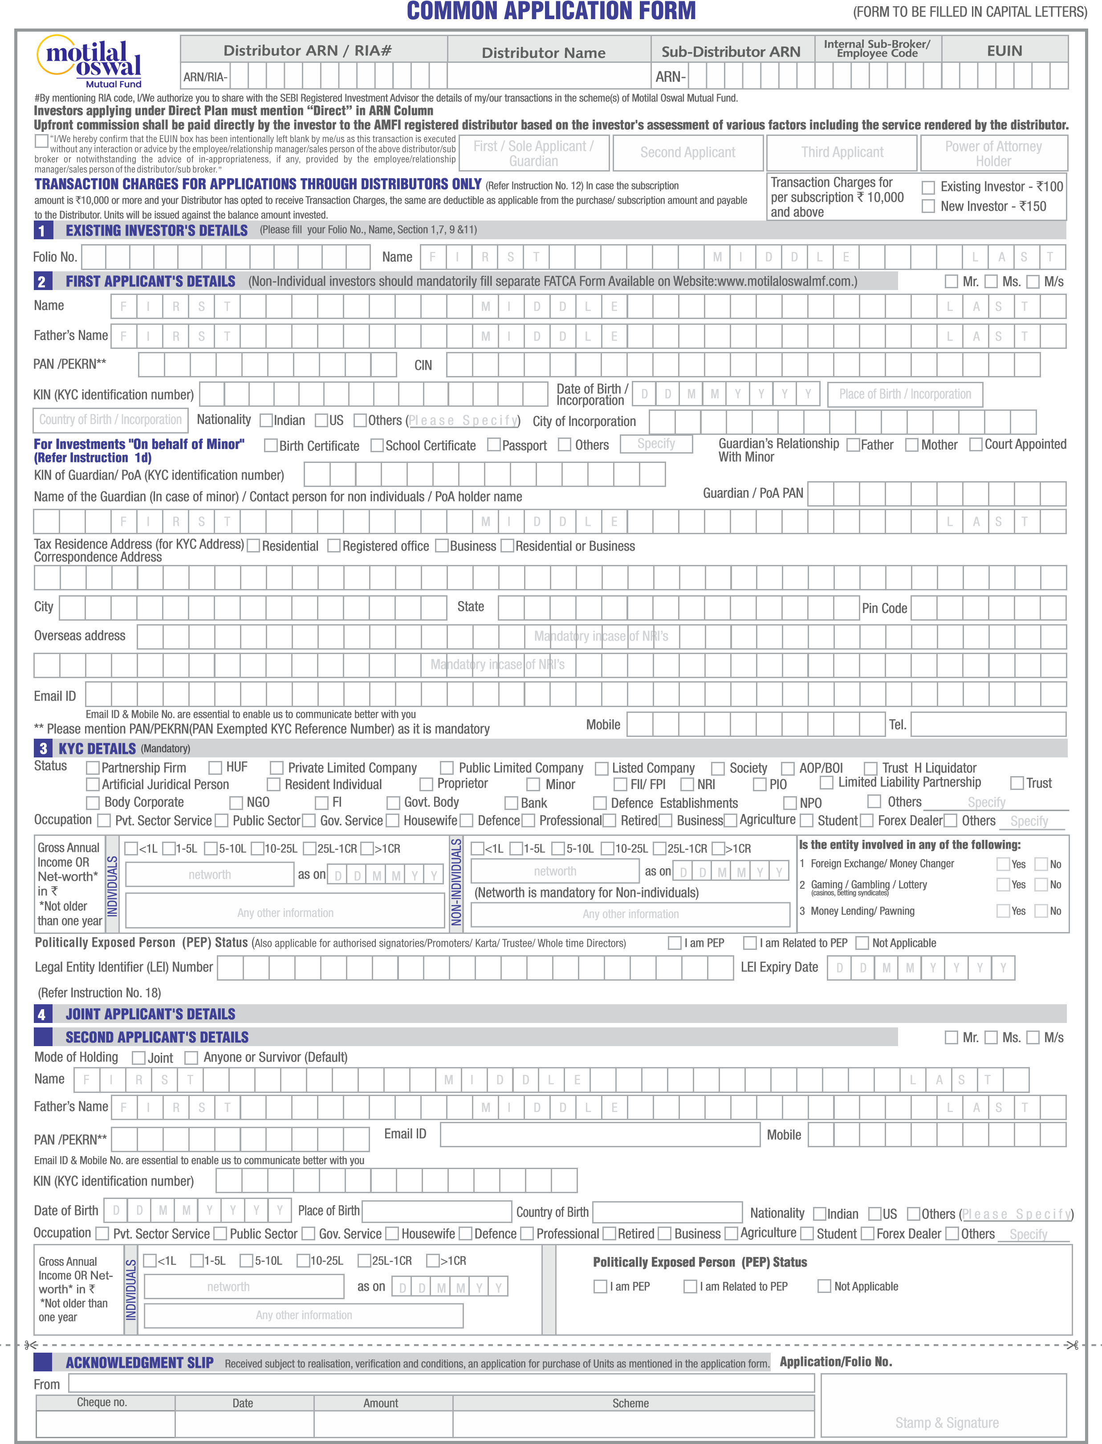
146262
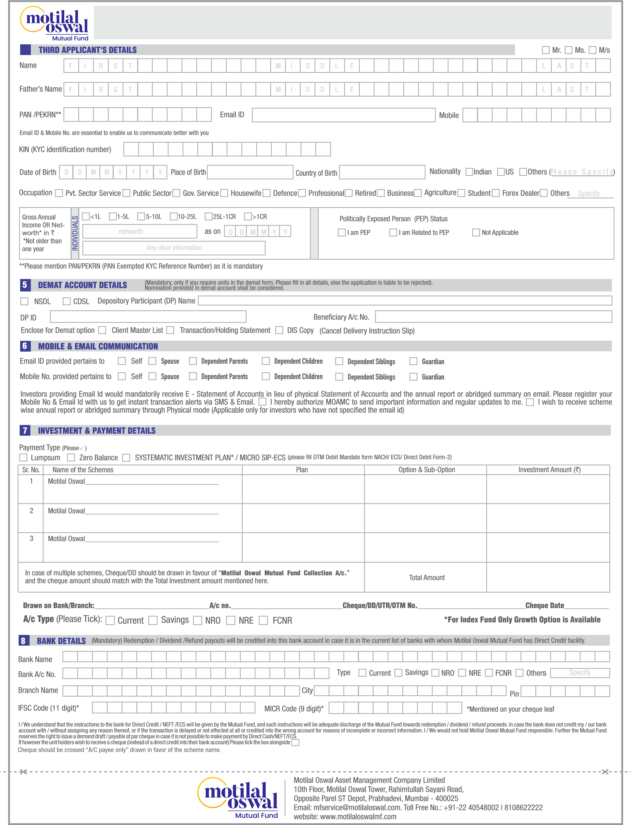
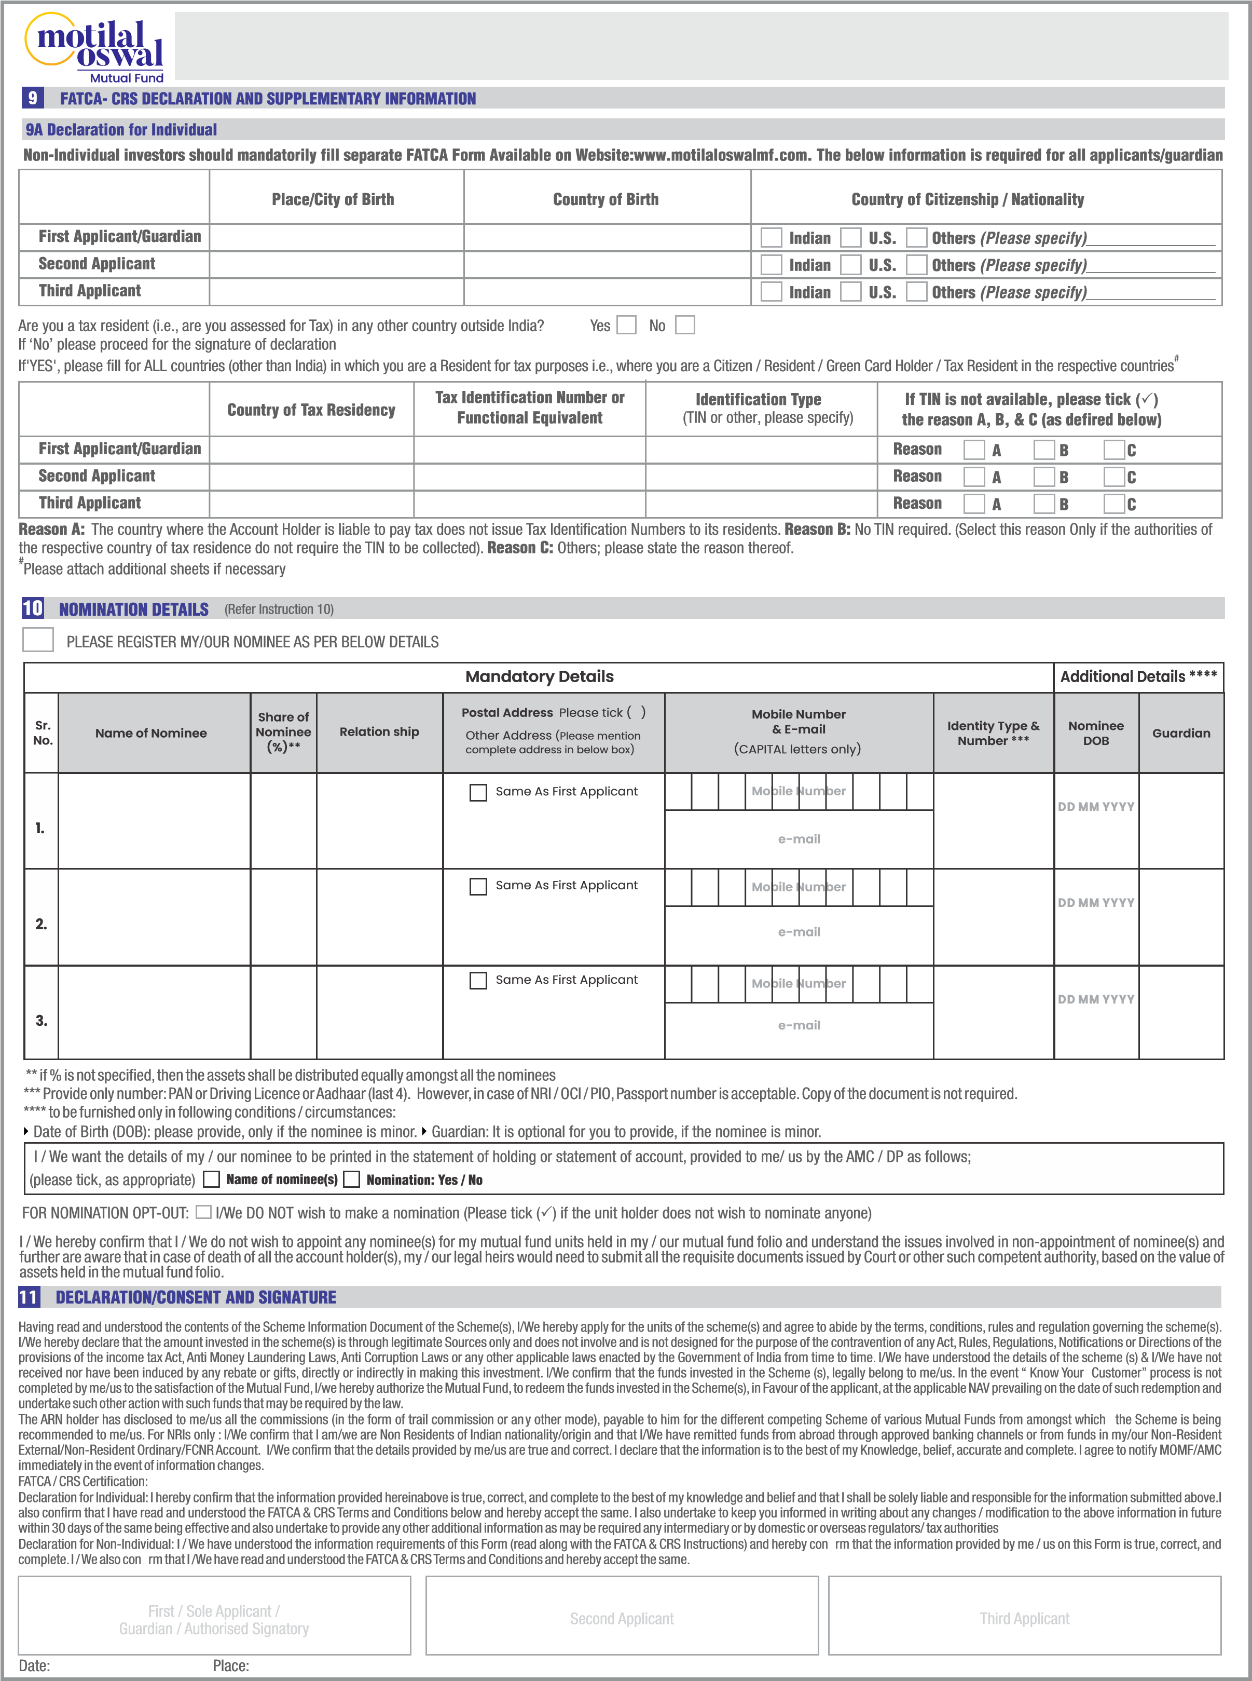
Investors who are Trusts/Societies/Section 8 companies (under Companies Act, 2013) constituted for religious or charitable purposes, have to declare their status as NPO to AMC:
We are falling under “Non-Profit Organization” [NPO] which has been constituted for religious or charitable purposes referred to in clause (15) of section 2 of the Income-tax Act, 1961 (43 of 1961), and is registered as a trust or a society under the Societies Registration Act, 1860 (21 of 1860) or any similar State legislation or a Company registered under the section 8 of the Companies Act, 2013 (18 of 2013). | ΟYes  Ο No
If yes, please quote Registration No. of Darpan portal of Niti Aayog
If not, please register immediately and confirm with the above information. Failure to get above confirmation or registration with the portal as mandated, wherever applicable will force MF / AMC to register your entity name in the above portal and may report to the relevant authorities as applicable. We am/are aware that we may be liable for it for any fines or consequences as required under the respective statutory requirements and authorize you to deduct such fines/charges under intimation to me/us or collect such fines/charges in any other manner as might be applicable.
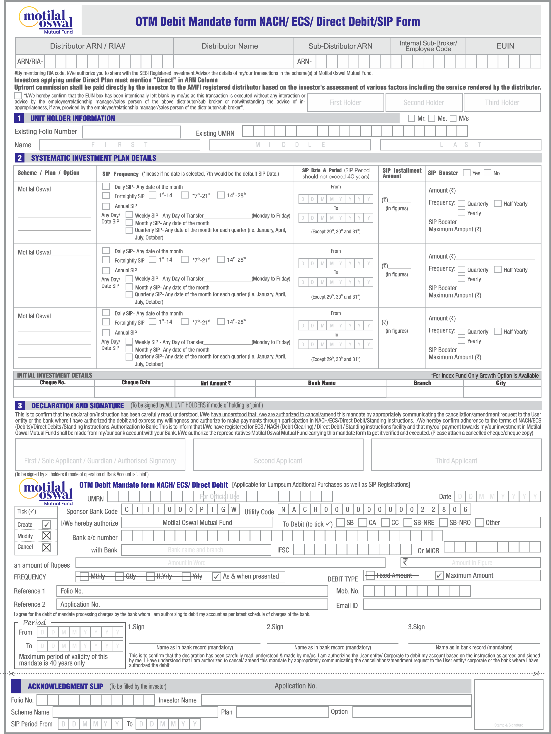
146262

