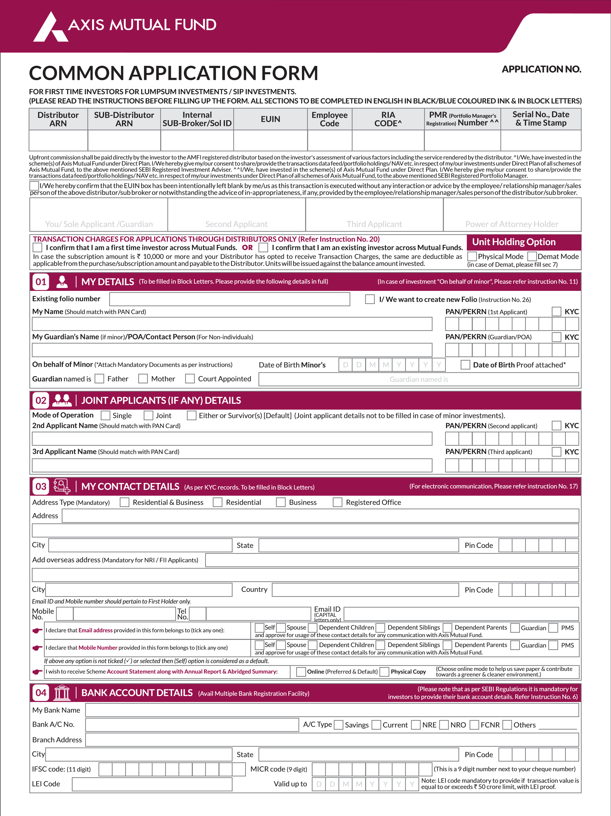
ARN ARN-146262

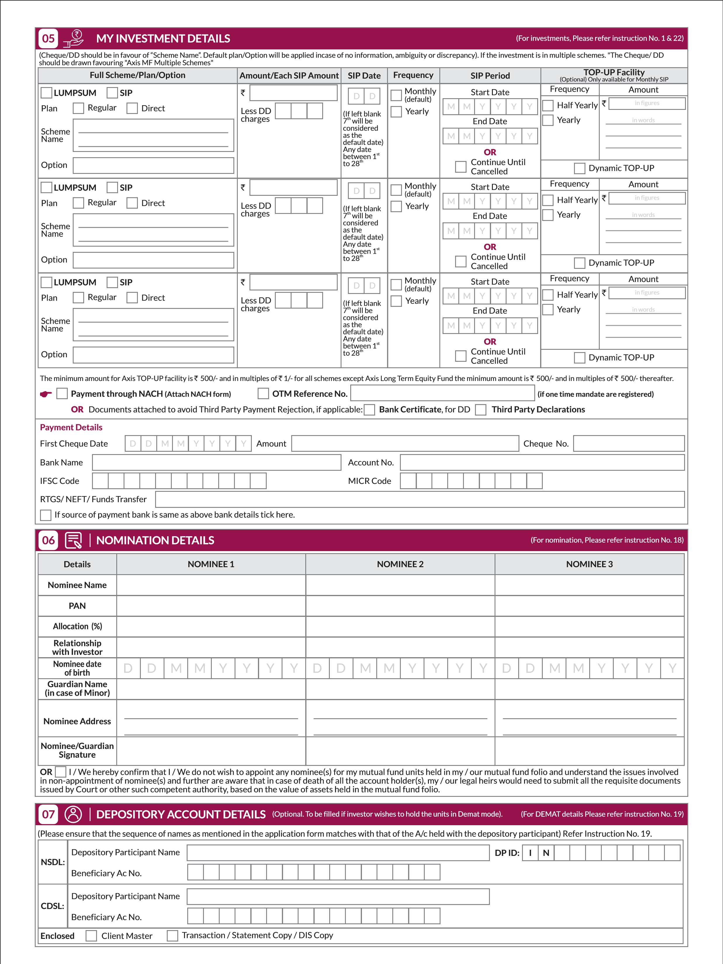
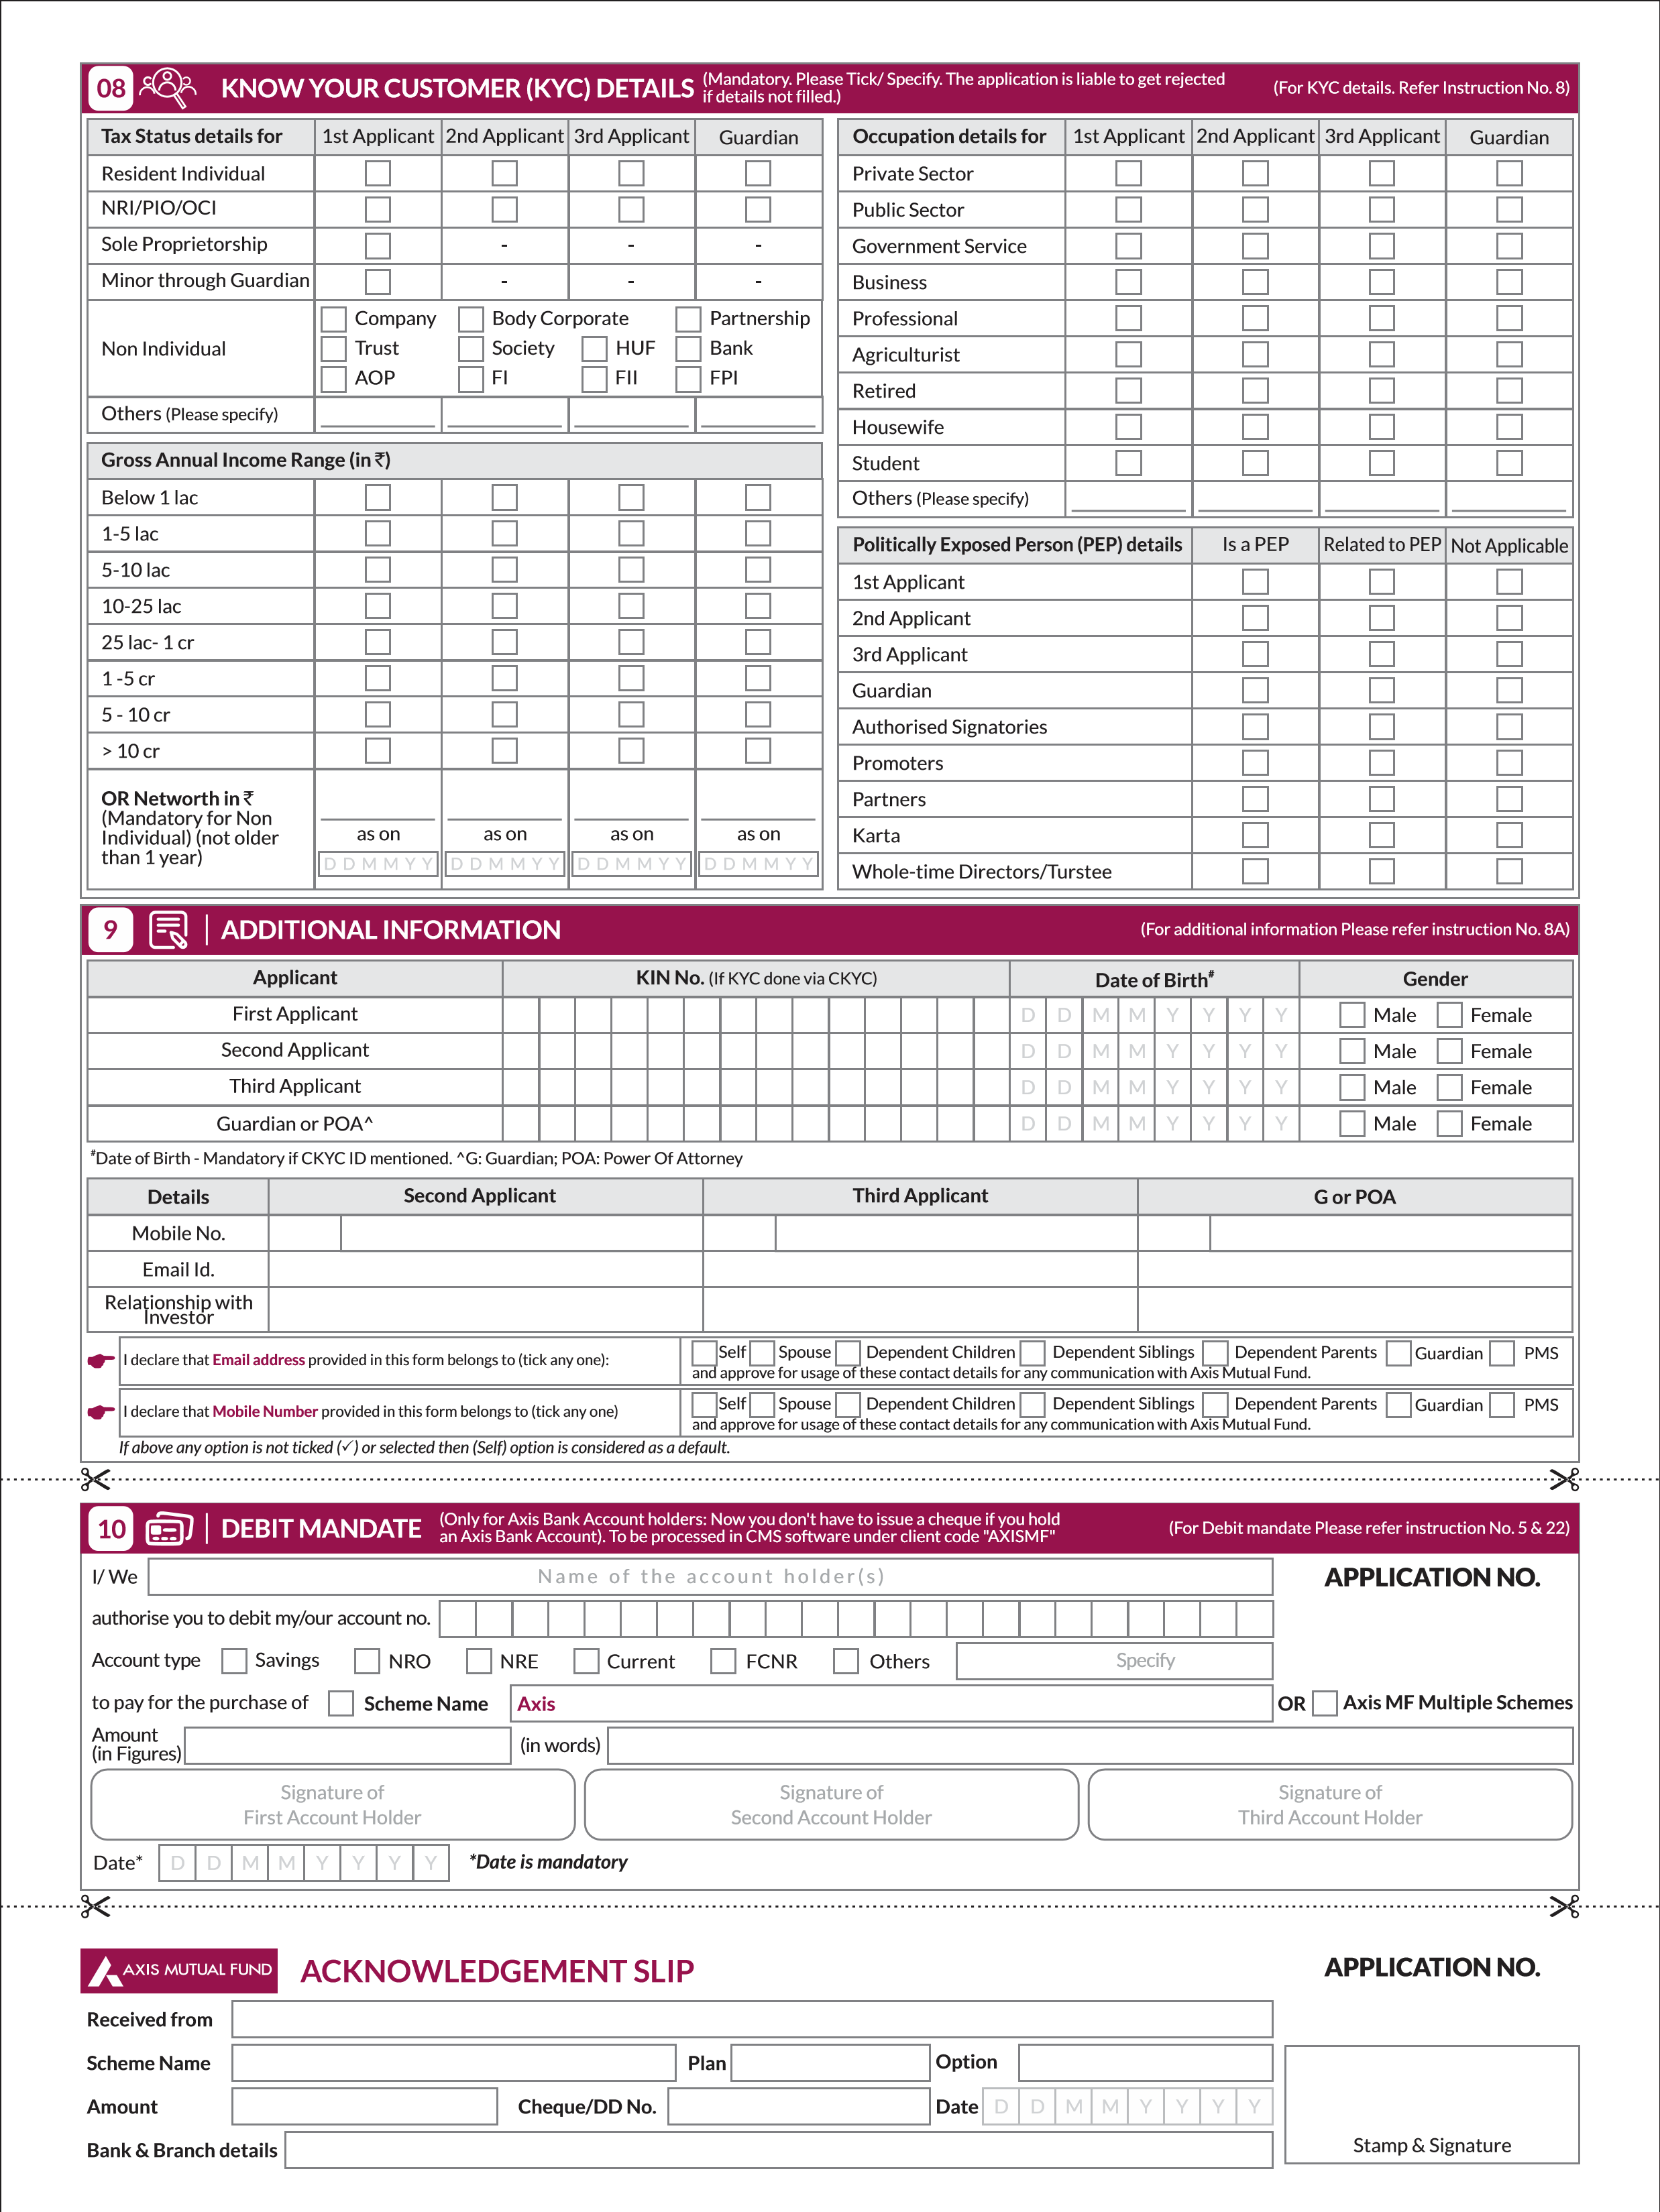
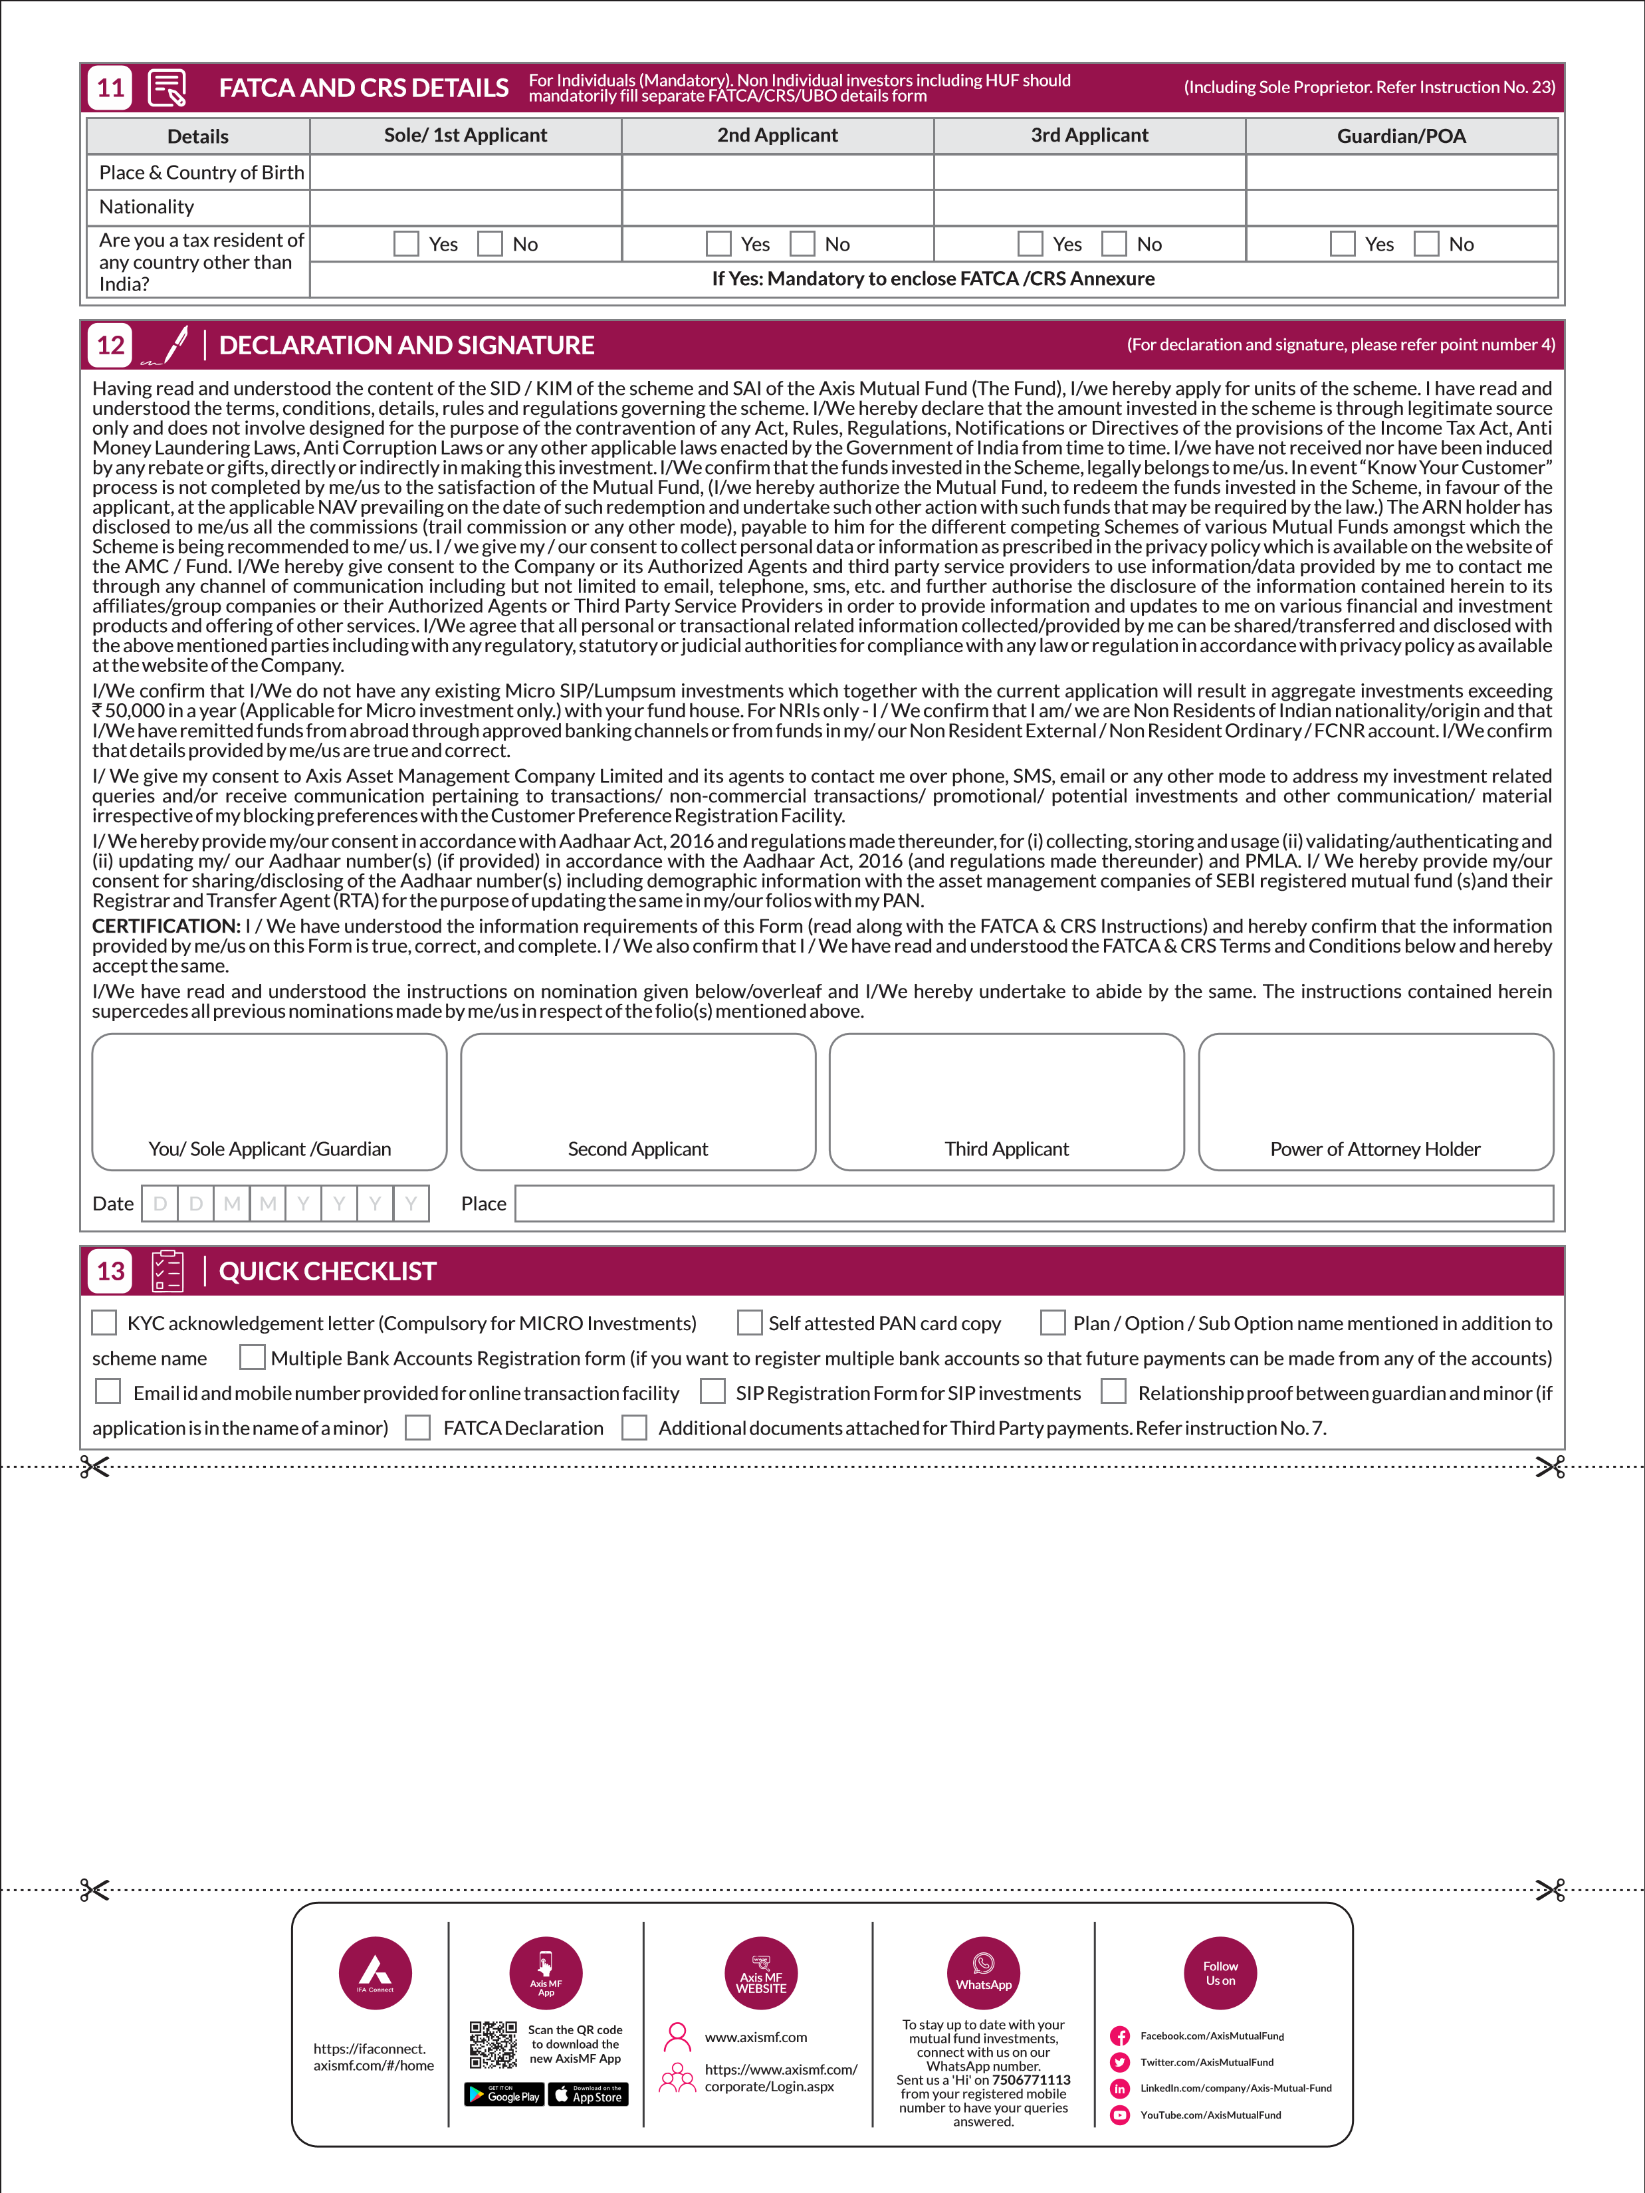

INSTRUCTIONS FOR COMPLETING THE APPLICATION FORM
(Please read the SID carefully before signing the application form and tendering payment.)

1. GENERAL INSTRUCTIONS
- The application form should be completed in ENGLISH and in BLOCK LETTERS.
- All cheques, demand drafts and pay orders should be crossed “Account Payee only” and made in favour of “Scheme Name A/c First Investor Name” or “Scheme Name A/c Permanent Account No.”.
- If the Scheme name on the application form and on the payment instrument are different, the application may be processed and units allotted at applicable NAV of the scheme mentioned in the application / transaction slip duly signed by investor(s).
- Any over-writing / changes made while filling the form must be authenticated by canceling the original entry, re-entering correct details and ensuring that all applicants counter-sign against each correction.
- Application forms along with supporting documents can be submitted to ISCs / OPAs, contact details of which are available on www.axismf.com.
- Investors must write the application form number / folio number on the reverse of the cheque / demand draft.
- Investors are requested to check contents of the account statement on receipt. Any discrepancy should be reported to the AMC / Registrar within 7 calendar days of the receipt of the statement; else contents of the statement would be presumed to be correct and binding. The AMC may modify any discrepancy at its discretion.
- Units will be allotted subject to realization of payment proceeds.
- Unitholder / Guardian name should be same as per PAN / KYC records. Please note that AMC at discretion may replace the name as per KRA.
- FATCA Declaration: Individual investors, please fill in FATCA / CRS annexure and attach along with Application form. Non-Individual investors, please fill in UBO form along with FATCA / CRS annexure and attach along with Application form available on our website www.axismf.com

2. DIRECT INVESTMENTS
Investors subscribing under Direct Plan of the scheme will have to indicate “Direct Plan” against the scheme name in the application form e.g. “Axis Arbitrage Fund - Direct Plan”. Investors should also indicate “Direct” in the ARN column of the application form. However, in case Distributor code is mentioned in the application form, but“Direct Plan” is indicated against the scheme name, the application will be processed under Direct Plan. Further, where application is received for Regular Plan without Distributor code or “Direct” mentioned in the ARN Column, the application will be processed under Direct Plan.
Note: Direct Plan investment not applicable for ETF schemes.

3. EMPLOYEE UNIQUE IDENTIFICATION NUMBER (EUIN)
Investor investing through distributor shall mention EUIN on the application form, if he/she has been advised by Sales Person/ Employee/ Relationship Manager of the distributor this would assist in addressing any instance of mis-selling. If left blank, applicant(s) need to tick and sign the following declaration “I/We hereby confirm that the EUIN box has been intentionally left blank by me/us as this transaction is executed without any interaction or advice by the employee/relationship manager/sales person of the above distributor/sub broker or notwithstanding the advice of in-appropriateness, if any, provided by the employee/relationship manager/sales person of the distributor/sub broker.” on the form. SEBI has made it mandatory to obtain EUIN no. for every employee/ relationship manager/ sales person of the distributor for selling mutual fund products.

4. DECLARATION AND SIGNATURES
- Thumb impressions must be attested by a Magistrate / Notary Public under his / her official seal.
- In case of HUF, the Karta needs to sign on behalf of the HUF.
- Applications by minors should be signed by their guardian.
- For Corporates, signature of the Authorised Signatory (from the Authorised Signatory List (ASL)) is required.

5. PAYMENTS
- The AMC intends using electronic payment services (NEFT, RTGS, ECS (Credit), Direct Credit, etc.) to the extent possible for dividends / redemptions for faster realization of proceeds to investors. In case an investor wishes to receive payments vide cheques / demand drafts to be sent using a postal / courier service, please provide appropriate written instructions to the AMC / Registrar for the same.
- Please enclose a cancelled cheque leaf (or copy thereof) in case your investment instrument (pay-in) is not from the same bank account as mentioned under bank account details.
- Any communication, dispatch of redemption / dividend payments / account statements etc. would be made by the Registrar / AMC as per reasonable standards of servicing.
- The Debit Mandate is an additional facility available to Axis Bank account holders only.

6. BANK DETAILS
It is mandatory for investors to mention bank account details on the form as per directives issued by SEBI. Applications without this information are liable to be rejected. The Mutual Fund / AMC reserve the right to hold redemption proceeds in case requisite bank details are not submitted. Option to register multiple bank accounts
The AMC / Mutual Fund has also provided a facility to investors to register multiple bank accounts. By registering multiple bank accounts, investors can use any of their registered bank accounts to receive redemption / dividend proceeds. Any request for a change in bank mandate requires 10 days for validation and verification. Further, these account details will be used by the AMC / Mutual Fund / R&T for verification of instruments (like cheques/DDs/POs) received at the time of subscription / purchase applications to ensure that subscription payments are received only from one of the registered bank accounts. Payments from nonregistered bank accounts (called third party payments) will not be accepted (except where permitted as per SEBI regulations). Investors are requested to avail of this facility by filling in the application form for registration of multiple bank accounts available at any of our ISCs / OPAs or on our website www.axismf.com.
Cheques submitted at the time of purchase should be from the beneficiary investors account or from an account mentioned in your Multiple Bank Accounts Registration form (except for minors for amounts less than ` 50,000 and Corporates / nonindividuals).
Demand drafts submitted at the time of subscription should be accompanied by a banker’s certificate clearly stating the investor’s name and PAN as well as mentioning that the demand draft has been issued by debiting the investor’s own bank account. Pre-funded instruments issued by the bank against cash shall not be accepted for investments of `50,000 or more. This pre-funded instrument should also be accompanied by a certificate from the banker giving the investor’s name, address and PAN.
Payments made through RTGS/NEFT/NECS should be accompanied by a banker’s certificate stating that the RTGS/NEFT/NECS payment has been made by debiting the investor’s own bank account along with mention of the investor’s name and PAN.

7. THIRD PARTY PAYMENTS
When payment is made through instruments issued from a bank account other than that of the investor, the same is referred to as a Third Party payment. Where an investor has opted to register multiple bank accounts (using the ‘Multiple Bank Accounts Registration Form’), and purchase payment is made from an account different from what is registered, any one of the following documents need to be provided as proof along with the payment instrument.
- Banker’s certificate stating that the investment is from the investor’s own bank account along with mention of his name and PAN
- Bank account passbook or statement mentioning the investor’s name / PAN
Restriction on acceptance of Third Party payments for subscriptions, and exceptions thereto
- In case of payments from a joint bank account, one of the joint holders of the bank account must be the first account holder under the investment application.
- The Asset Management Company shall not accept subscriptions with Third Party payments except in the following situations:
  - Where payment is made by parents/grand parents/related persons on behalf of a minor in consideration of natural love and affection or as gift for a value not exceeding ` 50,000
(each regular purchase or per SIP installment). However this restriction will not be applicable for payment made by a guardian whose name is registered in the records of Mutual Fund in that folio.
  - Where payment is made by an employer on behalf of an employee under Systematic Investment Plans through payroll deductions.
  - Custodian on behalf of an FII or a client.
Documents to be submitted for exceptional cases
- KYC is mandatory for all investors (guardian in case of minor) and the person making the payment i.e. the third party. Investors and the person making the payment should attach their valid KYC acknowledgement letter to the application form.
- Submission of a separate, complete and valid ‘Third Party Payment Declaration Form' from the investors (guardian in case of minor) and the person making the payment i.e. third party. The said Declaration Form shall, inter-alia, contain the details of the bank account from which the payment is made and the relationship with the investor(s). Please contact the nearest OPA/ISC of Axis Mutual Fund or visit our website www.axismf.com for the declaration form.

8. KYC
All Applicants (including POAs and Guardians) are required to be KYC compliant irrespective of the amount of investment. In case you are not KYC certified, please fill in the KYC form (individual or Non-Individual). A KYC acknowledgement letter should be submitted along with application for opening a folio or making an investment. Each holder in the folio must be KYC compliant.
Investors may kindly note that new SEBI Circular issued regarding uniformity in the KYC process was effective from January 1, 2012.
- SEBI has introduced a common KYC Application Form for all the SEBI registered intermediaries, new Investors are therefore requested to use the common KYC Application Form and carry out the KYC process including In-Person Verification (IPV) with any SEBI registered intermediaries including mutual funds. The KYC Application Forms are available on our website www.axismf.com.
- The Mutual Fund shall perform the initial KYC of its new investors and shall also accept the details change form for investors who have done their KYC prior to 31st Dec11.
- It is mandatory to carry out In-Person Verification(IPV) for processing the KYC of its new / existing investors from January 1, 2012.
- Once the KYC and IPV-In Person Verification has been done with any SEBI registered intermediary, the investor need not undergo the same process again with any another intermediary including mutual funds. However, the Mutual Fund reserves the right to carry out fresh KYC/additional KYC of the investor.
- Existing KYC compliant investors of the Mutual Fund can continue to invest as per the current practice.
- Non-individual investors will have to do a fresh KYC due to significant changes in KYC requirements.
- In accordance with SEBI Circular No. CIR/MIRSD/13/2013 dated December 26, 2013, the additional details viz. Occupation details, Gross Annual Income/networth and Politically Exposed Person (PEP)* status mentioned under section 2 & 3 which was forming part of uniform KYC form will now be captured in the application form of the Fund. Also, the detail of nature of services viz. Foreign Exchange/Gaming/Money Lending, etc.,(applicable for first/sole applicant) is required to be provided as part of Client Due Diligence (CDD) Process of the Fund.
The said details are mandatory for both Individual and Non Individual applicants.
*PEP are defined as individuals who are or have been entrusted with prominent public functions in a foreign country, e.g., Heads of States or of Governments,
INSTRUCTIONS FOR COMPLETING THE APPLICATION FORM (CONTD....)
(Please read the SID carefully before signing the application form and tendering payment.)
senior politicians, senior Government/judicial/ military officers, senior executives of state owned corporations, important political party officials, etc.
Subsequently, SEBI, vide its circular no. MIRSD/Cir-5/2012 dated April 13, 2012 advised various intermediaries to upload KYC data of its existing customers into the KRA system. While uploading KYC data into the KRA system, intermediaries were also required to highlight such ‘Missing/Not Available’ KYC information of a customer, which was either not required or not taken previously, but was mandatory as per uniform KYC guidelines issued by SEBI.
8. In accordance with AMFI circular - 35P/MEM-COR/54/2019-20 dated
February 28, 2020, it is mandatory, KYC to be verified by KYC Registration Agency before processing redemption. Further, investor requested to complete KYC process before placing redemption request.
In accordance with AMFI Best practices guidelines circular no. 62/2015-16 dated September 18, 2015, investors may note the following:
It is mandatory for all new/existing investors to provide additional KYC information such as Income details, Occupation, association with politically exposed person, net worth etc. as mentioned in the application form. Subscription requests, without providing these details, are liable to be rejected. No subscriptions (whether fresh or additional) and switches pertaining to ‘KYC on-hold’ cases are accepted, unless the investor / unitholder also submits relevant KYC missing / updated information, which is appropriately updated on the KRA - KYC.
Further, it is mandatory for existing customers to complete In-Person Verification process and provide the missing KYC information failing which their applications / transaction requests for additional subscription (including switches) is liable to be rejected.

8A Operationalisation of Central KYC Records Registry (CKYCR)
Central Registry of Securitisation and Asset Reconstruction and Security interest of India (‘CERSAI’) has been authorised by Government of India to act as Central KYC Records Registry under Prevention of Money-Laundering (Maintenance of Records) Rules, 2005 (‘PMLA Rules’).
SEBI vide its circular ref. no. CIR/MIRSD/66/2016 dated July 21, 2016 and circular ref. no. CIR/MIRSD/120/2016 dated November 10, 2016 has prescribed that the Mutual Fund/ AMC should capture KYC information for sharing with CKYCR as per the KYC template prescribed by CERSAI for uniform and smooth implementation of CKYC norms for onboarding of new investors in mutual funds.
In accordance with the aforesaid SEBI circulars and AMFI best practice guidelines for implementation of CKYC norms with effect from February 1, 2017:
- Individual investors who have never done KYC process under KRA regime i.e. a new investor who is new to KRA system and whose KYC is not registered or verified in the KRA system shall be required to provide KYC details in the CKYC Form to the Mutual Fund/ AMC.
- Individual investor who fills old KRA KYC Form, should provide additional / missing information using Supplementary KYC Form or fill CKYC Form.
- Details of investors shall be uploaded on the system of CKYCR and a 14 digit unique KYC identifier (‘KIN’) will be generated for such customer.
- New investors, who have completed CKYC process & have obtained KIN may quote their KIN in the application form instead of submitting CKYC Form/ Supplementary KYC Form.
- AMC/ Mutual Fund shall use the KIN of the investor to download the KYC information from CKYCR system and update its records.
- If the PAN of investor is not updated on CKYCR system, the investor should submit self-certified copy of PAN card to the Mutual Fund/ AMC.
The CKYC Form and Supplementary KYC Form are available at Investor Service Centre (ISC) of Axis Mutual Fund and on website www.axismf.com.
The AMC reserves the right to reject transaction application in case the investor(s) fails to submit information and/or documentation as mentioned above. In the event of non compliance of KYC requirements, the Trustee / AMC reserves the right to freeze the folio of the investor(s).

9. ULTIMATE BENEFICIAL OWNERS(S)
SEBI vide its circular no. CIR/MIRSD/2/2013 dated January 24, 2013 further read with AMFI Best practices guidelines circular no. 62/2015-16 dated September 18, 2015 and other applicable regulations and guidelines, for identification of Beneficial Ownership to be followed by the intermediaries for determination of beneficial owners. A ‘Beneficial owner’ is defined as a natural person or persons who ultimately own, control or influence a client and/or persons on whose behalf a transaction is being conducted and includes a person who exercises ultimate effective control over a legal person or arrangement. In this regard, all categories of investors (including all new / existing investors / unitholders) (except individuals, companies listed on a stock exchange or majority-owned subsidiary of such companies) are mandatorily required to provide beneficial ownership details for all investments. Failing which, fund reserves the right to reject applications / subscription requests / additional subscription requests (including switches) / restrict further investments or seek additional information from investors who have not provided the requisite information on beneficial ownership. In the event of change in beneficial ownership, investors are requested to immediately update the details with the Fund/Registrar.

10. PERMANENT ACCOUNT NUMBER (PAN)
Each applicant is required to submit self attested PAN Card Copy (Including Guardian in case of Minor and POA holders).However PAN is not mandatory in case of Investors residing in the State of Sikkim, Central & State Government officials and officials appointed by the Courts e.g. Official Liquidator, Court receiver etc. (under the category of Government) subject to Axis AMC confirming the above mentioned status.
PAN Exempt Investments
SEBI vide its circular dated 24th July 2012, conveyed that the investments aggregating ` 50,000 in a rolling 12 month period or in a financial year i.e. April to March, in all the schemes of Mutual Funds are exempt from the PAN requirement.
Where the aggregate of the Lumpsum Investment (Fresh Purchase & Additional Purchase) and Micro SIP installments by an investor based on the rolling 12 month period/ in a financial year i.e. April to March does not exceed ` 50,000/-, it shall be exempt from the requirement of PAN, (hereafter referred to as "Micro Investments”).
PAN requirement exemption will be available only to Micro Investments made by the individuals being Indian Citizens (Including NRIs, Joint Holders*, Minor acting through Guardian and Sole proprietory firms not having PAN). Person of Indian Origin, Hindu Undivided Family,(HUF),Qualified Foreign Investor (QFI) and other categories of investors will not be eligible for this exemption. However the eligible investors are required to submit PAN exempt KYC issued by SEBI registered KRA (KYC Registration Authority). * In case of joint holders, first holder must not possess a PAN.

11. APPLICATIONS ON BEHALF OF MINORS
Where the investment is on behalf of a Minor by the Guardian: a. The Minor shall be the first and sole holder in the account.
- No Joint holders are allowed. In case an investor provides joint holder details, these shall be ignored.
- Guardian should be either a natural guardian (i.e. father or mother) or a court appointed legal guardian.
- Guardian should mention the relationship with Minor and date of birth of the Minor on the application form.
- A document evidencing the relationship and date of birth of the Minor should be submitted along with the application form. Photo copy of any one of the following documents can be submitted a) Birth certificate of the minor or b) school leaving certificate / mark sheet of Higher Secondary board of respective states, ICSE, CBSE etc. c) Passport of the minor d) Any other suitable proof evidencing the relationship.
- Where the guardian is not a natural guardian (father or mother) and is a court appointed legal guardian, suitable supporting documentary evidence should be provided.
- If the mandatory details and/or documents are not provided, the application is liable to be rejected without any information to the applicant.

12. APPLICATIONS UNDER POWER OF ATTORNEY
An applicant wanting to transact through a power of attorney must lodge the photocopy of the Power of Attorney (PoA) attested by a Notary Public or the original PoA (which will be returned after verification) within 30 days of submitting the Purchase Application Form / Transaction Slip at a Designated ISC / Official Point of Acceptance, or along with the application in case of application submitted duly signed by POA holder. Applications are liable to be rejected if the power of attorney is not submitted within the aforesaid period.

13. SYSTEMATIC INVESTMENT PLAN
- A minimum gap of 21 days and not more than 90 days needs to be maintained between date of Application & SIP start date.
- Investor shall have the option of choosing any date of the month as the SIP date except the dates 29th, 30th and 31st. If SIP debit date is not mentioned default date would be considered as 7th of every month. If selected 29th, 30th or 31st, default SIP date would be considered as 28th of every month.
- All SIP installment cheques/payment instructions must be of the same amount and the same monthly debit date (excluding first cheque).
- The SIP will be discontinued automatically if payment is not received for three successive installments.
- Investors can discontinue a SIP at any time by sending a written request to any Official Point of Acceptance or to the registrar KFin Technologies Limited. Notice of such discontinuance should be received at least 20 days prior to the next due date of the installment / debit.
- In case payment is made using “At Par” cheques, investors must mention the MICR number of his bank branch. Where he hold’s the bank account.
- An Investor will not hold Axis Mutual Fund, its registrars and / or service providers responsible if a transaction is delayed or not effected, or the investor bank account is debited in advance or after the specific SIP date because of the various clearing cycles of RBI’s Electronic Clearing Facility (ECS) / Bank holiday. Axis Mutual Fund, its registrars and other service providers shall not be held responsible or liable for damages / compensation / loss incurred by the investor as a result of using the SIP or ECS / Auto debt facility.
- Please refer below table for minimum monthly/yearly installments:
Scheme Monthly Yearly
Minimum Minimum Minimum Minimum
Amount (`) Installments Amount (`) Installments
All Schemes except 1000 6
below schemes,
Axis Overnight Fund &
Axis Liquid Fund 12000 3
For Axis Bluechip Fund, 100 6
Axis Focused 25 Fund,
Axis Growth Opportunities Fund, Axis Flexi Cap Fund, Axis Mid Cap Fund,
Axis Small Cap Fund,
Axis ESG Equity Fund,
Axis Special Situations
Fund, Axis Quant Fund, Axis Value Fund,
Axis Multicap Fund,
Axis Multi Asset Allocation Fund (Formerly known as
Axis Triple Advantage Fund) Axis Arbitrage Fund,
Axis Equity Hybrid Fund, Axis Equity Saver Fund,
Axis Regular Saver Fund, Axis Balance Advantage Fund and Axis Nifty 100 Index Fund.
Axis Gold Fund & Axis Long 500 6 6000 3
Term Equity Fund*
Note: For all schemes, minimum amount is as per above table and thereafter in multiple of ` 1.
INSTRUCTIONS FOR COMPLETING THE APPLICATION FORM (CONTD....)
(Please read the SID carefully before signing the application form and tendering payment.)
For Long Term Equity Fund Minimum amount is as per above table and thereafter in multiple of `500*.
- If the period is not specified by the unit holder on the SIP section then the SIP enrollment will be consider from the upcoming month (Gap of 21 days) till perpetuity (December 2099).
- If no amount is mentioned minimum scheme amount would be considered. Please refer KIM & SID of the respective scheme. Change of Debit Bank Details (SIP Auto Debit Form)
- Investor can change debit bank details mentioned on SIP Auto Debit form by ticking the check box provided on the form and attaching signed cancelled cheque of the new bank along with the mandate.
- The cheque copy should have the investor’s name printed on it.
- A minimum gap of 21 days is required for incorporation of new bank details.
- In case of change of debit bank details the investor needs to provide the new bank details on mandate and SIP start date should be in continuation with the SIP cycle and end date will remain the same.
- Except new debit bank details rest of the details i.e. SIP period, amount etc. will remain same as the original SIP investment.

14. NATIONAL AUTOMATED CLEARING HOUSE (NACH)
NACH is a funds clearing platform set up by NPCI similar to the existing ECS of RBI. NPCI has implemented NACH for Banks, Financial Institutions, Corporates and Government a web based solution to facilitate interbank, high volume, electronic transactions which are repetitive and periodic in nature. National Payments Corporation of India (NPCI)
NPCI was set up by Indian Banks Association under a mandate from the Reserve Bank of India in 2008. It is the umbrella organization for all retail payment systems. NCPI would provide robust payment solutions to banks and financial institutions across India.

15. AUTO DEBIT PARTNERING BANKS
Partnering Banks: Axis Bank, Bank of India, Punjab National Bank (16 digit), State Bank of India & Union Bank Of India.

16. NRIs, FIIs

a. Repatriation basis
- NRIs: Payment may be made either by inward remittance through normal banking channels, or from funds held in a Non-Resident (External) Rupee Account (NRE) / Foreign Currency (Non-Resident) Account (FCNR). In case Indian rupee drafts are purchased abroad or from Foreign Currency Accounts or Non-resident Rupee Accounts, an account debit certificate from the bank issuing the draft confirming the debit will need to be enclosed.
- FIIs can pay their subscription either by inward remittance through normal banking channels or from funds held in Foreign Currency Account or NonResident Rupee Account maintained by the FII with a designated branch of an authorised dealer.
- Axis Mutual Fund has decided to restrict subscriptions from U.S. Persons (including NRIs and all persons residing in U.S, U.S Corporations or other entities organized under the laws of U.S) and Residents of Canada in the Schemes of Axis Mutual Fund.

b. Non-repatriation basis
In the case of NRIs, payment may be made either by inward remittance through normal banking channels or out of funds held in a NRE / FCNR / Non-Resident Ordinary Rupee Account (NRO). In case Indian rupee drafts are purchased abroad or from Foreign Currency Accounts or Non-resident Rupee Accounts, an account debit certificate from the bank issuing the draft confirming the debit will need to be enclosed.
c. TDS where ever applicable would be rounded off to the Rupee.

17. ELECTRONIC SERVICES
The AMC provides electronic transaction services through its website and over the phone.
- KFINKART: Transactions through electronic platform(s) of KFin Technologies Limited (effective from January 2, 2017): Investors will be allowed to transact through https://mfs.kfintech.com/investor/, an electronic platform provided by Kfin Technologies Limited, Registrar & Transfer Agent, in Schemes of Axis Mutual Fund (‘Fund’) (except Axis Gold ETF and Axis Nifty ETF). The facility will also be available through mobile application i.e. ‘KFINKART’.
- Online Schedule Transaction Facility (‘the OST facility’/ ‘the Facility’):
The OST facility shall enable Investors to schedule subscription / redemption / switch transaction(s) on specified date for specified amount/ units by giving online instruction.
The terms and conditions of the OST facility shall be as under:
  - The Facility is available to the existing Investors of open ended schemes of Axis Mutual Fund (except Axis Gold ETF and Axis Nifty ETF), subject to completion of lock-in, if any.
  - The Facility is available only to Individual (including sole proprietor) Investors for units held in / subscription in physical mode.
  - The Facility for subscription transaction would be available to Investors after completion of OTM Mandate / equivalent mandate registration process.
  - Under the Facility the transaction can be scheduled to be executed on a specified date which shall be within 30 calendar days from the date of the instruction. Such specified date shall be a business day. In case the scheduled transaction date falls on a nonbusiness day, the transaction will be executed on the immediately following business day.
  - The Facility shall be available on online transaction platform(s) viz website of Axis AMC i.e. www.axismf.com. Axis AMC may extend the Facility to other transaction platforms from time to time, at its discretion.
  - The scheduled transaction may be cancelled by giving suitable instruction atleast one calendar day prior to the scheduled transaction date.
  - The triggered transaction on the scheduled date shall be considered as time stamped and will be executed on the specified date at the applicable NAV of the relevant scheme.
  - The scheduled transaction(s) shall be subjected to exit load, minimum subscription/ additional subscription application and other terms and conditions of the relevant scheme as per SID applicable on the specified date.
  - The scheduled transaction shall be liable to be rejected if sufficient amount is not available for subscription or sufficient number of units / amount is not available for redemption.
  - Redemption transactions will not be executed in case units are pledged or where lien is marked on units, at the time of online instruction / on specified date;
  - Investors availing this facility shall acquaint themselves with the features of the relevant scheme(s), including any modification / amendments carried out before the specified date.
The above is an additionally provided facility to the Investors to plan their transactions in schemes using online platforms.
- Email facility - Applicants who provide their email address will receive communication by email. In case an investor wishes to receive a hard copy of an account statement or other document, he/she is requested to submit a request at customerservice@axismf.com or call us on Toll Free: 1800 3000 3300 or 1800 221322 Additional Contact Number: 8108622211 From Monday to Friday - 8 AM to 8 PM On Saturday & Sunday - 9 AM to 6 PM.
- SMS alerts facility - Applicants who wish to receive transaction alerts on their mobile phone need to provide their mobile no.
- Online investment facility - New or existing investors can invest with us online at www.axismf.com. To avail of this facility, applicants are requested to provide both their mobile no. and email address in the spaces provided.
- In case mobile no. & email ID is not provided on the application form then it will be capture as per KYC record.
- Investors should provide their own email address and mobile number to enable Axis AMC for speed and ease of communication in a convenient and costeffective manner, and to help prevent fraudulent transactions.

18. NOMINATION
- Nomination is mandatory for all the folios/accounts, where the mode of holding is single or the folio/account is opened by an individual without any joint holding. New subscriptions received from individuals without nomination will be rejected.
- The nomination can be made only by individuals holding units on their own behalf singly or jointly. Non-Individuals including Society, Trust, Body Corporate, Partnership Firm, Karta of Hindu Undivided Family, holder of Power of Attorney cannot nominate. If the units are held jointly, all joint holders must sign against the nomination.
- Nomination is not allowed for folios/accounts opened in the name of minors.
- A minor can be nominated against a folio/account. In such a case, the name and address of the Guardian of the minor nominee must be provided. If no Guardian name is provided, the nomination of the minor will be invalid. The Guardian of the minor nominee should be a person other than the holder of that folio/account. Nomination can also be in favour of the Central Govt, State Govt, a local authority, any person designated by virtue of his office or a religious charitable trust.
- The Nominee cannot be a trust (other than a religious or charitable trust), society, body corporate, partnership firm, Karta of HUF or a Power of Attorney holder. A non-resident Indian can be a Nominee subject to the exchange controls in force, from time to time.
- Nomination stands rescinded upon transfer of units or cancellation of nomination.
- The nomination facility extended under the Scheme is subject to existing laws. The AMC shall, subject to production of such evidence which in their opinion is sufficient, proceed to effect the payment / transfer to the Nominee(s) in the event of demise of the unit holder. Transfer of units / payment to the nominee(s) of the sums shall discharge Axis Mutual Fund / Axis AMC of all liability towards the estate of the deceased unit holder and his / her / their successors / legal heirs.
- Cancellation of nomination can only be made only by those individuals who hold units on their own behalf singly or jointly and who made the original nomination. (Please note that if one of the Joint Holders die, the other surviving holders cannot cancel or change the nomination.)
- Nomination shall be registered only if the form is filled in completely.
- Nomination will be updated at folio/account level and not at scheme level.
- Nomination can be made for maximum of 3 nominees. In case of multiple nominees, the percentage of allocation / share in favour of each of the nominees should be indicated against their name and such allocation / share should be in whole numbers without any decimals making a total of 100 percent. In the event of unit holders not indicating the percentage of allocation / share for each of the nominees, the Mutual Fund / the AMC, by invoking default option shall settle the claim equally amongst all the nominees.
- The investor(s) who nominate is / are deemed to have read and understood the provisions of Regulation 29 A of SEBI (Mutual Funds) Regulations, 1996, read with SEBI circular dated Feb. 16, 2004 and / or any amendments thereto or any rules / regulations framed in pursuance thereof governing the nomination facility and agree/s to be bound by the same.
- Fresh nominee registrations will override older nominations under the folio.
- In case an investor does not wish to nominate for a specific folio / account, he/she should strike off the nomination fields and mention “Nomination not required”.
- Even those investors who do not wish to nominate must sign separately confirming their non-intention to nominate.
- In case of existing Folio(s) where individual unit holder(s) holding mutual fund units either solely or jointly who have not registered nomination, the folio(s) shall be frozen for debit(s) after March 31, 2023.
- In case of investors subscribing to mutual fund units on or after October 1, 2022 under new folios, applications where details of nomination/intention to opt out of nomination, has not been provided, are liable to be rejected.

INSTRUCTIONS FOR COMPLETING THE APPLICATION FORM (CONTD....)
(Please read the SID carefully before signing the application form and tendering payment.)
19. DEMAT ACCOUNT DETAILS 3. Cheque/ DD/ Debit mandate should be drawn for Total Amount of investment in
If you wish to invest in the scheme through Demat you need to have a beneficiary all three schemes.
account with a Depositary Participant (DP) of the NSDL/CDSL and specify the same 4. The Cheque/ DD should be drawn favouring "Axis MF Multiple Schemes".
in this Application Form.You must ensure that the sequence of names with other 5. In case of payment through a Debit Mandate, please tick "Axis MF Multiple details like address, PAN, etc mentioned under Demat details should match with DP Schemes" only. records. Only those applications where the details are matched with the depository data, will be treated as valid application. If the details mentioned in the application 6. If the total amount of investments mentioned on the application is different from are incomplete /incorrect, or does not match with the depository data, the applicant the amount mentioned on the accompanying Cheque / Demand Draft / Debit shall be treated as invalid and shall be liable to be rejected and would be allotted in mandate, then the application is liable to be rejected.
Physical form. Demat option will be applicable for the applications along with SIP 7. Please mention all scheme/ plan/ option details in the table in section 7A of the option. form. If the scheme details are provided in any other format, the application is
Please attach Client Master List along with application form. liable to be rejected.
- TRANSACTION CHARGE 8. Investments will be accepted subject to minimum investment criteria applicable for the schemes opted for investment. Even if one of the schemes specified for
As per SEBI circular dated August 22, 2011, Transaction Charge per subscription of investment does not satisfy the minimum investment criteria, the application ` 10,000/- and above shall be charged from the investors and shall be payable to the will be liable to be rejected for all schemes. distributors/ brokers (who have not opted out of charging the transaction charge) in respect of applications routed through distributor/broker relating to Purchases / 9. This facility is only available for lumpsum purchases.
subscription / new inflows only (lumpsum and SIP), subject to the following: 23. FOREIGN ACCOUNT TAX COMPLIANCE (FATCA)
  - For Existing / New investors: `100 / ` 150 as applicable per subscription of FATCA & CRS TERMS & CONDITIONS : Details under FATCA & CRS: The Central
` 10,000/– and above. Board of Direct Taxes has notified Rules 114F to 114H, as part of the Income- tax
Rules, 1962, which Rules require Indian financial institutions such as Axis MF to
  - Transaction charge for SIP shall be applicable only if the total commitment seek additional personal, tax and beneficial owner information and certain through SIP amounts to ` 10,000/- and above. In such cases the transaction certifications and documentation from all our investors and counter parties. In charge would be recovered in maximum 4 successful installments. relevant cases, information will have to be reported to tax authorities / appointed • There shall be no transaction charge on subscription below ` 10,000/-. agencies.
  - There shall be no transaction charges on direct investments. Towards compliance, we may also be required to provide information to any
  - There shall be no transaction charges for transaction other than institutions such as withholding agents for the purpose of ensuring appropriate purchases/subscriptions relating to new inflows such as Switches, etc. withholding from the account or any proceeds in relation thereto.
  - Transactions carried out through the Stock Exchange platforms for mutual funds The onus to provide accurate, adequate and timely inputs in this regard would be shall not be subject to transaction charges. that of the investor or counterparty. Should there be any change in any information The requirement of minimum application amount shall not be applicable if the provided by you, please ensure you advise us promptly, i.e., within 30 days.
investment amount falls below the minimum requirement due to deduction of Please note that Axis MF will be unable to provide advice to you about any tax status transaction charges from the subscription amount. or FATCA/CRS classification relevant to your account. It is your responsibility to However, the option to charge “transaction charges” is at the discretion of the ensure that you record your correct tax status / FATCA/ CRS classification. You may distributors. Investors may note that distributors can opt to receive transaction seek advice from your tax advisor in this regard. charges based on type of the Scheme. Accordingly, the transaction charges would be Please note that you may receive more than one request for information if you have deducted from the subscription amounts, as applicable. multiple relationships with Axis MF or its group entities. Therefore, it is important
- A non-profit organization means any entity or organization that is registered as a that you respond to our request, even if you believe you have already supplied any Trust or a society under the Societies Registration Act, 1860 or any similar State previously requested information. legislation or a company registered under section 25 of the companies act, 1956 or FATCA & CRS INSTRUCTIONS: under Section 8 of the Companies Act, 2013. NPOs are requested to submit a copy If you have any questions about your tax residency, please contact your tax advisor. of certificate of registration under applicable laws (example Bombay Public Trust If you are a US citizen or resident or green card holder, please include United States Act) and/ or certificate from Charity Commissioner (as applicable) and/ or copy of in the foreign country information field along with your US Tax Identification appropriate registration certificate under Income Tax Act. Number. It is mandatory to supply a TIN or functional equivalent if the country in
- MULTIPLE INVESTMENTS which you are tax resident issues such identifiers. If no TIN is yet available or has not
  - Investor can make purchases in up to three schemes within the same Folio by yet been issued, please provide an explanation and attach this to the form.
making a single consolidated payment for the investments. Investors are requested to provide all the necessary information / declarations to
  - Multiple Investments facility is not available for Axis Children's Gift Fund, Axis facilitate compliance, considering India’s commitment to implement FATCA and Liquid Fund, Axis Overnight Fund, Axis Gold ETF, Axis Nifty ETF, any closed CRS under the relevant international treaties.
ended schemes, and during NFO period. Please consult your professional tax advisor for further guidance on your tax
residency, if required.

FATCA & CRS Indicia observed (ticked) Documentation required for Cure of FATCA/ CRS Indicia
U.S. place of birth 1. Self-certification that the account holder is neither a citizen of United States of America nor a resident for tax purposes; 2. Non-US passport or any non-US government issued document evidencing nationality or citizenship (refer list below);AND
3. Any one of the following documents:
Certified Copy of “Certificate of Loss of Nationality
or Reasonable explanation of why the customer does not have such a certificate despite renouncing US citizenship; or Reason the customer did not obtain U.S. citizenship at birth
Residence/mailing address in a country 1. Self-certification that the account holder is neither a citizen of United States of America nor a tax resident of any country other other than India than India; and
2. Documentary evidence (refer list below)

Telephone number in a country other If no Indian telephone number is provided
than India 1. Self-certification that the account holder is neither a citizen of United States of America nor a tax resident of any country other
than India; and
2. Documentary evidence (refer list below)

If Indian telephone number is provided along with a foreign country telephone number
- Self-certification that the account holder is neither a citizen of United States of America nor a tax resident for tax purposes of any country other than India; OR
- Documentary evidence (refer list below)
Telephone number in a country other 1. Self-certification that the account holder is neither a citizen of United States of America nor a tax resident of any country other than India than India; and
2. Documentary evidence (refer list below)

24. Submission of Aadhar Number 25. E-mail Communication
Pursuant to requirement under Prevention of Money Laundering (Maintenance of Investors should ensure that the email id provided is that of First /Sole holder or of Records) Rules, 2005 as amended from time to time, proof of possession of Aadhar their Family member. Family means spouse, dependent children or dependent can be accepted as a valid document for proof of address or proof of identity of parents. This email address and mobile no. provided shall be registered in the folio investors, provided the investor redact or blackout his Aadhar number while for all communications. In case, this section is left blank, the email id and mobile no. submitting the applications for investments. of the First / Sole Holder available in the KYC records shall be registered in the folio.
The aforesaid guidelines will be subject to change as per the directives issued by the 26. Declaration for Creating New Folio concerned regulatory/ government authority from time to time. If Name of the holders, Pan Proof, Bank Mandate, Address, Mode of holding & For further details refer to SAI. Nominee are in the same order the transaction will process under existing folio.

INSTRUCTIONS FOR COMPLETING THE APPLICATION FORM (CONTD....)
(Please read the SID carefully before signing the application form and tendering payment.)

27. Legal Entity Identifier no updation
RBI vide circular dated January 2021 on “Introduction of Legal Entity Identifier for Large Value Transactions in Centralized Payment Systems” decided to introduce the LEI system for all payment transactions of value INR 50 crore and above for Real Time Gross Settlement (RTGS) and National Electronic Funds Transfer (NEFT) from April 1, 2021. In view of the same it will be mandatory to include 20-digit Legal Entity Identifier (LEI) information while initiating any transaction of value INR 50 crore and above by entities (non-Individual) for purchase and redemption transaction.

28. Instructions for SIP & TOP-UP
- Multiple SIP registration facility is not available for Axis Children's Gift Fund, Axis Liquid Fund, ETF schemes and during NFO.
- Investors are required to submit Form along with a photo copy/cancelled cheque of Debit Bank Account at least 21 days before the first SIP Installment date.
- Investor shall have the option of choosing any date of the month as the SIP date except the dates 29th, 30th and 31st. If SIP date is not mentioned, default date would be considered as 7th of every month. If the SIP date falls on a non-business day or a bank holiday, the SIP debit will be processed on the following business day.
- Please refer below table for minimum monthly/yearly installments:
Scheme Monthly Yearly
Minimum Minimum Minimum Minimum
Amount (`) Installments Amount (`) Installments
All Schemes except 1000 6
below schemes,
Axis Overnight Fund &
Axis Liquid Fund 12000 3
For Axis Bluechip Fund, 100 6
Axis Focused 25 Fund,
Axis Growth Opportunities Fund, Axis Flexi Cap Fund, Axis Mid Cap Fund,
Axis Small Cap Fund,
Axis ESG Equity Fund,
Axis Special Situations
Fund, Axis Quant Fund, Axis Value Fund,
Axis Multicap Fund,
Axis Multi Asset Allocation Fund (Formerly known as
Axis Triple Advantage Fund), Axis Arbitrage Fund,
Axis Equity Hybrid Fund, Axis Equity Saver Fund,
Axis Regular Saver Fund, Axis Balance Advantage Fund and Axis Nifty 100 Index Fund.
Axis Gold Fund & Axis Long 500 6 6000 3
Term Equity Fund*
Note: For all schemes, minimum amount is as per above table and thereafter in multiple of ` 1.
For Long Term Equity Fund Minimum amount is as per above table and thereafter in multiple of ` 500*.
- If no amount is mentioned minimum SIP installment amount would be considered.
- For details about the Scheme and its facility please refer the SID, SAI & KIM of the respective schemes / Addendum issued from time to time carefully before investing.
- The SIP will be discontinued automatically if payment is not received for three successive installments.
- Investors can discontinue a SIP at any time by sending a written request to any Official Point of Acceptance or to the registrar KFin Technologies Limited. Notice of such discontinuance should be received at least 20 days prior to the due date of the next installment / debit.
- Mandate will be processed through NACH platform offered by NPCI.
- As per SEBI circular dated August 22, 2011, Transaction Charge per subscription of ` 10,000/- and above shall be charged from the investors and shall be payable to the distributors/ brokers (who have not opted out of charging the transaction charge) in respect of applications routed through distributor/broker relating to Purchases / subscription / new inflows only (lumpsum and SIP), subject to the following:
  - For Existing / New investors: `100 / `150 as applicable per subscription of `10,000/– and above.
  - Transaction charge for SIP shall be applicable only if the total commitment through SIP amounts to `10,000/- and above. In such cases the transaction charge would be recovered in maximum 4 successful installments.
  - There shall be no transaction charge on subscription below `10,000/-.
  - There shall be no transaction charges on direct investments.
  - There shall be no transaction charges for transaction other than purchases/ subscriptions relating to new inflows such as Switches, etc.
  - Transactions carried out through the Stock Exchange platforms for mutual funds shall not be subject to transaction charges.
The requirement of minimum application amount shall not be applicable if the investment amount falls below the minimum requirement due to deduction of transaction charges from the subscription amount.
However, the option to charge “transaction charges” is at the discretion of the distributors.
Investors may note that distributors can opt to receive transaction charges based on type of the Scheme. Accordingly, the transaction charges would be deducted from the subscription amounts, as applicable.
- Investor will not hold Axis Mutual Fund, its registrars and other service providers responsible if the transaction is delayed or not effected or the investor bank account is debited in advance or after the specific SIP date due to various clearing cycles of NACH Debit/ Local/Bank holiday. Axis Mutual Fund, its registrars and other service providers shall not be held responsible or liable for damages / compensation / loss incurred by the investor as a result of using the SIP or ECS / Auto debt facility. The investor assumes the entire risk of using this facility and takes full responsibility.
- Investor can change bank details for SIP by submitting a “CHANGE OF BANK MANDATE - FOR SIP” form available on the website or at any Investor Service Centre along with cancelled cheque of the new bank with the investor’s name printed on it.
- TOP-UP Facility: Under this facility the Investor can increase the SIP installment at pre-defined intervals by a fixed amount or any time as per the request. This facility is available for individual investors only. For availing the said facilities, investors are required to note the following:
  - Investor willing to register TOP-UP should provide the TOP-UP details along with the SIP enrolment details.
  - The minimum amount for Axis TOP-UP facility is ` 500/- and in multiples of ` 1/- for all schemes; except Axis Long Term Equity Fund the minimum amount is ` 500 and in multiples of ` 500 thereafter.
  - If no amount is mentioned as TOP-UP amount under frequency yearly and halfyearly, minimum TOP-UP amount would be considered, i.e., ` 500/- for all schemes.
  - TOP-UP frequencies available are Half-Yearly/ Yearly/ Dynamic requested intervals.
  - In case TOP-UP frequency is not indicated, it will be considered as Yearly by Default.
  - The date for Axis Mutual Fund TOP-UP Facility will correspond to the registered SIP.
  - TOP-UP will continue till the End of the SIP tenure by default.
  - In case an investor wishes to change the Top-Up amount, he/she has to provide a cancellation for the existing SIP and register fresh SIP.
  - Only TOP-UP cannot be discontinued anywhere during the SIP tenure.
  - In case of Dynamic Top up option, any changes in the amount can be made only after completion of 6 months from the date of the first installment and minimum gap between two top up requests should be 3 months and amount specified in last request shall be continued till the End of the SIP tenure.
  - Please see the illustration below to know how to calculate SIP Top-Up amount:
  - SIP Starts on 07/May/2016
  - SIP ends on 07/12/2099
  - SIP amount is `1000
  - Top-Up amount is ` 500
  - Top-Up Frequency is Half-yearly

Top-Up date SIP Amount Top-Up New SIP
(`) Amount (`) Amount (`)
7-Nov-2016 1000 500 1500
7-May-2017 1500 500 2000
7-Nov-2017 2000 500 2500
7-May-2018 2500 500 3000
14. If Investor do not wish to opt for One Time Registration (OTM) Mandate, they can submit SIP NACH Registration Form available on website www.axismf.com with SIP Registration Form.
Please refer below table for minimum monthly/yearly installments:

To,
Axis Asset Management Company Limited
Axis House, First Floor, C-2,
Wadia International Centre,
Pandurang Budhkar Marg,
Worli, Mumbai - 400 025, India.
NAME AND SIGNATURE OF UNITHOLDER(S)
DECLARATION FORM FOR OPTING OUT OF NOMINATION IN FOLIO
First Unitholder Signature
Mutual Fund Folio Number
Sole / First Holder Name
Second Holder Name
Third Holder Name
I / We hereby confirm that I / We do not wish to appoint any nominee(s) for my mutual fund units held in my / our mutual fund
folio and understand the issues involved in non-appointment of nominee(s) and further are aware that in case of death of all
the account holder(s), my / our legal heirs would need to submit all the requisite documents issued by Court or other such
competent authority, based on the value of assets held in the mutual fund folio.
Date
D
D
M
M
Y
Y
Y
Y
First Unitholder Name
Second Unitholder Signature
Second Unitholder Name
Third Unitholder Signature
Third Unitholder Name

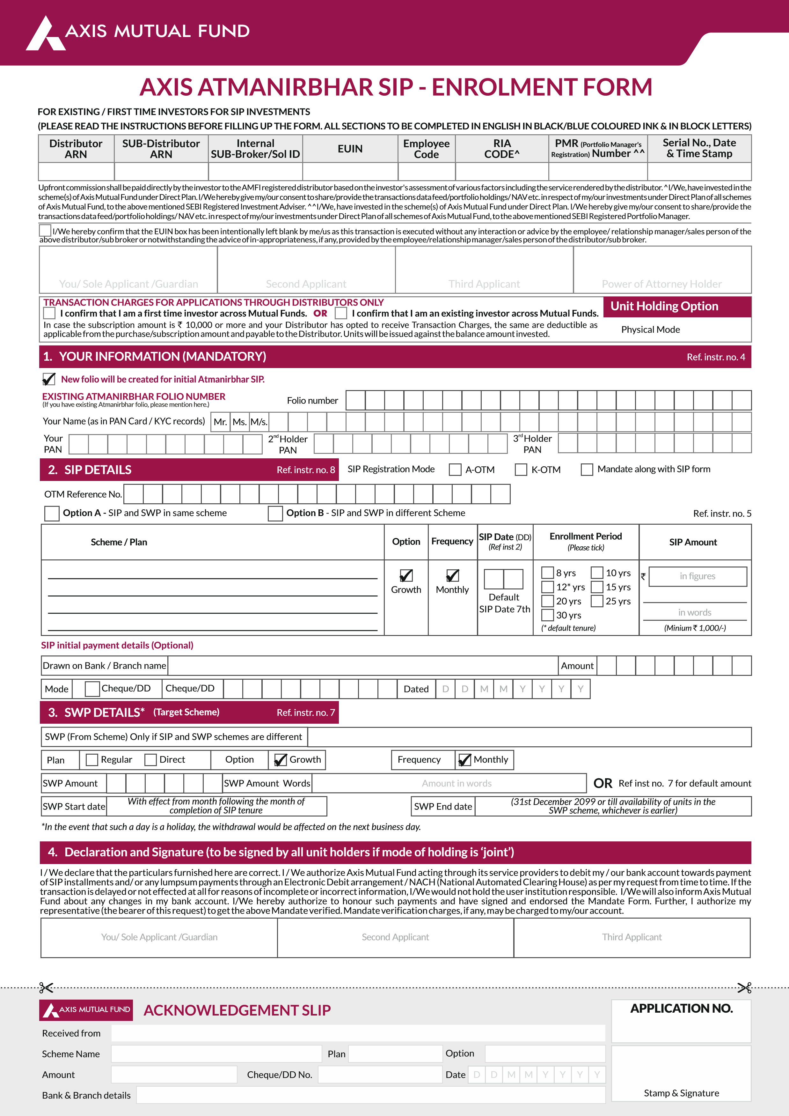
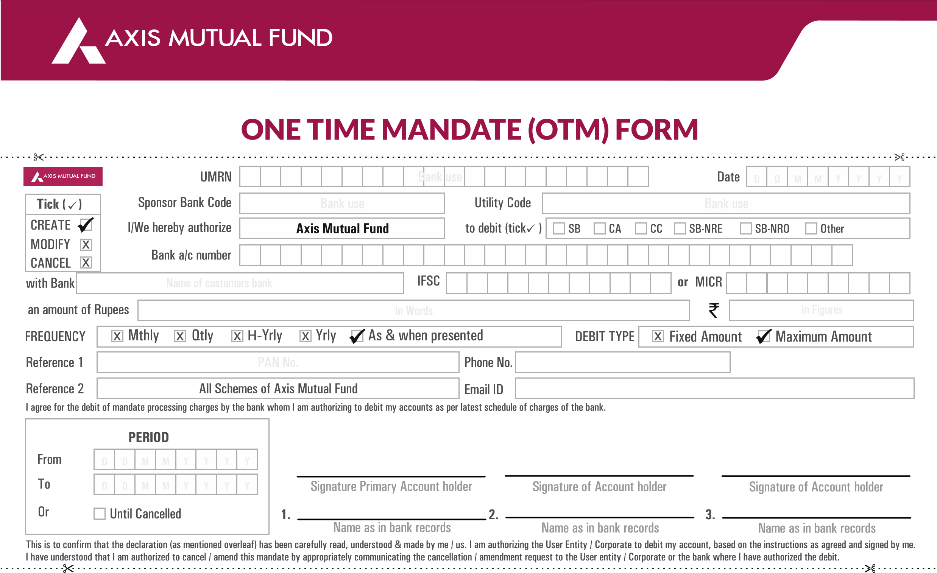
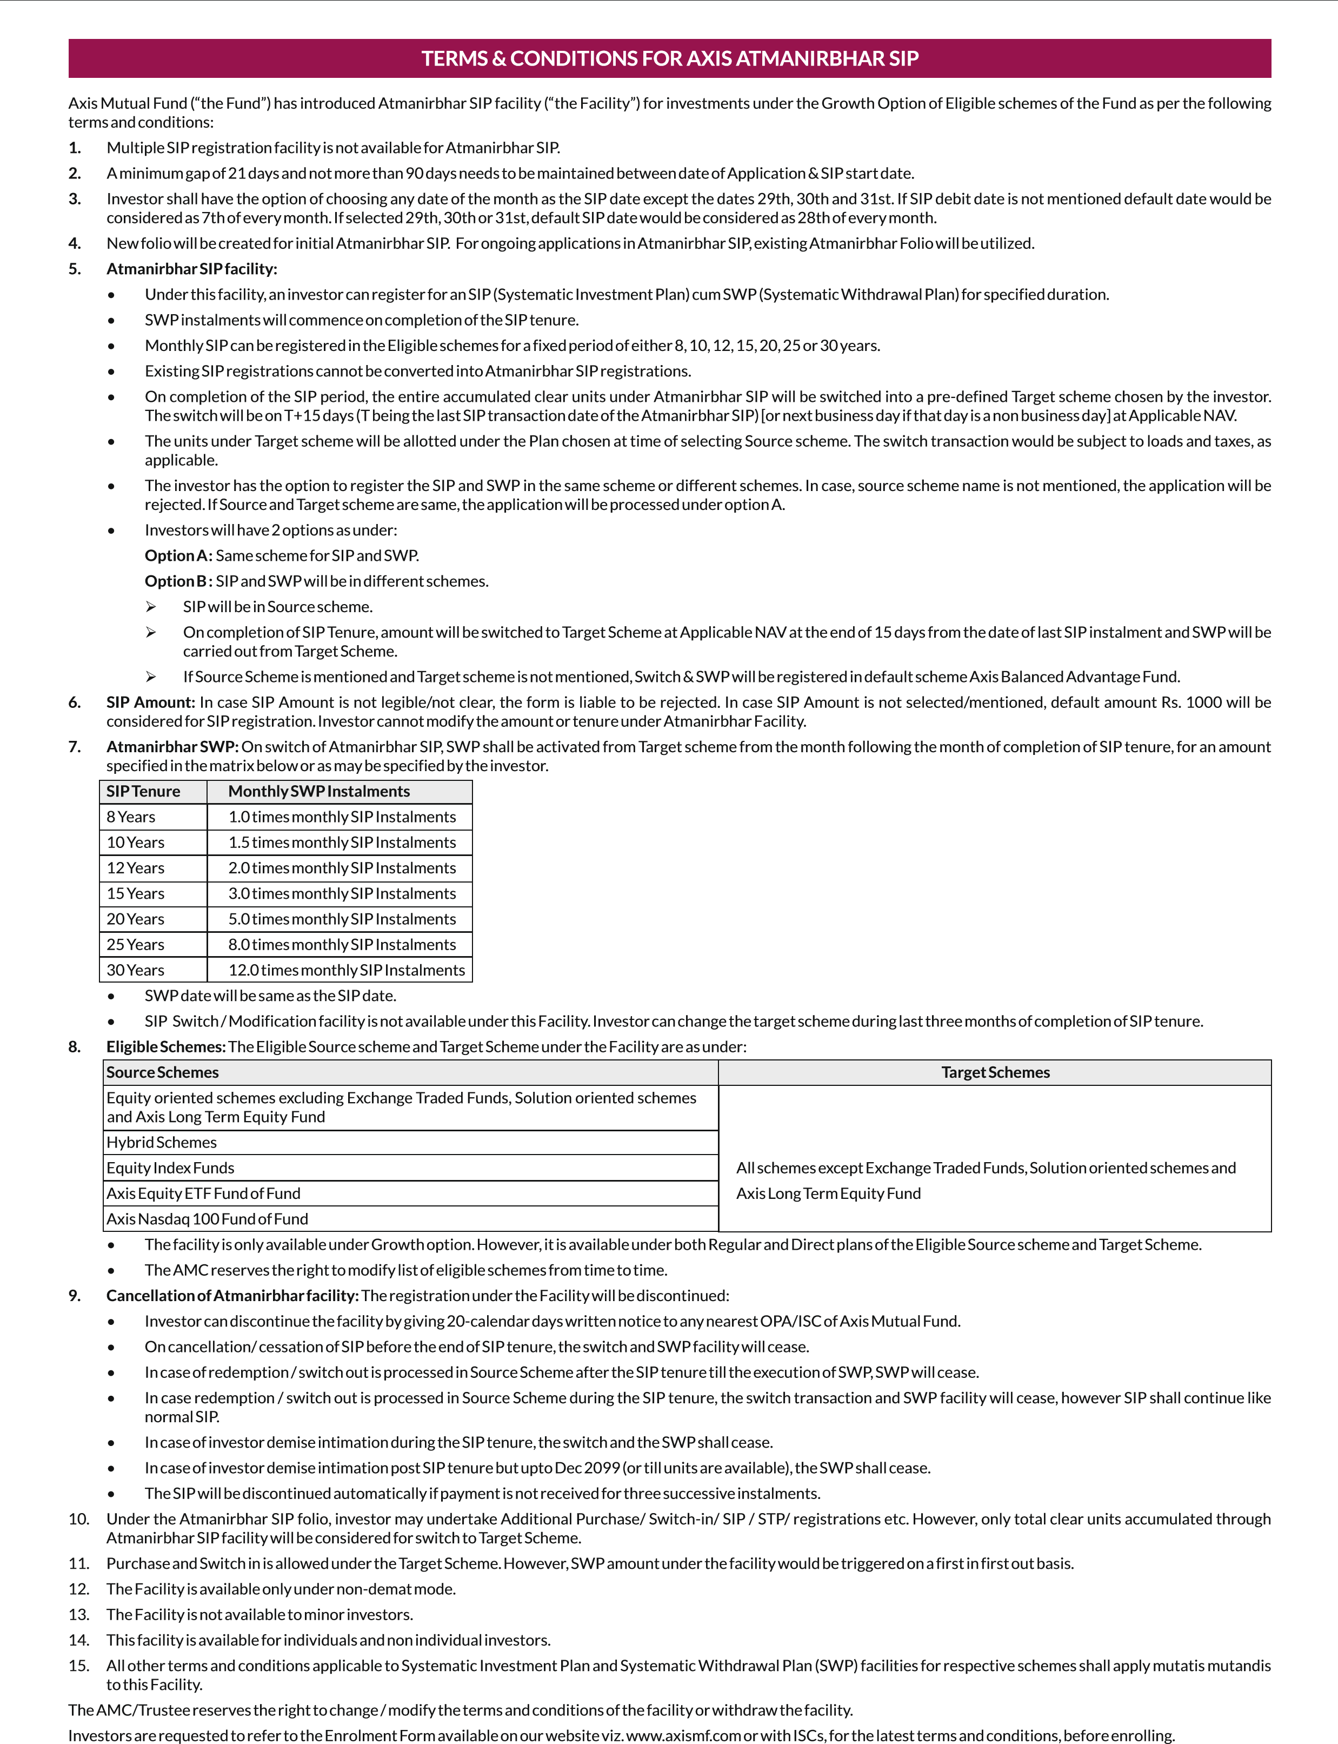
INSTRUCTIONS FOR ONE TIME MANDATE
1
.
One Time Mandate is currently available to HUFs, Proprietor Firms, Non-individual and individual investors with “Single” or "Either or Survivor" the mode of holding. If any other
record is reported, the same will be registered as NACH mandate only.
2
.
Registration of One Time Mandate will take 21 days from the date of submission of form.
3
.
Mandate will be processed through NACH platform offered by NPCI.
4
.
"National Automated Clearing House (NACH)" is Direct Electronic Debit mode implemented by National Payments Corporation of India (NPCI), list of banks is available on NPCI
website www.npci.org.in. The said list is subject to modifications. The investor agrees to abide by the terms and conditions of NACH Debit/ECS of Reserve Bank of India/Banks.
.
5
In case the Mandatory fields on the Mandate are not filled, the mandate will be rejected.
.
6
Maximum Amount: The MAXIMUM AMOUNT is the per transaction maximum limit. As investor can register for multiple SIPs with one time NACH mandate. The transaction
amount should not exceed the maximum amount mentioned in the NACH mandate. It is suggested to choose a higher amount to commence additional investments in future or to
absorb Top-Up increments.
7
.
Axis One Time Mandate cannot be utilized for Liquid schemes, ETF schemes, closed ended schemes, and during NFO period.
8
.
The Investor/s shall not hold the AMC liable for the following:

•
For any transaction using the Facility carried out in good faith by the AMC on instructions of the Investor/s.

•
For unauthorized usage/ unauthorized transactions conducted by using the Facility.

•
For any loss or damage incurred or suffered by the Investor/s due to any error, defect, failure or interruption in the provision of the Facility arising from or caused by any
reason whatsoever.

•
For any negligence/mistake or misconduct by the Investor/s.

•
For any breach or non-compliance by the Investor/s of the rules/ terms and conditions stated in the Scheme Information Document.

•
For not verifying the identity of the person giving the telephone instructions in the Investor/s name.

•
For not carrying out any such instructions where the AMC has reason to believe (which decision of the AMC the Investor/s shall not question or dispute) that the instructions
given are not genuine or are otherwise improper, unclear, vague or cause for doubt.

•
For carrying out a transaction after such reasonable verification as the AMC may deem fit regarding the identity of the Investor/s.

•
In case of error in NAV communication.

•
For accepting instructions given by any one of the Investor/s or his/her authorized person.
9
.
Axis Asset Management Company Limited (AMC) has the right to ask such information (Key Information) from the available data of the Investor/s before allowing him/her access
to avail the One Time Mandate facility (the Facility). If for any reason, the AMC is not satisfied with the replies of the Investor/s, the AMC has at its sole discretion the right of
refusing access without assigning any reason/s to the Investor/s.
10
. It is clarified that the Facility is only with a view to accommodate / facilitate the Investor/s and offered at the sole discretion of the AMC. The AMC is not bound and/or obliged in
any way to give access to the Facility to Investor/s.
11
.
The Investor/s shall check his/ her account records carefully and promptly. If the Investor/s believes that there has been a mistake in any transaction using the Facility, or that an
unauthorized transaction has been effected, the Investor/s shall notify the AMC immediately. If the Investor/s defaults in intimating the discrepancies in the statement within a
period of fifteen days of receipt of the statements, he waives all his rights to raise the same in favor of the AMC, unless the discrepancy/ error is apparent on the face of it. By opting
for the facility the Investor/s hereby irrevocably authorizes and instructs the AMC to act as his/ her agent and to do all such acts as AMC may find necessary to provide the Facility.
12
.
The Investor/s shall at all times be bound by any modifications and/ or variations made to these Terms and Conditions by the AMC at their sole discretion and without notice to
them.
13
.
The Investor/s agrees and confirms that the AMC has the right to ask the Investor/s for an oral or written confirmation of any transaction request using the Facility and/ or any
additional information regarding the Account of the Investor/s.
14
.
The Investor/s agrees and confirms that the AMC may at its sole discretion suspend the Facility in whole or in part at any time without prior notice.
15
.
The Investor/s shall not assign any right or interest or delegate any obligation arising herein.
16
.
The Investor/s shall take responsibility for all the transactions conducted by using the Facility and will abide by the record of transactions generated by the AMC. Further, the
Investor/s confirms that such records generated by the AMC shall be conclusive proof and binding for all purposes and may be used as evidence in any proceedings and
unconditionally waives all objections in this behalf.
17
.
The Investor/s agrees that use of the Facility will be deemed acceptance of the Terms and Conditions and the Investor/s will unequivocally be bound by these Terms and
Conditions.

